

August2016

**Country/Region**

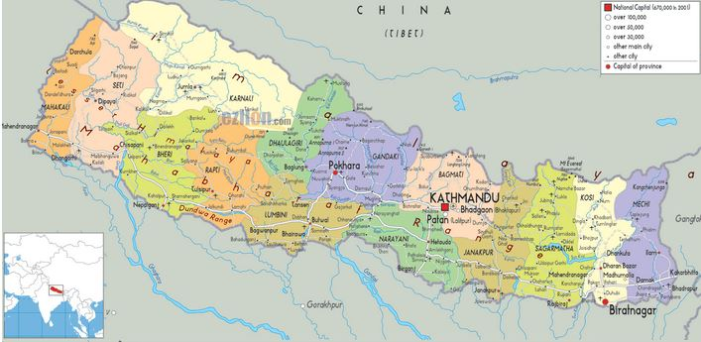

A political, or another relevant map of the country/region

**OVERVIEW**

Provide a short overview of:

* country’s risk profile (anticipated risks to country/ies, populations & operations ranked by impact and likelihood: low, medium, high) and identify the type of hazards: seasonal or static.
* country’s vulnerability profile (socio-economic and demographic).

**NEED ANALYSIS**



Provide a short overview of possible key needs in terms of shelter and NFI, this can, for instance, be based on contingency plans or risk assessments.

**EMERGENCY RESPONSE PREPAREDNESS**



Provide a short overview of emergency response preparedness, elaborating on:

* coordination structures reinforced, working relations with the national authorities and other international and local partners established.
* roles and responsibilities of members of the humanitarian community clarified: operational capacity & arrangements to deliver relief and protection, IM, assessm ents, response monitoring arrangements and etc.
* Contact lists of relevant agencies (agencies with permanent presence in the country, national authorities) maintained and regularly updated.

**GAPS / CHALLENGES**



Provide a short overview of the key gaps and/or challenges vis-à-vis [APA or MPA checklists.](http://sheltercluster.org/sites/default/files/docs/erp.pdf)

**ASSESSMENT PREPAREDNESS**



* Baseline data compiled and stored (census data disaggregated by existing vulnerabilities), key indicator sets populated.
* A list of trained staff (contacts) maintained.
* A common inter-agency assessment format agreed (at least within Shelter & NFIs sector)
* A price list for CGI & tarps maintained. Top 5 producers & suppliers identified.
* An overview of country’s housing typologies maintained.

**KEY FACTS & FIGURES**



The Latest Crises: November 2015

Activation of Cluster: 11 December 2015

Cluster management arrangements: for example working groups etc.

Frequency of cluster meetings:

**XX** Total cluster partners

**XX** IOs & INGOs with permanent presence in the country

**XX** Local NGOs

**CLUSTER TEAM - Contacts**



Cluster lead agency: IFRC

Co-lead: ACTED

Cluster coordinator:

Email:

Telephone:

Information Management Officer:

Email:

Telephone:

**KEY DOCUMENTS (hyperlinks)**



Shelter cluster contingency plan

Technical guidance

IM products

Contact lists of cluster partners, including national authorities

**KEY LINKS**



Country page on sheltercluster.org

**XX** visitors in *August*

Country page on humanitarianresponse.info

Country page on relief.web

**INFORMATION ON STOCKS**



* Amount and whereabouts
* Main warehouse locations
* Main supply chains