SAG Retreat 2016

Objectives: Review how the SAG has been working in 2016, analyse achievements and challenges, and define the way forward in 2017.

Participants:
In room: Ela Serdaroglu (IFRC), Brett Moore (UNHCR), Miguel Urquia (UNHCR), Pablo Medina (IFRC), Joseph Ashmore (IOM), Kip Scheidler (Habitat for Humanity), Luca Pupulin (ACTED), Hilmi Mohamed (InterAction), Amelia Rule (CARE), Neil Brighton (NRC), Andrew Powell (Save the Children), Brenda Rose Daniel (World Vision), David Evans (UNHABITAT).
Apologies: Seki Hirano (CRS).

Welcome from GSC Coordinators
B. Moore thanked participants who came to the SAG Retreat at a busy period of the year and expressed hope that the conversations will be open, frank, and constructive. As everyone had already been involved in drafting and approving the agenda for the retreat, E. Serdaroglu went through the latest version to see if there were any last comments.

1. Feedback and discussion on WHS and Habitat III
Background
The objective of this session was to identify the implications from these two events for the GSC, and what should the cluster do differently in order to address these issues. The SAG members broke out into two thematic groups to discuss the outcomes from Habitat III and the WHS, focusing on three separate questions:
- What does it mean for your organization?
- How can the Global Shelter Cluster (GSC) support this?
- How can the GSC demonstrate responsiveness and accountability?
After this the groups presented key discussion points in plenary.

Habitat III:
Localization: During Habitat III, localization was emphasized from the perspective of Disaster Risk Reduction (DRR), funding local governments, capacity building and sustainability. The conclusions on how the cluster can advance localisation are similar to those highlighted in WHS:
  - Preparedness is a key way to advance localization. Preparedness workshops in high risk countries can help in different ways: link with local actors (including government), identify their training needs, and identify sub-national coordination capacities. Agencies with field presence could also start collecting information needed for the emergency response. Country profiles could be developed with key information such as local construction methodologies and materials, HLP issues, and others. However, the challenge is to keep this information updated.
  - The link between humanitarian and DRR remains weak; preparedness is not good enough for the next inevitable crisis. For example, schools which have the potential to be used as collective centres should already include more toilets than the ones strictly needed for scholar use. They would be redundant outside of crises, but essential during crises.
  - Adequate coordination capacity at sub-national level is also important. Increasing the number of coordination team members who are national staff will also facilitate localisation and linkages with national and development actors.

Urban: The humanitarian community does not have a mechanism to respond effectively in urban contexts. With the growing urban poor population and lack of public housing policy more and more people move into slums, adding complexity to the issue.
- Ensuring ‘good’ urbanization has the potential to reduce poverty and not allow people fall into informality. In doing so, mapping emergency prone urban areas and use them for advocacy could be useful.
- Promoting the settlement approach as a way to facilitate humanitarian response in urban areas and make it more connected with development work and local capacities.
- At the same time, based on the example of Hurricane Matthew response, agencies seem to be defaulting to urban response at the expense of the affected populations in the hard to access rural areas. Serving dispersed vulnerable populations in hard to reach areas remains a challenge at this point.
- With around one billion people living in slums, a big role for the SC can be advocacy using a rights-based approach. To improve advocacy the SC has to redefine shelter in the language of protection – shelter is protection. The toolkit to reduce the Risk of GBV in Shelter Programming was cited as an example of successful shelter and protection collaboration.
- Early engagement needed with the development actors who understand urban land economics, real estate and other topics on the margins of shelter.
- Agreed processes/procedures for meaningful multi-sectoral work with other clusters are missing, thus working in that direction is important. Engaging with the WASH cluster could be a first step in that direction as well as engaging with other existing initiatives that work on urban contexts such as the Global Alliance on Urban Crises, the IASC Reference Group on Meeting Humanitarian Challenges in Urban Areas, and the ACTED IMPACT UCLG ECHO ERC-funded project to pilot and promote localised response and coordination in urban areas affected by crises.

WHS:
- The work of the clusters seems to be underrepresented despite being relevant to a number of issues that were discussed during the WHS, particularly on predictability – one of the reasons why the clusters were set up for in the first place. Is this a problem and clusters should be promoted? Or is this because clusters are fully mainstreamed and not questioned anymore?
- Participation revolution: The role of the cluster is unclear in regards to population participation. Should its role be limited to promoting that cluster partners use participatory approaches or is it possible for the cluster decision making processes to allow for participation of affected population? The cluster already advocates for cluster partners to use participatory approaches and should continue doing this in the future. Additionally, there have been some examples of clusters involving affected population. These examples could be expanded and assessed to learn lessons and new approaches could be piloted.
  - Population as partners: the cluster should do more around behaviour change to promote safer building techniques. This issue is not only an important shelter programming activity but it is also linked with localisation, participation, and cash. Some initiatives are advancing on this issue such as Promoting Safer Building and the work undertaken by CRS.
- Cash: The sector is seen as fallen behind cash although we are catching up with the position paper and the work undertaken by the Cash and Shelter WG. Despite the sector having a long history of using cash as a modality it struggles with deployment of cash and shelter experts, monitoring tools and market assessments. However, some individual agencies seem to be doing great work in this area. Unconditional cash requires accompanying shelter programming to ensure quality and that minimum standards are met. It can be used in combination with conditional cash, in-kind, and other modalities to match the needs. Unconditional cash programs will only increase – how do we make that work for shelter?
  - The discussions/arguments should be consolidated and agreed upon rather than having them scattered at each country level. The cluster needs to be balanced and compile evidence where it worked, not only where it failed. Donors want responses to be efficient and effective but unconditional cash will not always reach these outcomes.
  - The SAG members were invited to continue the lively discussion on cash in the Cash Working Group (WG). Keep the GSC Cash WG representative and inclusive.

- Humanitarian-development nexus:
  - Preparedness: Provides opportunity to increase involvement of local actors, to raise awareness and create an entry point to changing building practices. It is also a way to address the humanitarian-development divide, including in funding. The difference between government preparedness vs NGO or local actors preparedness was discussed.
  - Handover and transition: very important from the beginning. The cluster should work with local actors and governments to take over. In this regard, language should be accessible to local partners as well as discussions relevant and useful to them.
  - Non-traditional donors, private sector, and remittances: While continuing the engagement with traditional donors, how to engage with non-traditional donors who have not signed up to the Grand Bargain? In certain regions non-traditional donors have a huge impact. The same applies to private sector and remittances. The cluster should consider these stakeholders better to have a more accurate understanding of the capacities and the response.

General Discussion points on WHS and Habitat III:
- Aspirational, high-level outcomes (SENDAI, SDGs, WHS) are hard to operationalize. The short-term engagement processes are not clear.
- InterAction has funding to conduct a conference favourably with several clusters and donors, which can take place in Geneva or in Washington DC. There were already a number of discussions with donors and a lot of them are interested. The next step would be to collectively agree on an agenda and common messages. But it has to be clear that the aim of the event is not to ask for money, but to change policies and approaches.

2. Implementation of Global Shelter Cluster Strategy 2013-2017
The objective of this session was to discuss the implementation of the GSC Strategy 2013-2017, to assess progress, identify achievements and gaps, make recommendations for the last year of implementation and inform the development of the next GSC Strategy. This session was part of the GSC Strategy implementation review, which is conducted by an independent consultant Jean McCluskey who facilitated the session.

After the objectives and methodology for the evaluation were presented, the SAG members divided into three groups on each of the three strategic aims of the strategy, to identify what the cluster has achieved. Achievement reports from 2013 and onwards were distributed.

Discussion of strategic aims (Please refer to the annex for detailed comments on each of the sub-points of the strategic aims):
Strategic Aim 1: Responsive and flexible support to country-level shelter coordination mechanisms
- Progress was made in terms of developing surge capacity systems (Technical Coordinator, Roving cluster coordinators, Global Focal Points).
- The agencies have more and more cluster-specific positions.
- The Humanitarian Shelter Cluster Coordination Training (HSCT) now covers both natural disasters and conflict and offers a common methodology for shelter cluster coordination. It is open to participants from all interested agencies but especially to those that are on a cluster assignment.
- The GSC support team did not exist before and most of the issues were managed separately within agencies.
- It is still challenging to find experts with specific technical and/or language skills.
- Better linkages with NORCAP would be great to enhance search for human resources.
- Smaller crises in comparison to L3s were discussed in terms of how they are resourced from the national level to the hub levels.
Strategic Aim 2 – An effective and well-functioning GSC
- Governance-wise the group saw improvements over the years.
- Involvement of the GSC in operational elements is still limited, but it may be sufficient as the SAG is there for strategic guidance.
- In terms of participation and engagement – successful in terms of getting more NGOs and people coming to global meetings, however, have not done anything to encourage emerging humanitarian actors. Innovation on processes (WGs, CoPs, DCG and so on) was good, but less so in terms of technical tools.
- The strategy has points with outdated wording. For example 2.10 talks about ‘division of responsibility between clusters’ (language coming from the Global Cluster ToRs), while currently the focus has shifted to ‘clear and predictable synergies across clusters’.
- Similarly, the aim of 2.7 - ‘common understanding of global shelter response capacity’ - might not be relevant. Even within agencies it can be difficult to say where the stockpiles are.
Strategic Aim 3 – Increased recognition of the shelter and settlements sector as an essential component of the humanitarian response, through enhanced advocacy and communication.
At the beginning a Communication and Advocacy Focal Point was hired to establish the cluster brand, develop templates, communication tools, posters and other products. There is more to improve, but it has advanced a lot. The website is a strong positive.
- Efforts were made on the issue of a consistent donor base, but we have not advanced much beyond donors who are cluster partners. Donor consultation group was set up but has not met yet.
- In terms of enhanced articulation of the linkages of shelter with other sectors - posters were produced, inter-sectoral working groups set up. Shelter Projects also contribute to it.
- There has been increased professionalization, more engagement with academic institutions. The HSCT was accredited.
- Some ad-hoc efforts to engage with the private sector: WEF, a private sector advisor was hired for the Shelter Cluster Nepal.
- The State of the Humanitarian Shelter initiative will also contribute to Strategic Aim 3.
- With regards to the third pillar, more has been achieved at country level, although a lot has been achieved globally as well.
The SAG members asked if the strategy is going to be the main focus of the evaluation, pointing out that they were already aware of its weaknesses. The independent consultant replied that the methodology includes a variety of methods such as interviews, which will allow her to get an overall understanding of the degree to which the strategy succeeded, thus focusing more on implementation.

3. Way forward for 2017-2018 and beyond
After discussing the achievements and gaps in the implementation of the 2013-2017 Strategy the group discussed what would the priorities be for 2017-2018 and beyond as well as the process that should be followed for the new strategy. The GSC is going to submit a proposal to the ECHO Enhanced Response Capacity grant. This proposal will follow these priorities identified for 2017-2018.

Strategic Aim 1 - Country-level shelter clusters are effective, efficient, predictable, accountable, and advance the commitments from WHS and Habitat III.

  - Country-level shelter clusters and shelter operations are appropriately staffed:
  - Surge capacity is deployed to support country-level clusters: timely, right expertise, languages, skillsets, duration, diversity, national/regional staff.
  - Analysis of staffing, needs available, training.
  - Improve links between training/retaining and rosters (NORCAP, DRC) and agencies.
  - Internships, shadowing, green programme.
  - Country-level shelter clusters and coordination mechanisms are effective, transparent, predictable, and accountable:
  - Coordination Performance Monitoring Tool is used and acted upon regularly. A lighter CPMT to be developed and used more regularly.
  - GSC has objective criteria to monitor performance of country-level clusters.
  - Support is provided to country-level clusters by GSC bodies beyond Support Team (SAG, WGs, CoPs).
  - Participation revolution
  - People as partners.
  - Local partners: municipality and civil/private sector.
  - Encourage more involvement of more actors.
  - Increase national staff and better gender balance in coordination teams.
  - Cash champions.
  - Links to development and resilience.

Strategic Aim 2 - An effective and well-functioning Global Shelter Cluster supports the delivery of good shelter responses.

  - The GSC identifies and promotes innovative approaches for shelter coordination and operational support: Working Groups, CoPs, Shelter Projects…
  - The GSC supports understanding of local actors and recognises that synergies with local actors and lead to a more effective, efficient, RS, and sustainable response.
  - The GSC actively engages clusters and inter-agency actors to ensure more and better multi-sectorial planning and response.

Strategic Aim 3 – Enhanced advocacy
3.1 Shelter actors deliver good shelter and settlement programs:
  - Participatory and inclusive
  - Integrated
  - Innovative
  - Holistic (cycle): Build Back Safer, evidence-based, M+E
  - Context specific
3.2 Change in perception, policies, and practice in selected issues
  - to Governments, Clusters, Sr Management, Agencies, and Donors (diverse) (funding gap)/approaches.
  - These issues could include: Settlement approach, cash, local + part, urban, right to shelter, HLP, BBS/PSB, Gender/GBV, Consistent funds.

Process to the new Strategy 2018-2022

What to keep: | What to change:
- Short and concise – 1 pager format  - Light drafting and formalization process  - Time-frame – 5 years with a mid-term review | - Ambiguity of language  - Lack of objective indicators against which to measure progress  - Too focused on coordination and process-oriented  - Too many results – keep it to maximum 3 per strategic aim

Timeframe for the 2018-2022 GSC Strategy:
- Create a SAG small group with a facilitator to lead the process.
- Start early with a Draft 0, based on available feedback and strategic discussions during the 2016 SAG retreat (point above).
- Define the consultation process and stakeholders – cluster coordination team members, SAG members, governments, partners, Working Groups, CoPs, etc.
- 2014-2017 GSC Strategy mid-term review results published in March 2017 – to inform the consultation process.
- Consultations findings and analysis - present at the mid-year GSC teleconference (June 2017).
- Draft 1 writing – Sept 2017.
- Draft 2 shared at the GSC Annual Meeting for feedback – October 2017.
- SAG Meeting finalization of draft and Strategy Implementation and Communication plan – November 2017.
- Formal endorsement of the 2018-2022 GSC Strategy during the 2017 SAG Retreat – December 2017.

4. The Sphere revision process – a coordinated approach
The objective of this session was to clarify how the GSC can support the Sphere revision process to ensure that shelter stakeholders provide a coordinated feedback and that synergies are found with other sectors.

The aim of the revision process is to make Sphere more relevant. The two authors for the Shelter Chapter revision and working group are Ela Serdaroglu and Seki Hirano– they will keep the SAG informed on opportunities to engage and provide input into the revision process. Discussion around:
- Whether Sphere standards and especially indicators relating to covered living space should be endorsed by the GSC – Sphere indicators should not be prescriptive and should be adapted to the context rather than be taken as a minimum to be reached at all costs. Dogmatic approach to technical indicators could often be counter-productive.
- Expanding the Sphere with every revision has made it less effective as a tool – we should advocate for re-focusing it to its initial purpose.
Action points:
- The GSC should engage with the Sphere revision process – chapter authors will inform SAG members on opportunities to influence the process after the first WG meeting in February 2017 – especially on engagement with cash.

5. Working Groups
The objective of this session was to review the achievements of the WGs in 2016 and agree on a way forward.

NFI WG by G. McDonald (UNHCR) and C. Treherne (IFRC)
Held a workshop in Nairobi, Kenya (7-9 Dec, 2016) – to review NFI materials/documents:
- Vulnerability scorecards – to identify what is available, potentially develop a “build your own kit” with Oxford Brookes.
- NFI Fairs (DRC) – good practice identified.
- Quality control for NFIs – how to do this at the field level? => publish findings and disseminate.
Next steps for the WG:
- Complete activities for 2017.
- Ensure resources and seek further engagement.
- Hold a similar workshop (possibly in Asia) to increase localization and gather additional good practices.
The WG will continue into 2017 – a Work Plan is to be discussed during the first 2017 SAG teleconference.

Cash WG: Presented by Davide Nicolini (UNHCR)
Achievements in 2016:
- Position Paper, draft cash guidelines, cash literature review.
Plans for 2017:
- Finalize cash guidelines.
- Design training and provide tools for the field to operationalize cash in shelter response.
- Conduct trainings in the field.
- As a cluster we can do more on market assessments.
- Under SAG guidance, move away from advocacy and more towards building capacity and resources for the field.
- Develop cash expertise on behalf of the cluster.
- Work more and closer with CaLP.
- Focus on advocacy for cash as a modality.
- Joint NFI/Cash workshop possible.
- Developing a body of evidence on cash for shelter from the field – cash studies, best practices, field research to prove impact.
The WG will provide a revised Work Plan at the next SAG teleconference.
Construction Standards WG: Presented by Brenda Rose Daniel (WVI)
The proposal for this WG arose with Save the Children to produce a policy framework to inform due diligence for construction standards. The next draft of the framework will be produced in the first quarter of 2017. The WG has no new activities after the completion of the document and will be closed.

Gender-Based Violence WG: Presented by Joseph Ashmore (IOM)
The WG has produced two guidance documents (Good Shelter Programming and Site Planning Guidance) which were distributed at field level and feedback is expected.
In 2017, the WG plans to:
- Develop a suite of training materials for addressing GBV;
- Roll out and test the created tools;
- Conduct a field implementation workshop for the Site Planning – Guidance to reduce the Risk of GBV edition – through a field review process and funding available for the next workshop through IOM;
- Engage and invigorate the Gender & Diversity CoP;
- Exit strategy – the WG will eventually phase out into the CoP;
- Accompanying CARE Gender & Shelter Programming Guidance.
Shelter Projects 2015-2016 WG: Presented by Joseph Ashmore (IOM)
Key achievements in 2016: inception workshop held and peer review process started and ongoing.
Next steps for 2017: Launch the English version of the Shelter Projects 2015-2016 publication

6. WASH and Shelter
The objective of this session was to discuss and identify initiatives on how to improve coordination to support operations in the field. The Deputy Global WASH Cluster (GWC) Coordinator, Franck Bouvet, and GWC SAG member Murray Burt presented an overview of the cluster, its strategy and challenges.

Key Discussion Points:
GWC consists of 36 organizations, 7 sitting on the SAG, supported by the Cluster Advocacy and Support Team (CAST) and the Field Support Team which is deployable personnel - predictable response capacity. Partners are categorised according to the following criteria: full members, associate members, standing observers and ad hoc/special invitees. The GWC representatives shared some of the challenges that they are facing.

New strategy for 2016-2020 is being finalized now, to deal with the issues above, based on 4 strategic pillars:
- Provide operational support to national WASH coordination platforms, going beyond active or formally active cluster countries.
- Capacity building: individual and sectorial – for the humanitarian WASH sector.
- Improved cooperation with key partners on advocacy, reinforce a systemic approach to better serve the country level.
- New knowledge management systems, focusing not only on coordination but also on the quality of the response.

How can the GSC and the GWC work closer together?
- The issue of urban represents an opportunity for cooperation, given increasing number of emergencies where this is relevant and the focus on linking humanitarian and development. Thus, a joint technical WG on urban is proposed.
- A coordinated cross-sector push for development donors showing them the need to invest into long-term infrastructure projects, focusing on preparedness and transition, will have a higher chance of securing longer term funding.
- Coordinated approach to Sphere revision, particularly on NFIs.
- The two cluster support teams knowing each other is valuable, perhaps organize meetings, joint workshops, etc.
- The cluster matrix was discussed as providing a vision on how clusters could work, what belongs to which cluster, however it is not operational. Creating a more practical guidance could be useful.
- Rapid Response Mechanism (RRM) could be an interesting topic for discussion: present in a number of countries created with strong funding from donors, but they have a life of their own, and in some cases there is a clash with the cluster system.

The impact of WHS on the WASH strategy: discussions started on local engagement, working with local authorities and national NGO representation. Cash WG was set up, and WASH is in the process of solidifying a common understanding, specifically around risks, challenges and appropriateness of cash. A joint advocacy on cash can be beneficial. Both clusters are worried about ensuring quality and meeting of minimum standards when using multi-purpose cash grants.

With regards to working on the settlements approach and whether there is an interest in creating a joint WG, it was pointed out that focusing on working better within agencies between departments could help, because WASH departments of various agencies could already be working together, but departments within the same agencies tend to work in silos. Also the WASH cluster does not tend to distinguish a variety of settlement typologies (rural, urban, dispersed, collective centres etc.) as much as shelter.

Decisions:
- Coordinated approach to Sphere revision particularly on NFIs.
- Setting up a joint Technical WG on Urban.
- ECHO: ensure to have activities articulated in both proposals to show the connection between clusters. Technical WG on Urban, for example, both clusters already agree on this activity.
- Joint advocacy messaging on such issues as cash, durable solution and approaching development donors was mutually understood to be beneficial.
- Define common problems and challenges to identify collaboration, operationalization opportunities. Priority countries could be compared, including discussions at the level of cluster coordinators.
- Review the inter-cluster matrix with an aim to expand and operationalize it.
- The WASH cluster will share their position paper on cash.
- WASH field support team is undergoing restructuring until 1st February 2017, thus engagement on these issues is possible only after this date.

7. HLP and Shelter
Background:
This session discussed the engagement of the Shelter Cluster in Housing, Land and Property Area of Responsibility (HLP AoR). Earlier in 2016, the Protection cluster requested the GSC to co-lead the HLP AoR as a bi-cluster WG. The proposal was ultimately retracted and the HLP is to remain under the Protection cluster only. Consequently the SAG discussed how the GSC could work better with HLP AoR and whether the AoR will be able to address the HLP needs of the Shelter Cluster. N. Brighton presented on NRC Shelter HLP training of trainers.

Key discussion points:
- Quick, short, location specific HLP factsheets are hugely beneficial, however, creating such a document in Nepal during the earthquake took a long time. Despite the existence of such guidance as due diligence, information collection by people who are skilled in HLP is required. HLP issues need to be integrated into preparedness, so that such work is done before crises.
- Working on HLP in the context of humanitarian crises is very different from normal legal practice. Thus, HLP advisors should not only have legal expertise, but also understand the humanitarian implications of their decisions.
- Donors should be made aware of the risks; be more flexible and share the risks rather than putting all the responsibility on the implementing agencies.
- The HLP AoR has limited capacity to provide support to country level clusters. The Shelter Cluster needs were mainly defined as deployment of HLP advisors to country-level clusters. This may not be the priority of the Protection cluster.
- A concern regarding the lack of natural disaster representation in the AoR was brought up.
- HLP is high on the priority list of the GSC regardless of where the HLP AoR sits. The GSC should still provide HLP operational support to country level shelter clusters in coordination with the Protection Cluster.
- The Special Rapporteur on the Right to Adequate Housing recently voiced interest on the issue.
- The reasons behind the closure of the WG on Regulatory Barriers were discussed. Restarting the WG was not considered a good option because the main need is the deployment of capacity to the field and NRC has that capacity.

Decision:
- On December 8, HLP AOR is hosting an event on better integration of HLP into 2017 HRPs and its overall plans for 2017. A number of GSC SAG members will participate to influence their agenda from the GSC perspective.
- Participants agreed that HLP activities initiated by the GSC would be closely coordinated with the HLP AoR.

Engagement with Global Alliance for Urban Crises
D. Evans presented on the Global Alliance for Urban Crises and Urban Crises Charter asking questions on whether the GSC should be engaging with it.

Key discussion points:
- No formal request or call for expression of interest has come to the GSC from the Global Alliance for Urban Crises.
- Individual agencies are already engaging as far as their capacity allows.
- There seems to be no formal space or benefit to engage as a cluster.

Decisions:
- More information is needed on the initiative, level of engagement possible/expected and how it could contribute to the SC.
- L. Pupulin (ACTED) is already engaged with the alliance and can provide feedback to the cluster.

8. Final Remarks:
The Global Cluster Coordinators thanked the SAG members for the convivial manner in which the SAG members participated at the retreat. They felt that the group has a common agreement on the overall direction of the GSC.

SAG Retreat 2016 Minutes: Annex I

A focus group work outcomes during the SAG retreat on the Implementation of Global Shelter Cluster Strategy 2013-2017 session.
Strategic Aim 1: Responsive and flexible support to country-level shelter coordination mechanisms.
Aims | Achievements | Gaps | Prioritization
- A harmonized surge capacity system for shelter coordination. | - Global Focal Point, Technical Coordinator, Senior Roving Cluster Coordinators, Roving Focal Points  - There is more staff at global level to support clusters  - Major improvements at agency level and Norcap, Canadem, REQR, standby partners. | - There has been sufficient coordination capacity for L3s but it is difficult to state the same for smaller crises.  - More work towards better capacity for cluster-like situations | Need for comprehensive staffing capacity development – offering a growing and structured career path through a HR Strategy for the GSC – “right people at the right place at the right time”.
- A diverse pool of available technical expertise, reflecting the wide scope of disciplines involved in the shelter and settlements sector. | - Joint IFRC and UNHCR coordination training open to partners | - The challenge is cluster-like mechanism which have less resources thus less capacity, especially on sub-national level: how do we get resources from the national level to the hub levels?  - It is still challenging to find experts with specific technical and/or language skills.
- An established mechanism to leverage the existing capacities of the private sector in support of the humanitarian shelter response. |  | - WEF did not work out. Otherwise only agency based initiatives.  - Different context and opportunities to engage with the private sector – it may be more appropriate to do so at the agency level rather than as a global cluster.
- Provision of technical advice for shelter sector emergency preparedness and contingency planning. | - Global surge support  - Technical Coordination Focal Point now available
- A coordinated approach to shelter assessments | - 27 Shelter Cluster assessments with more than 100 NGOs participating  - Some improvement in MIRA, REACH, partner led, country level specific assessments | - More work needed on common terminology  Need better links with ACAPS, JIPS, DTM, REACH
- A transparent and inclusive approach to facilitating access to pooled funds for shelter response. | - Stronger advocacy to encourage donor support for pooled funds, pipelines and funding in line with cluster
- Available capacity to provide learning support for ongoing shelter responses, by reviewing and defining success, and capturing and sharing innovation and good practice in the field through interagency impact evaluations, reviews, and other learning support options. | - Coordination workshop: strong facilitation from coordinators and attendance by people ‘on the job’  - Common evaluation methodology and more evaluations happening  - Shelter projects, evaluations, coordination workshop, Website, dropbox by coordination teams, facebook, yammer
- Increased capacity to engage in shelter early recovery activities and a consistent approach to cluster handover and exit strategies | - Through improved global cluster support team | - Links with Grand Bargain but no formal systems, limited agreements
- Increased engagement with and participation of local and national actors, providing relevant and adaptive support to local needs and existing national coordination mechanisms. | - Nepal case: preparedness and training of national authorities  - Increased engagement, national authorities co-chairing cluster and working group  - At country level and global workshops  - More national staff being hired in coordination teams | - Increased engagement by national and local actors was envisaged as a thematic priority back in 2014 but there was no interest from the partners to lead a Working Group. | Participation revolution – through increased engagement of local partners, inclusion of more national staff in SCTs + better gender balance and more clarity on co-chair arrangements.
- A clear and consistent approach to shelter cluster coordination, readily available and kept up-to-date. | - Coordination toolkit, website, training, coordination workshop |  | Harmonized monitoring tools for country-level clusters’ performance against objective criteria – CPMT light version and used more consistently;

Strategic Aim 2: An effective and well-functioning Global Shelter Cluster
2.1. An inclusive and broad-based GSC, with increased participation of emerging humanitarian actors. | - More people (NGOs) coming to global meetings: 31 – 35 – 43 NGOs | - We have not managed to make it more broad based and inclusive  - Not enough engagement with emerging humanitarian actors.
2.2. Effective and accountable governance and management structures, open to the participation of all cluster partners | - SAG now engages in sectoral issues, open for all sector partner agencies  - SAG sets annual meeting agenda  - Scope for influencing GSC strategies, not operation/implementation  - A SAG and a strategy |  | Accountability should be a direct link between a shelter operational actor and beneficiaries – placing people back at the centre of the GSC Strategy. The GSC could help with guidance and encourage accountability of agencies.
2.3. An innovation culture, harnessing new technologies and programming approaches for enhanced shelter response. | - Improved engagement between GSC and other fora  - Process is good, technical tools need improvement |  | The GSC should actively identify and promote innovative approaches for shelter operations and coordination (through WGs, CoP, Shelter Projects, etc.)
2.4. Consistency in technical standards, specifications, reporting, indicators and policies. |  | - Consistency is a problem/issue
2.5. The prime global humanitarian shelter knowledge hub, providing the primary information portal for all actors engaged in humanitarian shelter response. | - Website improvements and usage increased  - It is getting better |  | Focus on general knowledge management of best practices/tools from different agencies to maintain the knowledge hub
2.6. Cohesive training and capacity building initiatives | - Good at coordination level | - Technical level less so
2.7. A common understanding on global shelter response capacity, including material stockpiles and pre-positioning approach, suppliers, human resources, and overall capacity of humanitarian agencies. | - Informal links with QSE and LOG Cluster + standby partners | - Working Group started but engagements are insufficient  - “Common understanding”?
2.8. Active participation in IASC activities and inter-cluster initiatives. | - Lead agencies are engaged | Cluster representatives still speak with a different voice at the different humanitarian fora. Lack of a communications and advocacy strategy to allow GSC representatives to convey key messages, talking points (e.g. position on cash) | GSC should actively engage other relevant clusters (Protection, WASH, Livelihoods, etc.) and Inter-Agency actors to ensure more and better multi-sectoral planning & response and bring the global discussions on shelter-related issues to the country-level.
2.9. Enhanced partnerships among shelter actors allow for pooling resources and ensuring complementarity of efforts. | - Ad hoc partnerships have happened thanks to GSC links
2.10. A clear and predictable division of responsibilities with other clusters. | - Found less relevant. The focus has changed from division to ensuring a holistic approach.

Strategic Aim 3: Increased recognition of the shelter and settlements sector as an essential component of the humanitarian response, through enhanced advocacy and communication.
3.1. A raised profile and understanding of the humanitarian shelter sector, resulting in a reduced gap in funding coverage of stated shelter needs. | - Enhanced country level response + tracking  - ‘State of Humanitarian Shelter’ initiative |  | Advocating on shelter impact to raise the profile of the sector but also identifying longer-term specific issues around which to build a comprehensive advocacy campaign.
3.2. A diverse, predictable, and consistent donor base for shelter coordination and response. | - Donor consultation group  - Donor talking points |  | Donor funding base diversification remains important – re-confirms the GSC’s pre-meeting survey results where predictable funding for cluster coordination and shelter operations came up as the highest GSC priorities ranked by cluster partners.
3.3. Coherent, coordinated and targeted public communication and advocacy on humanitarian shelter issues, with governments and other humanitarian stakeholders. | - Tools (website, twitter), templates, factsheets, posters, etc.
3.4. Consistent and accurate understanding and messaging of the shelter sector capacity and resource needs. | - Surge Capacity  - National articulation of gaps
3.5. Wider acceptance of a settlements approach in humanitarian response strategies. | - Progress made: settlements advisor for Haiyan  - HLP etc.
3.6. Increased integration of the humanitarian shelter response, through strengthened linkages with other sectors. | - Posters, factsheets, video, etc.  - HLP WG / GBV WG  - Inter-cluster sessions
3.7. Broader understanding among humanitarian stakeholders of the role and scope of the shelter sector in the coordination of NFIs. | - Others linking/copying GSC website to their pages  - NFI working group and workshop
3.8. Enhanced articulation of the linkages between shelter risk reduction, preparedness, relief, recovery, and development, through a resilience approach, resulting in a seamless transition from emergency relief to recovery and reconstruction. | - Shelter in Recovery WG  - ‘Shelter Projects’ |  | Improved advocacy on humanitarian shelter as a process (from DRR to reconstruction)
3.9. Increased professionalization of the humanitarian shelter sector, through enhanced partnerships with the private sector, academic establishments and research institutions. | - Accreditation of the Humanitarian Shelter Coordination Training  - Diversification of GSC participation (meeting)  - Disaster Response Preparedness

During the next exercise, the participants rated all the strategic goals on the basis of the extent to which they are satisfied with the achievements, from 1 to 6, the latter being the highest amount of satisfaction.

The exercise aimed to assess whether there is agreement among the SAG on the performance of the cluster. Looking at the results of the exercise, it was clear that most of the statements were rated similarly, but there were a few instances of disagreement.

Strategic Aim 1: Responsive and flexible support to country-level shelter coordination mechanisms
- Surge capacity received one of the biggest scores, ranging from 3 to 6.
- Some of the aims could have been broken down further so participants were voting on specific parts of these statements, making the rating more spread out.

Strategic Aim 2: An effective and well-functioning Global Shelter Cluster
- If the word ‘emerging’ in 2.1, is taken out then it could be graded much higher. That is also connected to the language issue as the GSC has a strong Eurocentric outlook due to its composition.
- The participants discussed that these rates would differ if broken down by region or even by country.
- The rating of the 2.6 was very spread out, probably because of the different types of trainings that exist.
- A similar point with 2.10, the results are spread out, probably due to the high turnover of staff.

Strategic Aim 3: Increased recognition of the shelter and settlements sector as an essential component of the humanitarian response, through enhanced advocacy and communication.
There was a shift to the left in the rating of this pillar, meaning the opinion of the participants on advocacy was worse than on the other two pillars. Thus the group discussed the importance of this pillar.
- Four years ago there was more need to strengthen and establish the shelter cluster brand, now that this is achieved, the cluster can focus on more substantive issues that are a level above. Larger external advocacy is easier from now on than it was in the past.
- This pillar is still important, especially when thinking about the competition for resources between clusters.
- Do the coordinators in country know how to argue for the cluster, do they have the materials needed for that? It is fairly easy once the numbers are known - how many people need housing? The ask is based on this figure.
- However, it seems that donors do not understand the value of humanitarian shelter programming, because in some instances they were ready to put all shelter funding into unconditional cash under the assumption that the result would be the same as in a programmed shelter response, which is wrong.
- Do we have the evidence to show how well unconditional cash programming actually works? Choice does not mean access.

The third phase of the exercise was to prioritize each of the aims. Each SAG member was given 10 sticker dots, 5 to use on aims that in their opinion should be more prioritized, and 5 on those that should be less prioritized.

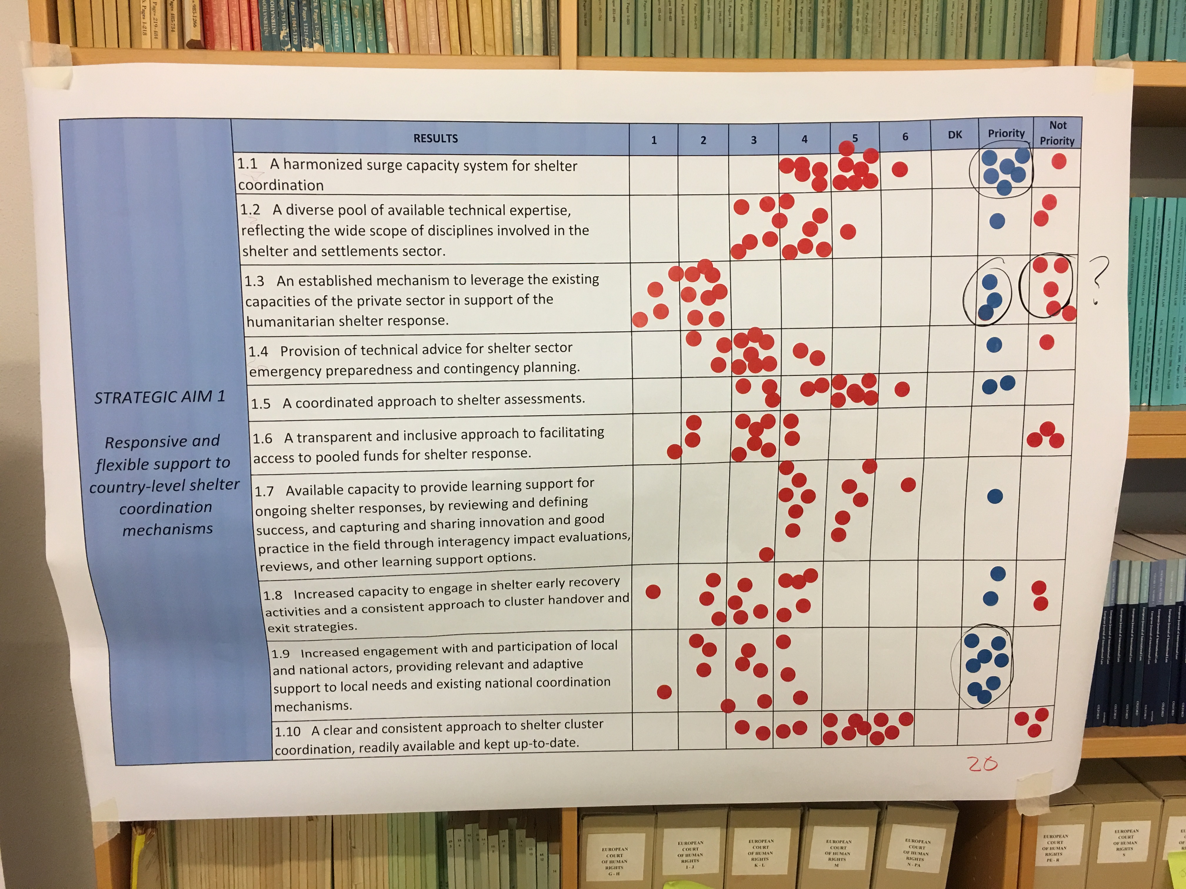

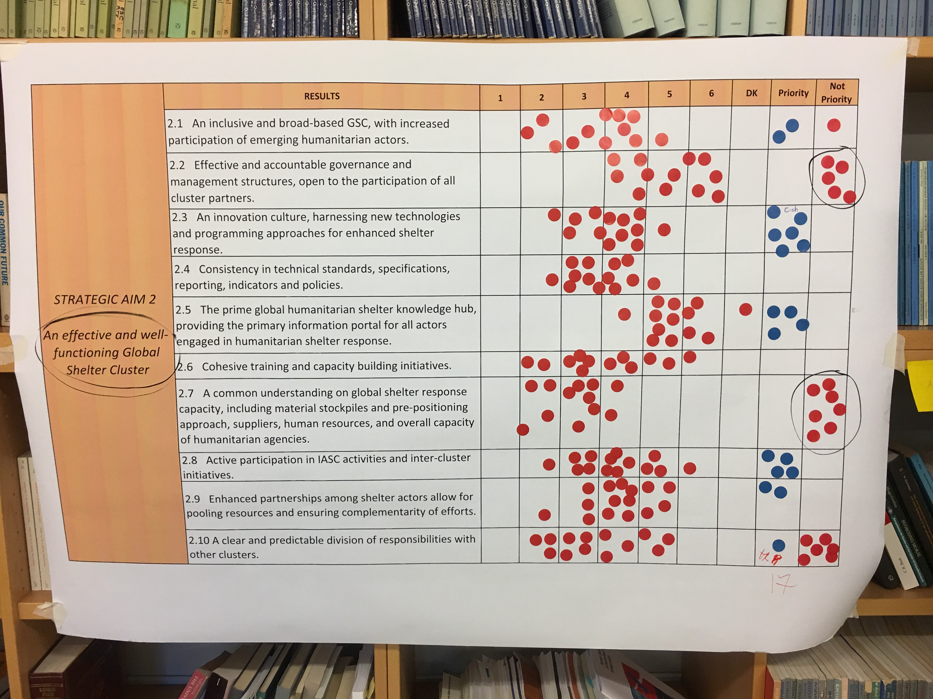

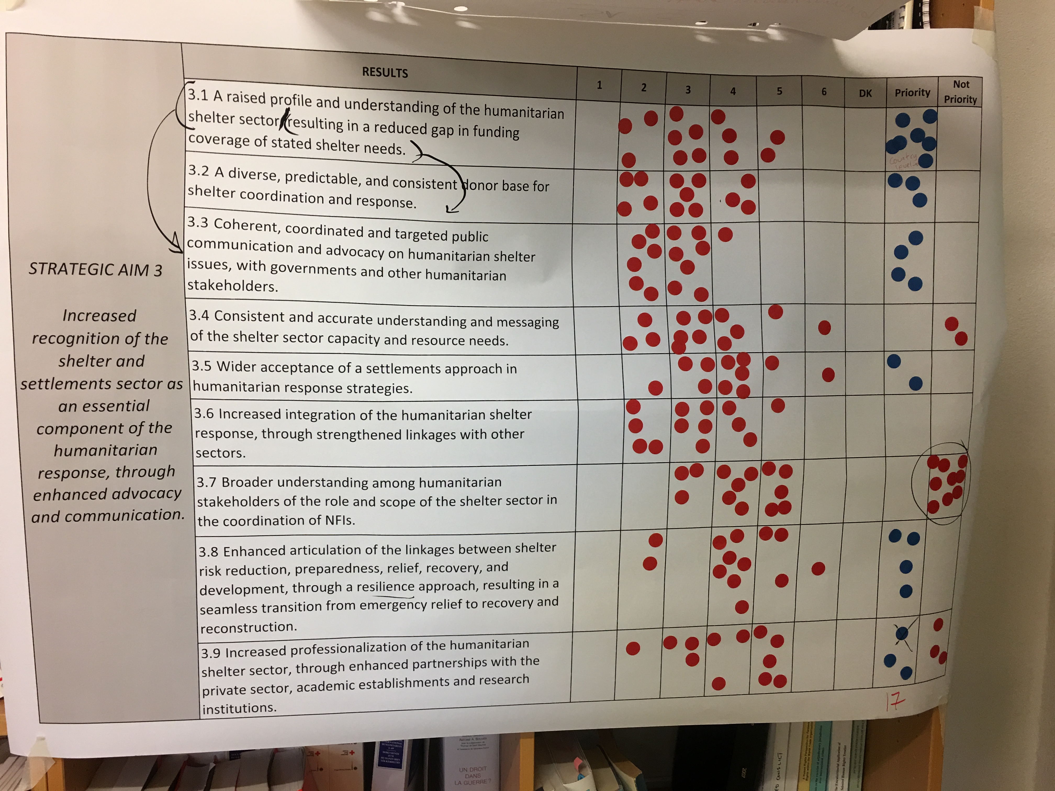

Strategic aim 2.1: An inclusive and broad-based GSC, with increased participation of emerging humanitarian actors.
Strategic aim 2.6: Cohesive training and capacity building initiatives.
Strategic aim 2.10: A clear and predictable division of responsibilities with other clusters.

