GUIDANCE NOTE TO IMPLEMENTING PARTNERS ON HOW TO SUBMIT A PROJECT TO THE 2022 HRP

The Humanitarian Response Plan (HRP) is a document that is used for planning and managing the humanitarian response in a crisis, through the development of a country strategy and cluster plans implementing that strategy. In addition, the HRP can be used as an advocacy and communications tool and as a resource mobilization tool.

The HRP is not a fund, and having a project in the HRP is not a guarantee of funding. Individual partner organisations will still need to fundraise bilaterally with donors. The advantage of having a project in the HRP is that many donors prioritize funding for projects that are part of the HRP as projects are perceived to have been well-coordinated and part of a comprehensive humanitarian strategy.

HRP projects are developed by the Cluster partners, vetted by peer review panels, and finally approved by the Humanitarian Coordinator (HC).

29 September Project Module clinic (9 am – 11 am) covering Protection mainstreaming & PSEA, GAM and CVA

30 September Project Module clinic (2 pm – 4pm) covering Protection mainstreaming & PSEA, GAM and CVA

1 Summary
The HPC projects module (https://projects.hpc.tools) is part of the HPC tools suite. It enables users to create projects and submit them for review and approval for inclusion within response plans. Projects submitted to a plan follow a basic workflow for approval by cluster leads. A plan lead manages the overall process. Each plan can have a set of customized fields specified for projects that wish to be a part of them. The Response Planning and Monitoring (RPM) tool is the companion module which is used by plan leads and cluster leads to manage plans’ logical frameworks, which can be then referenced by projects. Projects that are accepted and approved for publication in a plan can then referenced or viewed publicly via the HPC tools suite (e.g. Financial tracking service, FTS).

2 User login and registration
Please access the Projects Module (https://projects.hpc.tools/), All users of the projects module must log into the application with a Humanitarian ID (HID) account
2.1 If you already have an HID account click on login, and then enter your email and password, and then click on login again.

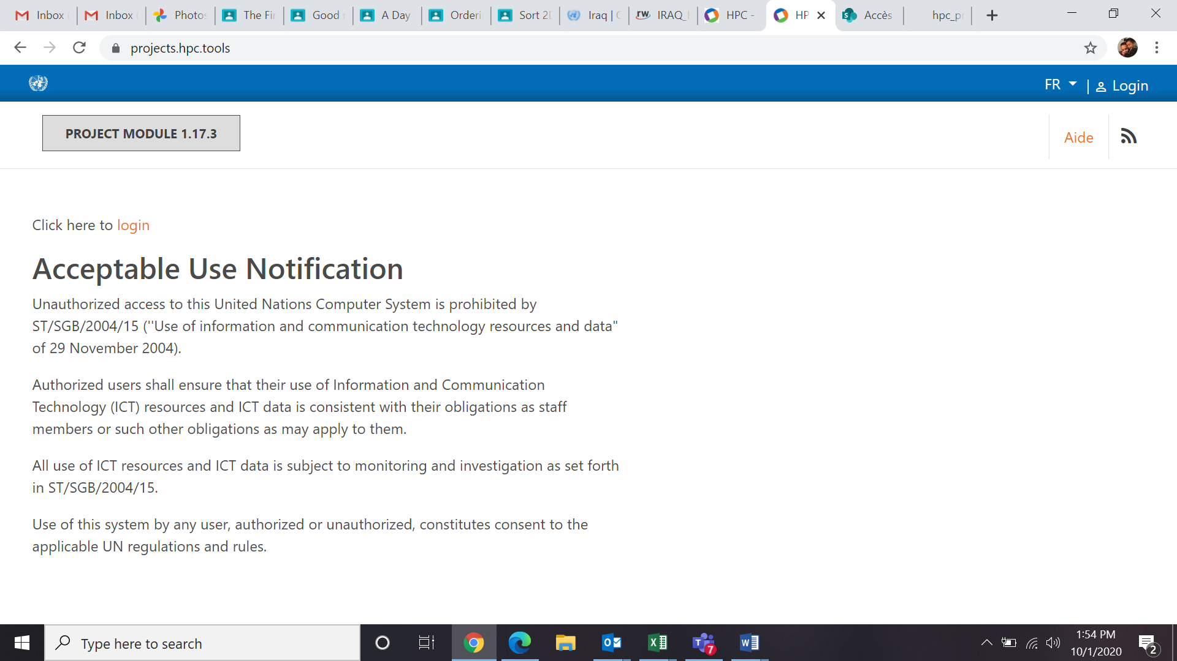

After clicking on the login button you will be directed to HID to enter your details:

2.2 If you do not have an HID account Click on login, and then click on the “register” button 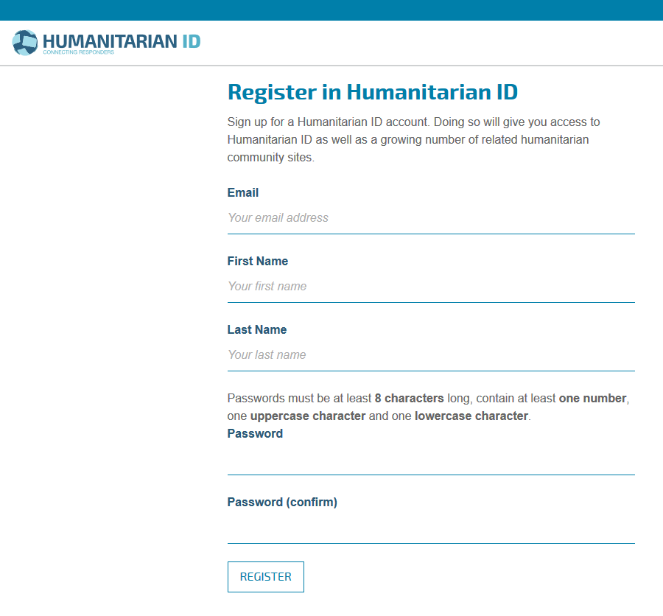
Fill out the details and click register. You will then receive a confirmation email from HID to verify your address. Open the email and click on the link. Now return to projects module, click login, and enter your email and password to login.

2.3 Approving access to HID and entering the project module for the first time
You will then be asked if you want to allow HPC project module to access your HID details. Click “Allow”
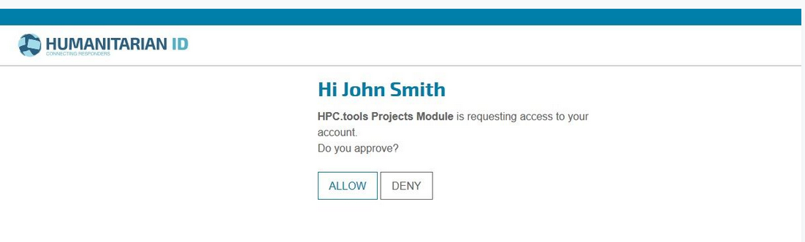

You will now see the “User profile screen”. You must fill out your organization’s name and the country in which you are working. Start typing into the box and the system will try to find a match for your organization and country. When complete, click “save and continue” and you will be directed to the map screen.

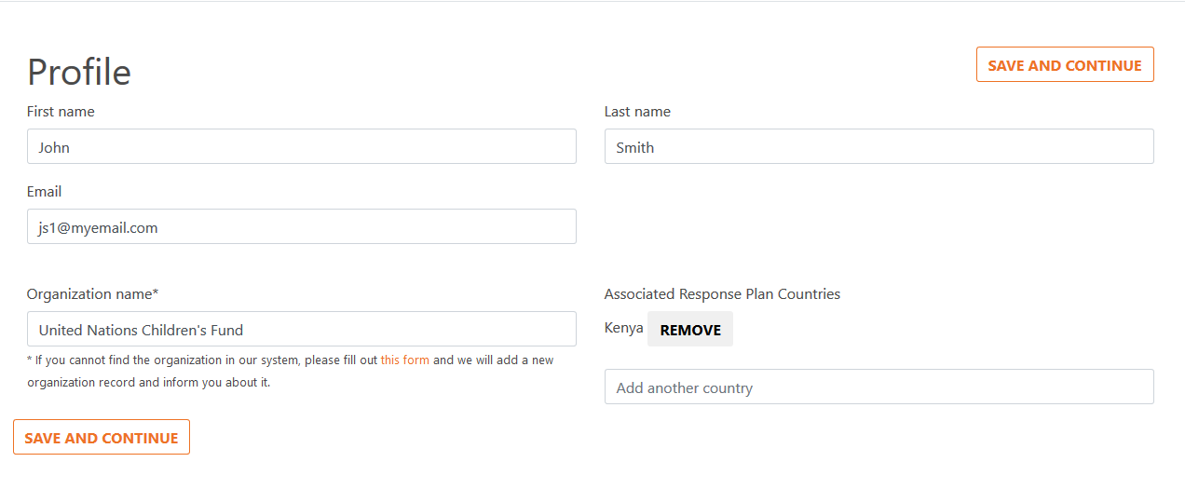
If you cannot find the organization you are looking for, then click on the link circled below, where you will be directed to a form to fill out.

We will review your submission and add the organization for you and inform you by email. You will not be able to proceed until you have added this organization, so you will have to return to the HPC projects module after you have received this confirmation.
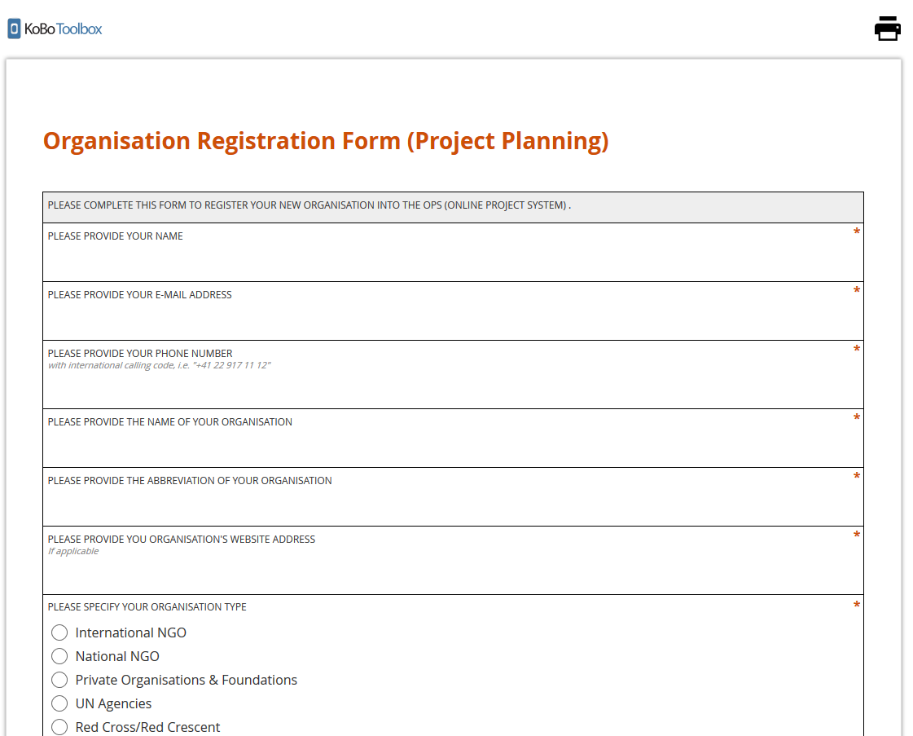

Project Development Basics

Projects are developed to “operationalize” the Cluster plans in the HRP. Projects should only be developed after the Cluster/Sector response plan is developed, in order to ensure that projects implement the strategy set forth in the Cluster plan. Projects show what will be done where, how, by whom and how much it will cost. Projects are the actions needed to implement the Cluster/Sector plan. The Cluster Coordinators can provide specific guidance to their Cluster partners on project development in line with the Cluster/Sector strategy.

The Cluster/Sector response plan and strategy should include the following elements:
- Identification of vulnerable groups to be targeted (disaggregated by sex and age) and geographical scope.
- Which activities and outputs are needed to contribute to the Cluster’s strategic objectives.
- The targets to be reached.
Managing multi-sectoral projects in 2022
- For projects with activities that span more than one Cluster (for example, multi-sectoral projects), the following will be undertaken:
  - Cluster Coordinators should inform implementing partners before the upload of projects period that, if they are submitting a multi-sectorial project, they need to identify the relevant Clusters in advance of the project submission to facilitate the process.
  - OCHA will extract all the multi-sectorial projects from the system and channel these to the relevant clusters at the conclusion of the project upload period.
  - OCHA will chair an ICCG vetting meeting whereby the relevant cluster coordinators (National and at the Sub-National level) will review the multi-sectorial projects against the vetting criteria.
  - The process in which the project is reviewed will follow the same approach as a regular project, i.e. following the first round of review no project shall be rejected. At the second round of review the vetting panel shall determine whether a project has addressed all the panel’s concerns and meets the criteria t be included in the HRP.
  - The outcome of the review of multi-sectorial projects will be fed back to the appealing agency through OCHA copying all relevant clusters.

Upload your new project on the Projects Module
The oPt 2022 Project upload is to be undertaken from 3 October through 15 October.
To upload a new project for the HRP, please access the Projects Module (https://projects.hpc.tools/). After logging-in, click “new project”, and fill in the online project form with the required information. Projects must be submitted by 23:59PM, 15 October 2020.

Project vetting
Cluster project vetting to be undertaken from 17 October through 31 October.
Cluster/Sector Coordinators have the responsibility to ensure that only approved projects are presented to the Humanitarian Coordinator (HC) for inclusion in the HRP. This is done by vetting the projects.

Vetting panels should be established by the Clusters in advance, and include, as a minimum: the Cluster Coordinator, an INGO, a local/national NGO, a UN agency and, the Cluster Protection and Gender Focal Points. A line-ministry representative may act as an advisor (non-voting member) to the vetting panel, to ensure consistency with policies and standards and promote synergies with national programmes where appropriate. OCHA focal points will support each Cluster vetting panel as active advisors.
Final approval of HRP projects

Clusters to approve projects by 5 November.
Based on the recommendations made by the Cluster/Sector vetting panels, the HC has the authority to review and finally approve all projects that are included in the HRP.

ANNEX: ANNOTATED TEMPLATE FOR THE PROJECTS MODULE
https://projects.hpc.tools

- Basic project information
Provide your project name; a short project summary; the project start and end dates; appealing organization(s); implementing partners; and primary contact details.

- Response Plan
- Association Response Plan
Click on “Filters” select “occupied Palestinian territory 2022 from the drop down list.

- To Create a New Project

- BASIC INFO
- Create new project
Click on: “Click here to create a New Project”

- Please enter a name, brief description, and dates for this project.
Project Name*
Please provide a short and succinct name, e.g. 'Food Assistance for Returnees in the South'

Project Summary*
Please provide a short summary of the intervention, describing its purpose and target

Max length: 0/4000

Start and End Date *
Set standard dates. Projects’ timeframe are 12 months and must end on 31 December 2022

Set standard dates: Click on USE 2022

N.B. No need for tagging

Organizations
Enter the names of all organizations and implementing partners that will be participating in this project.
Appealing Organizations*
Organization(s) receiving primary funding for this project
If you can't find the organization in the list, please inform us using this link

Implementing Partners
Organization(s) assisting in project implementation with funding provided by the appealing organizations
Primary Contact*
Enter the primary contact details for this project. Additional contacts may be also added. Please note that these details will be publicly visible so do not enter in any details that should be kept private.

CLICK SAVE or SAVE & NEXT to proceed.

- RESPONSE PLAN
Associated Response Plan*
- Select: occupied Palestinian territory 2022

Select the Cluster(s) that will be participating in this project*
If unsure of which cluster to select, or designing multi-sectoral project(s), please consult with relevant Cluster coordinators.

Plan Fields

1-Needs*
Please describe the needs your projects aims to address.
Your narrative on the needs should not be too long (4,000-character limit). Use this space to enter specific information on the needs of the area/ people that your project is targeting, referencing any specific assessments or secondary information that adds to what is already in the 2022 HNO. Please do not waste space by repeating large parts of the HNO analysis or including lengthy general descriptions of the context – instead you can make brief reference to which of the needs identified in the 2022 HNO you are responding to.

Information on the specific vulnerable groups and their needs that the project is targeting should be included. Include protection concerns in your needs analysis as appropriate. Make sure to include a gender analysis, explaining any differences in the needs identified for women, men, girls, and boys that have been considered, demonstrating evidence that relevant gender and age vulnerabilities have been included in your analysis for the project. While there is a specific section (below) to identify community engagement elements of the project, briefly outline in the needs section the methodology used for consultations with women, men, girls, and boys, that took place in order to identify needs and design the project. Partners should demonstrate a commitment to mainstreaming protection in their programme delivery, and the project sheet should have evidence of protection mainstreaming in the needs analysis,

2-Activities*
Please describe the activities that make up your project.
Please provide narrative on the “Activities” making sure to address the gender needs and priorities (as outlined in your gender analysis in the “Needs” section). You should briefly explain how you have prioritised the safety and dignity of beneficiaries and considered the principles of Do No Harm and how does the project enable equal and impartial access to assistance and services and the targeting of vulnerable groups and people with specific needs in the activities. Explain here how PSEA activities were built into the project activities.
(4,000-character limit)

3-Indicators*
Please describe how the success of the project will be measured, including compulsory reporting on the three PSEA indicators (see technical note) (4,000-character limit)

4 - IASC Gender with Age Marker (GAM) *
Partners should ensure gender mainstreaming is included at every step – design, implementation, monitoring and evaluation – with the aim of promoting equality between women, men, children, elderly and adult. All partners are required to identify the Gender with Age Marker (GAM) code for your project, by using the GAM system.

In order to identify the GAM code for your project, please follow below instruction:
- Consult with the Gender Focal Points of your Cluster, in order to improve gender elements of your project
- Access the IASC Gender with Age Marker through https://ee.humanitarianresponse.info/single/::lKbQTg7d.
- Answer to the questionnaire in the GAM survey based on your project sheet that you will submit to the Projects Module.
For the definition of each gender group, please refer below:
- Women: Females 18 years and older
- Girls: Females under 18 years old
- Boys: Males under 18 years old
- Men: Males 18 years and older
- Diverse gender: While humanitarians often consider the sexual orientation of the affected population to be heterosexual and the gender identities to be cis-gender, there are calls to include an option to consider how people with alternative orientations and/or identities are excluded from assistance based on the lack of conformity to gender norms and rules. The GAM provides the option to operations and agencies to factor this spectrum (mostly Lesbian, Gay, Bisexual, Transgender and Intersex persons/LGBTI) into its programming.

Clusters will inform its partners about the specific age breakdowns required for their projects. Age categories are different for different organizations, so the GAM uses broad age group descriptions instead. This allows comparison and analysis beyond the agency or Cluster level. While the GAM only looks at generalized age groups (younger, older, etc.), the Cluster is likely to expect a more detailed breakdown in project documents.

- Provide GAM code and GAM reference number that you received at the end of the GAM questionnaire to OPS. See below screenshots for your reference.
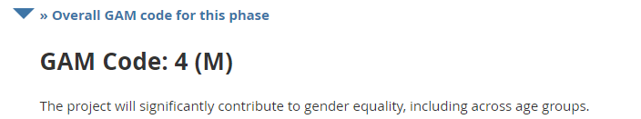
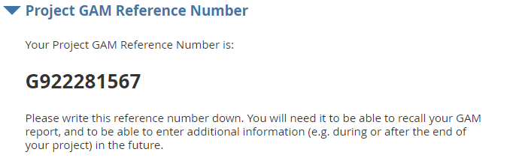
(GAM System: Screenshot example)

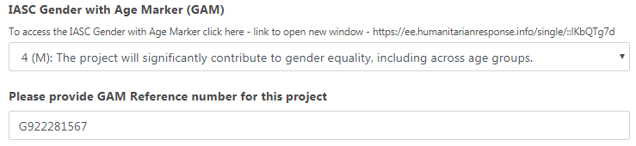
(OPS: Screenshot example)

- Please consult with your Cluster Gender Focal Point for any additional guidance or if you would like to improve the GAM code. This will be validated or changed by the vetting panel and gender advisors.

For details of the weekly webinar on GAM, please visit: https://iascgenderwithagemarker.com/

4.1 - Provide the GAM Reference number for this project *

5 - Breakdown by response modality

For the 2022 planning cycle, the project form will include a new field to indicate what percentage of the response will be delivered by the four modalities. Following approval of projects, OCHA and Clusters will tally up the data and prepare an overall breakdown by response modality to inform the Cluster response plan narrative.

5- Breakdown by response modality | 5.1 Response modalities | Please estimate the percentage of the response delivered by the respective modalities:  Please ensure the total for all response modalities selected does not exceed 100%  - 5.1.a State the percentage of the response delivered by the service delivery modality if applicable  - 5.1.b State the percentage of the response delivered by the voucher modality if applicable  - 5.1.c State the percentage of the response delivered by the cash modality if applicable  - 5.1.d State the percentage of the response delivered by In-kind modality if applicable  5.2 Please briefly explain why the specific modality/ies for this response were chosen.

6 - Which Strategic Objective(s) do(es) your project address?
Select at least one Strategic Objective your project will be linked to. Please ensure the total for all SOs selected here does not exceed 100%
6.1 - Strategic Objective 1 (SO1)
The rights of Palestinians living under occupation, including those living under the blockade and other restrictions, are protected, respected, and promoted in accordance with IHL and IHRL
6.2 - Strategic Objective 2 (SO2)
Ensure acutely vulnerable Palestinians under occupation in Gaza and the West Bank have access to essential services
6.3 - Strategic Objective 3 (SO3)
The ability of vulnerable Palestinians to cope with the protracted crisis, including environmental threats, is supported, while solutions to violations and other root causes of threats and shocks are pursued

7 - Breakdown of requirements by location (%)
Please ensure the total for all selected locations does not exceed 100%
7.1 - Gaza *
7.2 - Area C *
7.3 - East Jerusalem *
7.4 - Hebron H2 *
7.5 - Area A&B*

The vetting panel will look into the programming quality of the project design for integration and mainstreaming of gender, protection, community engagement, PSEA, partnerships with local NGOs and budget and timeframe. The below provides information on questions related to Community engagement, protection mainstreaming and PSEA in the projects’ module. For information on GAM and gender mainstreaming in project narrative partners should refer to the “Plan Fields” in the Response section and questions related to the GAM survey above.

8 - Protection mainstreaming and PSEA

You will be reflecting your project’s Community Engagement (CE) in a more detailed way on your project sheet. CE, often referred to as Communication with Communities (CwC), includes three components: participation, feedback and complaints, and providing information. It is the process by which Accountability to Affected Populations (AAP) is achieved. PSEA is a compulsory protection measure as well as quality assurance, you will be required to address minimum standards and details on your project sheet. You will be able to identify the measures taken and/or planned for the project during the project design, implementation, monitoring and evaluation phases.

Protection mainstreaming focal points are encouraged to brief respective Clusters on protection mainstreaming in the context of Cluster meetings, Cluster-specific HPC information meetings etc. Cluster coordinators are encouraged to ensure that the incorporation of protection mainstreaming principles (safety and dignity, meaningful access, accountability, participation and empowerment) in project proposals is substantively assessed and given due weight in the HRP vetting process, and Cluster Coordinator must ensure that partners receive adequate information and access to technical assistance (provided by the PSEA Network) to address PSEA mandatory requirements.

The Protection Cluster is available to support each Cluster, including through joint briefings to Cluster members, alongside the protection mainstreaming focal points, as well as bilateral meetings with the Cluster Coordinators and protection mainstreaming focal points. Additionally, the Protection Cluster stands ready to provide specific guidance on how to tailor protection mainstreaming indicators for each Cluster.
Similarly, the PSEA Network coordinators are available to provide ad-hoc technical assistance and induction sessions to support the required integration of PSEA assurances in all projects. According to IASC commitments, all projects must consider assurances to prevent misconduct from humanitarian workers towards beneficiaries. The IASC has instated three PSEA indicators, listed below, against which reporting is mandatory. The PSEA network has circulate a technical note on PSEA Indicators. Accordingly, the drop-down list of PSEA activities introduced in the 2022 HPC cycle is being revised and modified to the effect of making several activities mandatory.

- Number and Percentage of children and adults who have access to a reporting mechanism that can handle SEA complaints
- Percentage of the affected population (disaggregated by sex and age) reached through consultation in the establishment of community-based complaint mechanisms (CBCMs), awareness activities and community mobilisation interventions on PSEA including how to report SEA-related complaints (disaggregated by type of PSEA communication materials developed for each population group identified).
- Percentage of sites reached with communications materials on PSEA, how to report on SEA and how to access victim/survivor-centred assistance (disaggregated by type of PSEA communication materials developed for each population group identified).

Partners are required to answer the following questions in the project sheet to ascertain to what level the project has considered these issues, as a best practice. It is encouraged that protection mainstreaming focal points are invited to sit on Cluster vetting panels in an advisory capacity and that partners are required to integrate and report against protection mainstreaming indicators in their projects.

PROTECTION MAINSTREAMING & PSEA*

8 – Participation (Community Engagement) | 8.1 - Project needs assessment | 8.1.a - How will beneficiaries be involved in needs assessment? *  "Surveys",  "Focus groups",  "Interviews",  "Information products and outreach",  If not checked, please explain why (narrative text)
 | 8.2 - Project design | 8.2.a - How will beneficiaries be involved in project design? *  "Surveys",  "Focus groups",  "Interviews",  "Information products and outreach",  If not checked please explain why (narrative text)
 | 8.3 - Implementation (delivering assistance) | 8.3.a - How will beneficiaries be involved in implementation? *  "Surveys",  "Focus groups",  "Interviews",  "Information products and outreach",  "Not Applicable"  If not checked please explain why (narrative text)
 | 8.4 - Monitoring and evaluation | 8.4.a - How will beneficiaries be involved in M&E? *  "Surveys",  "Focus groups",  "Interviews",  "Information products and outreach",  "Not Applicable"  If not checked please explain why (narrative text)
 | 8.5 - Representation of community groups | Have representation of different groups within the community been considered when engaging with the community in these phases (I.e. Women, children, people with disabilities, other vulnerable groups within the community, formal and informal power structures, etc.)? * see disability mainstreaming Tip Sheet  Yes/No  If you answered no please explain why (narrative text)
9. Accountability to Affected Populations | 8.6 - Feedback and complaints mechanisms | 8.6.a - Specify the mechanisms for feedback and/or complaints (Please select one or more options.) *  "a - Generic email",  "b - Project hotline",  "c - Complaint box",  "d - Satisfaction survey",  "e - Field visit",  "f - Other"  8.6.b - If 'Other', please specify:  8.6.c - How will feedback be used? *  8.6.d – Explain how you have ensured that mechanisms are accessible to all population groups?  If your project does not have mechanisms for feedback and/or complaints, please explain why (narrative text)
10. – Do No Harm * |  | 9.1 - Do No Harm*  How have you prioritised the safety and dignity of beneficiaries and considered the principles of Do No Harm, including an analysis of the protection context, identification and mitigation of risks to people’s safety and wellbeing that the project might inadvertently exacerbate?
11. Equal and impartial access to aid * |  | 9.2 - Equal and impartial access to aid*  How does the project enable equal and impartial access to assistance and services and the targeting of vulnerable groups and people with specific needs?  Have you considered all the elements of the Disability Mainstreaming Checklist? Yes/No  If you answered no please explain why (narrative text)
12 - PSEA (Prevention of Sexual Exploitation and Abuse) | 10.1 Were PSEA activities built into the project? | If yes, then  10.1.a How? (from drop-down list, check all that apply) *  - (MANDATORY) Project has adopted a safe complaint channel(s) for beneficiaries based on consultations with the beneficiaries and accessible to different groups (Number of beneficiaries and percentage against your target group).  - (MANDATORY) Project has built in activities involving development and dissemination of PSEA awareness raising material including information on rights and safe complaint channels available to beneficiaries and that awareness raising targets all project sites. (Number of beneficiaries and percentage against your target group).  - (MANDATORY) Project has built-in clear process for receipt and referral of complaints of PSEA, in accordance with the oPt PSEA SOPs on Inter Agency Referrals.  - Project staff are required to attend a minimum of one PSEA training  - Project-related contracts include standard clause on PSEA in accordance with IASC principles and guidance  - Project staff will directly or indirectly engage in the HCT oPt PSEA Network  - Project will carry out other PSEA-related activities  10.1.b If 'Other' (No 7.), please specify  If you answered no, please explain why (narrative text)

Clusters
If more than one Cluster was selected in Step 2, then you can switch between the selected clusters to add the caseload and cluster activities and target.

CLICK SAVE or SAVE & NEXT to proceed.

- Locations
Please select locations where your project plans to implement its activities. Use this step to specify governorate and community levels by clicking on the relevant checkboxes.
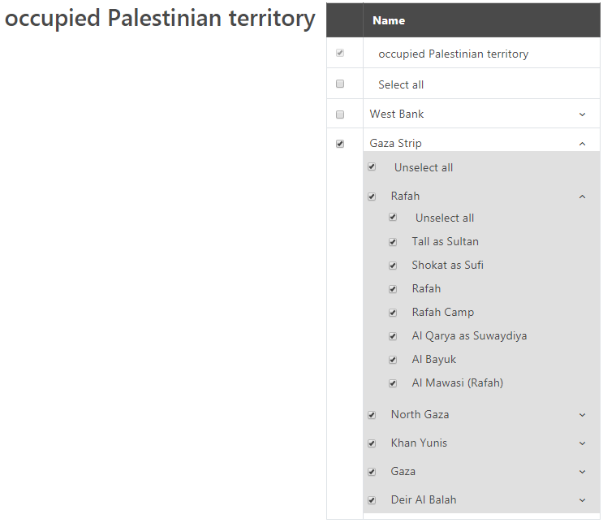
(Screenshot example)

CLICK SAVE or SAVE & NEXT to proceed.

- Clusters
Select the applicable response plan indicators and enter the corresponding disaggregation targets for this project.

- Caseload
Provide the number of targeted beneficiaries that your project plans to reach. By ticking the box “Include disaggregation and targets”, disaggregate your project beneficiaries by age, gender, disability (Children (<18 years old), female adult (>18 years) and male adult (>18 years) and vulnerable group. Add another disaggregation level as needed. In projects where the numbers of direct beneficiaries are unequal for males/females/children/adults/elderly, the Needs narrative section should provide a justification explaining the reason for this (e.g. a project on children in detention will have higher number of male beneficiaries as they are most affected by child detentions).

- Cluster activities
Select the activities and indicators for your project. These pre-defined options will come directly from your Cluster strategy and response plans. Cluster partners will have had the opportunity to input to these during the Cluster discussions on their strategy and response plans. Please make sure to select all the activities and indicators that apply to your project. It is possible to select activities and indicators related to a different Cluster, in order to facilitate better monitoring of projects that have multi-sector components (e.g. your project is an Education Cluster project but there are WASH or Protection components also, you can select activities related to education, WASH and protection).

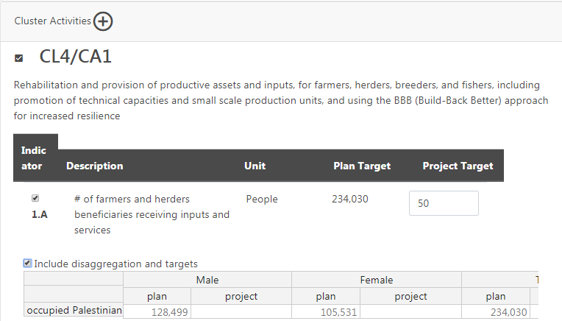
(Screenshot example)

- Budget
Projects will only be able to identify single-year funding requirements. The following categories are suggestions/recommendations, however, ALL PROJECTS MUST SPECIFY INDIRECT COSTS – these are typically corporate costs incurred by HQ, which cannot be linked to the implementation of activities.

Direct costs (a minimum of 89% of the whole budget is considered a good indicator of cost efficiency)
1. Staff and other personnel costs
Costs of staff, consultants and other personnel to be recruited by the organisation for project implementation. Staff under this line is supposed to be the “support staff”, and not the technical staff who are considered a direct input of the project. For example, a logistician is under this line, while a nurse or a teacher who works with patients and children are under the “Direct inputs and services to beneficiaries” line (#2). But, if the nurse is not directly managing patients, or if the teacher is coordinating or supervising, but not working with the children, then they should be under this budget line. Agronomists hired for designing, supervising and coordinating agricultural-related activities should be under this budget line. A water engineer designing a water supply or storage system is under this line as well.

2. Direct inputs and services to beneficiaries (Supplies, Commodities, Materials, Services, and dedicated Staff whose job is considered as project outputs)
Costs of consumables and supplies to be purchased under the project, including associated transportation, freight, storage and distribution costs. Costs for personnel that directly deliver the outputs of the project. For example, the counsellor for a GBV project who directly handles cases. Or a veterinary who provides medical treatment to animals is also under this budget line. However, if the veterinary is hired to set standards, to control quality of service, then it should be considered support staff and should be registered under the “Staff and other personnel” budget line (#1).

3. General operating and other running costs
General operating expenses and other direct costs for project implementation (security expenses, office stationary, and utilities such as telecommunications, internet, office rental and other direct costs, including expenses for monitoring, evaluation and reporting, related to the implementation of the project).

Indirect / Overhead Costs (max 11% of the whole budget is required)
4. Indirect / Overhead Costs
This refers to all costs that are incurred by the implementing partner, which cannot be traced unequivocally to specific activities, projects or programmes, including corporate costs (i.e. headquarters and statutory bodies, legal services, general procurement and recruitment etc.) not related to the service provision towards a particular project. Indirect / overhead costs should maximum be 11% of the overall total budget.

Positive consideration will be given to projects that have lower overhead costs than 11%, particularly those meeting the oPt Humanitarian Fund standards of max. 7%. Should there be some concerns related to the cost efficiency of the project, the vetting panels may decide to run a calculation of the total number of direct beneficiaries by total cost of project.

CLICK SAVE or SAVE & NEXT to proceed.

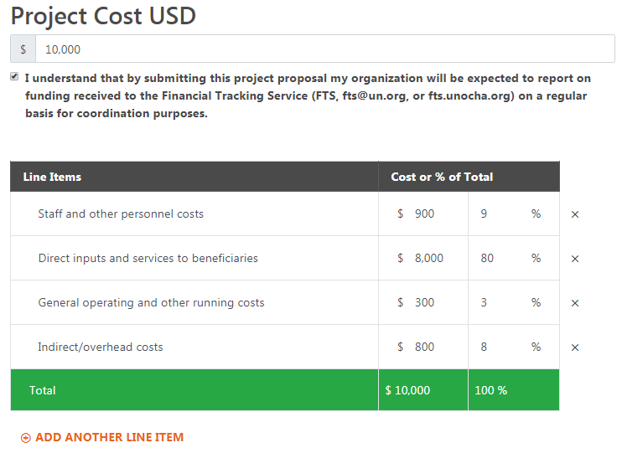
(Screenshot example)

Multi-sectoral projects must indicate a primary Cluster that the project belongs to, by indicating budget under a primary Cluster as below. Multi-sectoral projects budgets can be split this year. Please consult with relevant Cluster Coordinators, in order to identify a primary Cluster.

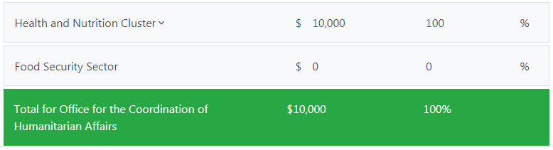
(Screenshot example)

If you are submitting a project sheet for Health and Nutrition Cluster, please put 100% of budget for ‘Health’ and do not put any budget percentage for ‘Nutrition’.

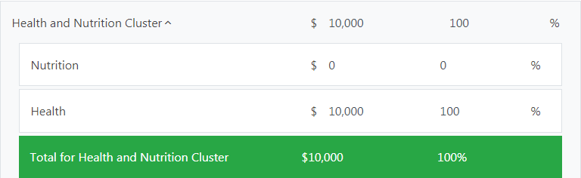
(Screenshot example)

CLICK SAVE or SAVE & NEXT to proceed.

- Review
After the review of your project sheet, please submit your project sheet. Once your project has been submitted, cluster leads will then be able to review your project. While it is in status submitted to plan, you will not be able to edit your project details any further. However, you can change it back to “Draft” if you wish to make any amendments. All projects must be submitted by 23:59PM, Friday, 16 October 2020, by clicking “SUBMIT PROJECT FOR REVIEW”. After the submission, the vetting panel will review your project.
(Screenshot example)

We advise you to register in good time and the start of the project upload as registering can take several days.

For technical assistance, contact OCHA oPt:
- (English and Arabic) Firas Qaimary, OCHA oPt, Email: qaimary@un.org for West Bank projects
- (English and Arabic) Mohanad AL DIRAW, OCHA oPt, Email: mohanad.aldirawi1@un.org for Gaza projects
- Majed Abuqubu, OCHA oPt Jerusalem, 054-717-8950, abukubi@un.org for back-up.

