Shelter and WASH Working Group Meeting - #12
10.08.2017 at APAD Office at 10.00am

Agenda
- Introductions & Agenda
- Information Management updates
- District focal point updates
- NBRO policy framework
- Donor meeting
- AOB

IM Updates
- WASH WG representative briefed on ongoing activities based on an analysis of the 3W data.
- Shelter WG IM provided an update of planning, response and gap data at divisional level: both maps and tables are available on the Shelter WG website.
- WASH WG requested agencies to ensure data in the 3W is correct and up to date.
- WASH WG will start collecting data regarding wells in addition to the 3W, to be able to provide a more complete and usable overview. In addition, as assessments become available of actual damage data, there is a potential to set targets as part of the data overview.

District Focal Point Updates
WASH
Kalutara -WV
- World Vision shared their activities and plans in Ratnapura District
  - A few cash for work activities have been completed by Sri Lanka Red Cross Society which was appreciated by the government partners. Additional cash for work activities are planned in affected areas.
  - WASH partners to focus on the dengue prevention plans as well, the authorities plan door to door awareness and cleaning activities.
  - Palindanuwara division, including its hospital lack clean water. WV plans to distribute purifiers to each water supply point, funded by UNICEF.
  - Request to increase capacity of the water consumer society, so they can continue maintenance of the water supply system established by the INGOs/NGOs.
  - District level coordination meeting has taken place for all sectors; WV plans to organize a WASH sector meeting around the end of August.

- Ratnapura and Matara – LEADS
  - DS requested support in renovating 600 toilets in Ratnapura district.
  - All agencies reached the target on their initially planned well cleaning activities but there are still needs. Request from LEADS to other WASH partners to extend plans for well cleaning activities.
  - Request for WATSAN facilities in the centres/camps as part of the preparedness phase, as the camps are natural displacement sites and are currently not functioning sufficiently.
  - Ratnapura GA has circulated a standardized data collection format to receive updates from all agencies about their targeted activities is Ratnapura district.
  - Request for partners to provide gully suckers in Matara

- Galle – OXFAM
  - There are no camps in the Galle district, however 361 families still live with host families.

Shelter
- Ratnapura -WV
  - Collected data indicate that 931 houses are fully damaged and 14415 partially damaged.
  - Rental provision is ongoing.
  - The NBRO resettlement option details need to be shared with district and divisional secretaries, no implementation yet due to shortage of funds.
  - Some issues regarding families using space in between tents as kitchens covered by tarpaulins: the heat is dangerous. A discussion with government officials resulted in a request for support to provide better facilities.
  - 20 acres of lands was approved by NBRO and likely to be released towards the end of next month for resettlement in Ratnapura; there will be space for 150 families.
  - IOM plans to provide 50 transitional shelters in Kigibathgala division.
  - In addition, JEN and Dialog have expressed interest to support transitional/ permanent shelters.

- Galle and Kalutara – UN-Habitat
  - Targeting 3 divisions in each district.
  - 650 houses will be repaired and 85 transitional shelters provided in total.
  - Awaiting NBRO’s decision on safe sites, UN-Habitat will provide transitional shelter to those families that are confirmed with host families (prioritization): materials provided will be reusable as much as possible.
  - UN Habitat plans to provide support to NBRO core houses and technical support.
  - Activities are implemented, materials procured through CBOs.

All the working group members, in particular district focal points were requested to coordinate with focal points of other sectors before and during implementation of activities.

Plan International
- Briefed on their activities at division level:
  - 02 divisions / 12 schools were assessed in Matara district.
  - Some schools have a latrine, however lack water supply for proper use.
  - Most schools lack mitigation plans.
  - Schools are selected through discussions with the government (DS & ZDE)

NBRO policy framework
- The participants were briefed on the updated NBRO policy framework.
  - There are two stages of government financial assistance:
Stage 1: Construction of one room with toilet
Stage 2: Completion of complete house
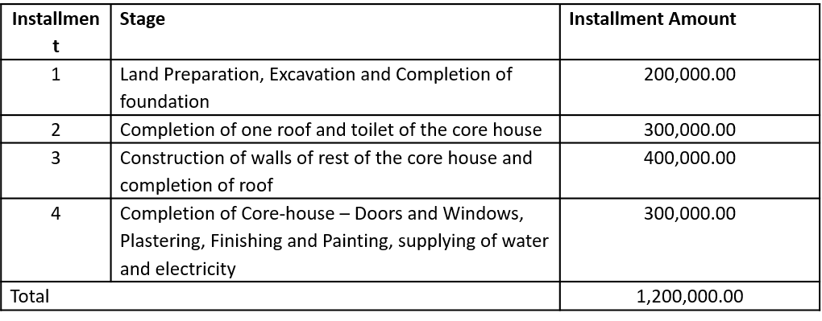
  - 1.2 million for the full house is divided into 4 instalments, which will be assessed by divisional engineers to be trained by NBRO:
  - Beneficiaries, as per NBRO guidelines and DS prioritization, includes all landslide affected households and households living in landslide prone areas.

Donor briefing
  - The meeting could include needs/ gaps, lessons learned (2016 Kegalle for shelter) and provide an overview of ERP progress as well as overall needs.
  - A meeting between the Partner Development Secretariat, the RC office, working group leads and co-leads will be called as soon as possible to determine on the structure and date for a donor briefing.

Shelter IEC materials and DRR (Small group discussion)
- Collected DRR IEC materials were shared to determine whether these were relevant/ useful for printing and distribution in households in addition to shelter repair kits etc:
  - Members have suggested few IEC materials (flyers, posters and kids’ games) to be used for the current situation, these will be shared with the working group.
  - DMC will be contacted for original versions for future adaptation.

AOB
- Need for all partners to update 3W regularly to keep the information up to date.
- Well cleaning activities are only ‘completed’ when these are certified by government officers.
- A next WASH/Shelter meeting could include a ‘lessons learned’ section, including an overview of transitional shelter standards etc.
- 500 family tents are available with IFRC, agencies may put in a request for tents directly with IFRC or through the Shelter WG coordination team.

Next Meeting
Venue: APAD Office
Date: 24.08.2017 (Thursday)
Time: 10AM

