WOQOOYI GALBEEDAND AWDAL REGIONS, SOMALILAND
IDPs’ ASSESSMENT
29 September – 07October 2015
INITIAL INVESTIGATION REPORT

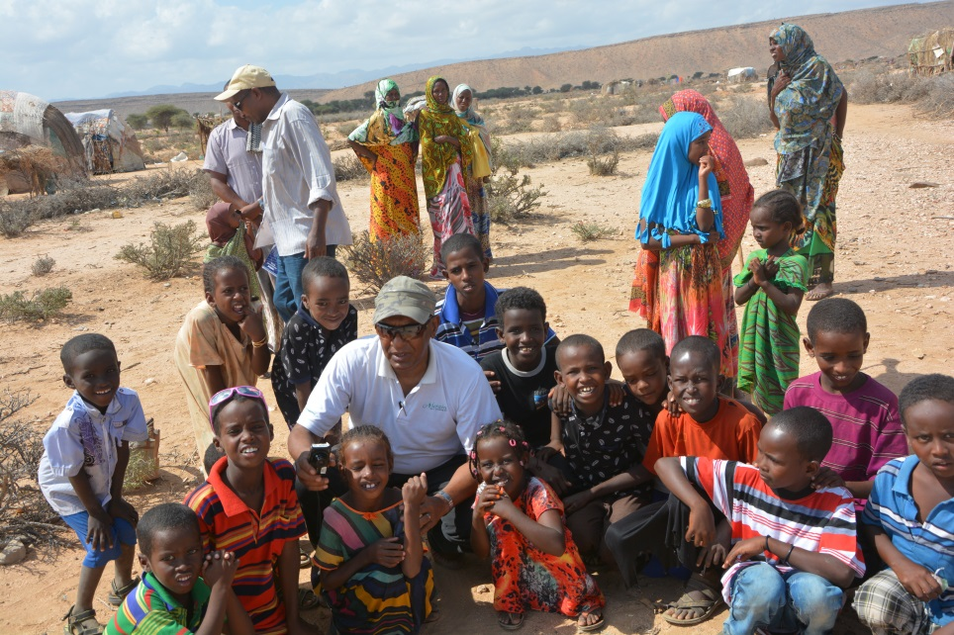

- BACKGROUND AND CONTEXT

The IDP population in Somaliland is estimated as 79,000 persons (UNHCR, 2005 less the former Mohamed MoogeIDPs relocated to Digaaleon 12 December 2013 to 26 January 2014). The National Development Plan (2012 – 2016) of Somaliland, however, says that there are 379,818 internally displaced persons, consisting of 58,303 households, in the six regions of the country (MarodiJeeh, Awdal. Togdheer, Sahil, Sool and Sanaag). Most of the IDPs are pastoralists or agro-pastoralists who moved to urban centres after losing their livelihood, esp. livestock, to drought and returnees who had fled to other countries due to conflict. Challenges faced by the displaced include inadequate shelter, water supply and sanitation facilities, as well as limited social services such as education, health and employment opportunities.

The Ministry for Resettlement, Rehabilitation and Reconstruction (MoRRR) is the lead government agency responsible for coordinating assistance to the displaced. Government efforts are supplemented by non-state actors which include international organizations. Hargeisa, the capital city, hosts over half of the internally displaced persons in Somaliland.

This mission, therefore, is perceived as a preliminary step inunderstanding the effect that the drought reported in the two regions had on the existing as well as newly created (if any) IDPs. This assessment hence facilitated a simplified snap shot that looked into the IDP situations in light of the on-going drought in Awdal and Marodijeehregions to lay the foundation for mobilizing and enabling targeted & coordinated response initiatives.

The mission has, therefore, looked into:

- The total population of IDPs in the visited locations, the number of newly displaced people and the conditions of all IDPs in each region in light of the on-going drought
- The state of basic needs &services/facilities for IDPs (food/livelihood, water, health, hygiene/sanitation, shelter, educationand security) on the ground, and
- Humanitarian assistances so far received by IDPs, and existing linkages between IDPs, local authorities and aid agencies in the regions

- PURPOSE AND SPECIFIC OBJECTIVE

Purpose:

The purpose of the mission was to undertake a joint fact finding observation on the current situations of the IDPs in Awdal and Marodijeeh regions,in light of the reported drought, for mobilizing and enabling coordinated lifesaving humanitarian assistances to these vulnerable groups.

Specific objective:

To visit the IDPs in Awdal Region (at Garbadadar, Gargara, Lughaya, El-gal, Ashacado, Jidhi, Abdiqadir, Harirad, Bon, Borama, Dila and Magala cad villages/towns) as well as those in Marodijeeh region (Bulahar&Gabiley districts) and closely observe their current living conditions.

- INITIAL INVESTIGATION FINDINGS

On 29 Sep to 07 October, OCHA and MoRRR led a fact finding mission to WoqooyiGalbeedand Awdal Regionsto assess the effect of the currently reported drought on the existing and newly displaced IDPs in the two regions. UNHCR, NRC and DRC were the other active participants of the mission.

The following are the key preliminary findings of the mission in each region:

WOQOOYI GALBEED REGION:

Bulahar District(Sahil Region: According to GoSL’sReginal Classifications of SL):

Bulahar town:

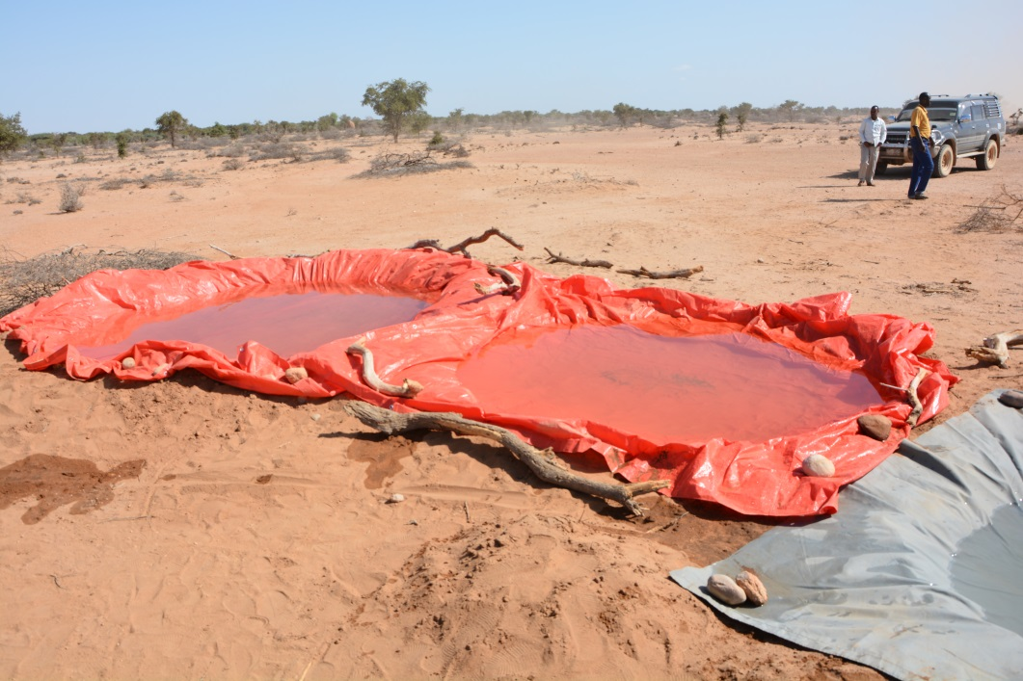

- As mentioned by Chairman of the district, Ismail Hassan, the total population of the district is in the range of 5000 – 7000 people
- Severe drought exist in the district at the moment
- Around 70% of the people in the district are estimated to be affected by the drought
- A lot of livestock died as the people were trying to flee with their livestock to mountainous areas
- Food assistance provided to the following households (HHs) in the district so far:

No. | Town/Village | No. of HHs supported | Assisting Agency | Remark
1 | Bulahar | 150 | GoSL | -
2 | Bulahar | 300 | Khadar foundation | Different HHs than previous one
3 | Geri | 200 | " | -
4 | El-Sheik | 200 | " | -
5 | Boodale | 200 | " | -
6 | El-Laheley | 200 | " | -
 | Total | 1450

- Abdi Gedi is one of the villages that didn’treceive food assistance in the district and the mayor requested these people to soon be supported as the village is highly affected by the drought
- No internally displaced people were seen in the district
- Situation of basic services:

  - Source of livelihood: the people in the district are pastoralists. They have lost theirlivestock due to drought and hence have no source livelihood. Fishing nets and three boats supplied by UNHCR to the town in 2003, to improve the livelihood of the people, are all destroyed/out of use at the moment. Only one generator and a boat (taken away by Somaliland’s marine force) survived. The people in the district are not used to fishing and only one man in the town knows how to fish. The fishing project, so initiated by UNHCR, has hence failed mainly because of the lack of essential equipment, especially refrigerators, and means of transport to access fish markets in big town like Hargeisa. People hence depend at the moment only on the assistance of their relatives in the village for survival.
  - Water: during the summer 6 people died in the district because of thirst caused by the drought. Save the Children International (SCI) is distributing water to 9 villages (CeelLeheleay, Abdi Geedi, Bilaalay, Qabiley, Hulka, Afad, GarabMadoobe, Karuure&Kalowle)in the district through water trucking since July 2015. Water is trucked to the villages once every two to three days. The water trucking is done by a local company called Norad& village (who also distributed food donated by an organization called Suna Al-Kheyriya from UAE to three villages). A committee of 5 people (3 men & 2 women) is established in each village to manage water distribution.
  - Health: No ambulance in the town but there is enough health service. However, the wards inthehealth centre are highly crowded with patients. HPA supports the health centre since 2012.
  - Education: A primary school (consisting of only tworooms), in which grade 1 – grade 8 students are enrolled, exist in the town. Around 60 students learn at the school. But only four teachers teach all subjects at the school. Different grade students sit next to each other in one room and one teacher moves from one corner to the other in the room to teach each grade at a time while the other students listen when he is teaching the other grade students. So, there are severe classroom and teachers shortages at the school. UNICEF has promised to construct two additional rooms for the school.

- Identified Priority Needs (of the IDPs & host community) - GAPs:

  - Restocking & livelihood creation (fishing support): people need restocking to re-establish their livelihood. A complete package of fishing support (fishing gear, means of transportation, cold storage and trainings) is also highly required for diversifying livelihood.
  - Health: additional wards are highly required at the health centre in the town as existing wards are highly crowded with patients. The town is also in dire need of an ambulance for life saving during hospital referrals to big towns such as Berbera.
  - Water: water supply improvement required in the town
  - Education: additional classrooms at existing school and teachers incentives (to increase number of teachers) required for the town

Gabiley district(Gabiley Region: According to GoSL’sReginal Classifications of SL):

Gabiley town:

- According to the deputy Mayor of the town, Gabiley is one of the areas to which IDPs have fled to as a result of the current drought. Most people affected by the drought in the district, however, remain at their villages as they were unable to move. Few new IDPs have therefore joined the previous ones. People have heavily lost their livelihood (livestock & crops) and are awaiting support
- Displaced people were coming to the town since the first drought of 2011 and a clan conflict. Currently around 1000 HHs are estimated to be affected by the drought in the district
- At the end of August 2015, the government of Somaliland distributed food (25 Kg of each of rice, flour & sugar, and 3 litres of oil per household) to 800 and 1100 rural HHs, in 6 districts found in “Gabiley region”, in two rounds
- IDPs in Gabiley town are estimated to be 800 HHs at the moment
- There are also 37 returnee HHs that have been brought back from Borama to their place of origin in Gabiley town. DRC distributed 20 shoats and a donkey to each of the 37 HHs in January 2015. A blanket andjeericans were also distributed to these returnees in 2014 by UNHCR
- Situation of basic services:

  - Source of livelihood: Most of the IDPs are agriculturalist and pastoralist HHs who have lost their crops and livestock due to drought (2011 and 2015). They live within the town &close to their relatives to get assistance. Hence, they have no livelihood source
  - Water: the town has water supply that also serves the IDPs, who pay 1000 SLSH/jeerican
  - Health: A TB hospital, one general hospital and 6 MCHs are available in Gabiley town which IDPs also access
  - Shelter: IDPs live in worn-out traditional Somali huts (bulls)
  - Sanitation: IDPs have extremely limited latrines and require support in this regard
  - Education: IDP children learn at the town’s primary schools

- Identified Priority Needs (of the IDPs & host community) - GAPs:

  - Food: Food is the major need of the IDPs as they have totally lost their livelihood base
  - Restocking & livelihood creation: to re-establish their livelihood and end dependency
  - Water: water supply expansion required to reduce the water cost for IDPs
  - Shelter: Permanent/semi-permanent shelter and NFIs required
  - Sanitation: IDPs need latrines to reduce health risks associated with open defecation

AWDAL REGION:

(Selel Region: According to GoSL’sReginal Classifications of SL)

Garbadadar District:

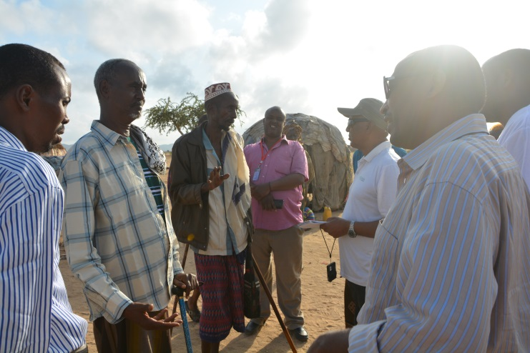
Garbadadar town:
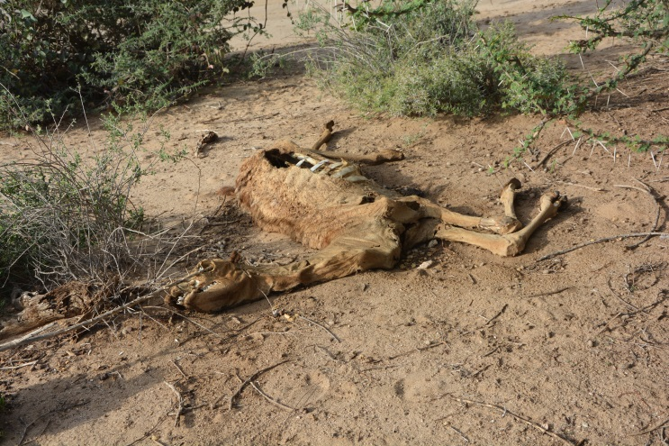

- Garbadadar is one of the districts highly hit by the current drought. Villages that include WaraqaaDhiigta, Gobdhere, Biyodhader, Jeri, Karinbiyale, Biyacadadley, Geriisa and Gargara are severely affected
- It has a population of 850 households out of which IDPs constitute 300HHs (according to Deputy Mayor – Hassan Isse). Only 10 HHs of new IDPs joined the previous ones in the town.
- IDPs live close to the town (close to their relatives to get services such as food, water, school, etc.) and not necessarily at an IDP settlement
- IDPs mentioned that the 2015 drought came to them while they were struggling with the impact of the 2011 drought. A lot of people, who lost their livestock, are still staying in their villages as they couldn’t reach the IDP settlement at Garbadadar. They need to be reached and supported
- IDPs complained about being interviewed several times but get no response and support so far. The current drought, as explained by IDPs, is the most severe they have ever seen.Livestock are dying, including camel, which is known to resist severe water stress.
- Situation of basic services:

  - Source of livelihood: Most of the IDPs are pastoralists who have lost their livestock due to drought (2011 and 2015). They live close to the town & their relatives to get assistance. They also try to engage in daily labour for survival. Hence, they have no livelihood source. WVI provided 5 goats per household for 80 HHs in 2013. DRC also gave 20 shoats and 1 donkey per HH to 120 HHs in January 2015 for restocking purpose. However, most of these animals have died due to the drought and livestock diseases. IDPs indicated that the shoats distributed to them in 2015 were sick at the time and they even spread disease to local livestock causing all animals to die as a result. They say they were no consulted when the animals were purchased and they were brought sick animals from highland areas
  - Water: the village has an existing water supply source that is also shared with the IDPs who pay 100 SLSH/jeerican. However, water is distributed in shift between the town and the IDPs as it is not enough to supply both at once. WVI erected a water tank at the IDPs location (2kms from centre of town) in 2013 to make water more accessible to them
  - Health: An MCH is available at the town which IDPs also access. People are also affected by diseases and need support
  - Education: The IDP children learn at the town’s primary school of 12 classes (grade 1-8), though the school is a bit far from their location. The school is extremely overcrowded and is not sufficient for all the children (the town and the IDPs)

- Identified Priority Needs (of the IDPs & host community) - GAPs:

  - Food: around 400HHs at 4 IDP locations (in the district) were given food (25kgs of rice, 25kgs of flour& 3 litters of oil per two households) by the government two months ago. However, that is far from being sufficient and food is the major need of the IDPs as they have totally lost their livelihood base
  - Restocking & livelihood creation: to re-establish their livelihood and end dependency
  - Water: water supply expansion required to alleviate water shortage
  - Health: Human health and livestock health support highly required
  - Education: additional classrooms required as student number is growing. Uniforms and books also required for IDP students

Response activities by NGOs met at Garbadadar:

WVI:

- The team met WVI at Garbadadar
- WVI conducted rapid assessment in Garbadadar and Lughaya districts (Awdal Region) and reported to the team that the drought is severe, especially at Karin village in Garbadadar district, and death of livestock and disease incidents are observed
- WVI also say that people were gathering at very few water points, with their remaining livestock and a lot of congestion and fast depletion of the water was occurring as well as transmission of diseases

HIRDA:

- HIRDA (LNGO) distributed food to HHs in 9 villages of Baki districtin in Awdal region and a village (Sheik dhere) in Garbadadar districtin September 2015
- It also provided human health assistance (including drug distribution for the treatment of diarrhea, anemia for pregnant women &PUD- peptic ulcer disease)to over 560 people and conductedpublic awareness raising sessions, on sanitation,in the above 10 villages of Baki and Garebadadar districts
- The assistances are donated & funded by the Arab organization called Qadar Charity

Lughaya District:

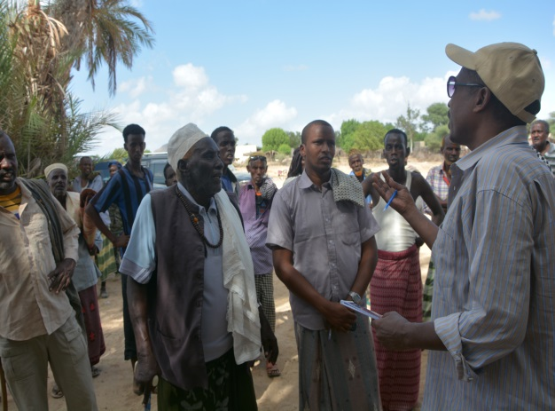
Gargara village:
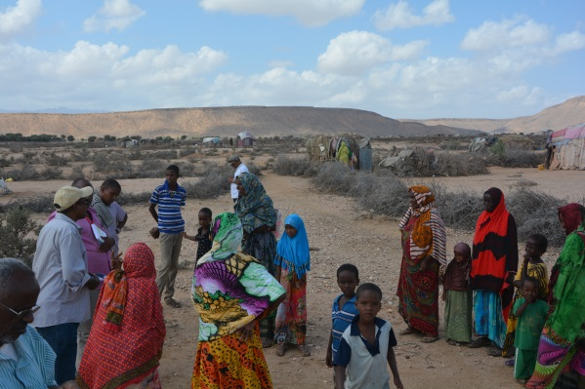

- A Member of Lughaya district Parliament (from Gargara) and the community indicated that Gargara is one of the villages highly hit by the current drought. The drought has been on-going for the last four years since 2011
- 70% of the population in the 10 villages of Lughaya district (including Gargara village) are affected by the current drought
- Around 750 IDP HHs are believed to exist in the IDP settlement in the village
- IDPs and the village received good support from humanitarian agencies since 2011 when IDPs came to the village. However, except WVI, other agencies have long ceased their support.
- Some goats were given to 20 IDP HHs. But the goats were sick and even infected the other livestock in the village causing a lot of deaths
- A lot of livestock in the village and surrounding areas died due to the drought and associated diseases
- Gargara village itself has now totally became an IDP
- The only assistance so far received in the village during this drought is the food distributed by GoSLto 200 HHs in August 2015
- A lot of assistance is required as all people have lost their livelihood source, livestock.
- JamacAbdulahi, an IDP who received 20 shoats (15goats& 5 sheep) and a donkey in January 2015 as DRC assistance, indicated that only 5 goats remain from what he received and all the others have died. He says that the animals died as they were already sick when they were given to him and were bought from areas far away from their district
- Situation of basic services:

  - Source of livelihood: the IDPs have no source livelihood as they have lost their livestock. They depend on the support of their relatives in the village for their survival
  - Water: the village has water supply and IDPs purchase two jerricans of water for 500 Somaliland shillings. They request for water supply expansion
  - Health: There is no clear information on the presence of an MCH at the village; and people say health service is very limited & require support
  - Education: IDPs share school (primary) with host community. The school is crowded
  - Shelter: IDPs live in worn-out traditional Somali huts (bulls)

- Identified Priority Needs (of the IDPs & host community) - GAPs:

  - Food assistance: this assistance is highly requested by the IDPs
  - Restocking & livelihood creation: to re-establish their livelihood and end dependency
  - Health: Health support is the other major request of the IDPs
  - Schooling: additional classrooms at existing school
  - Shelter: Permanent/semi-permanent shelter; NFIs (incl. plastic sheets &mosquito nets)

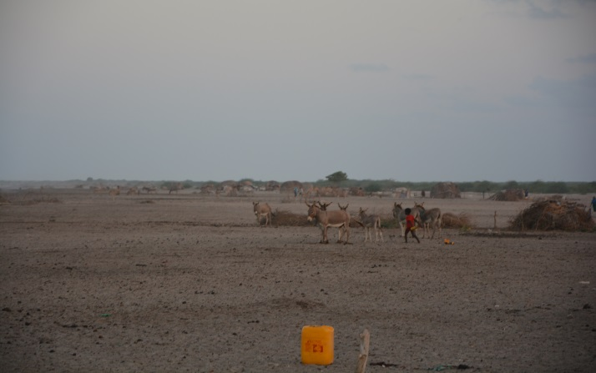
Lughaya town:
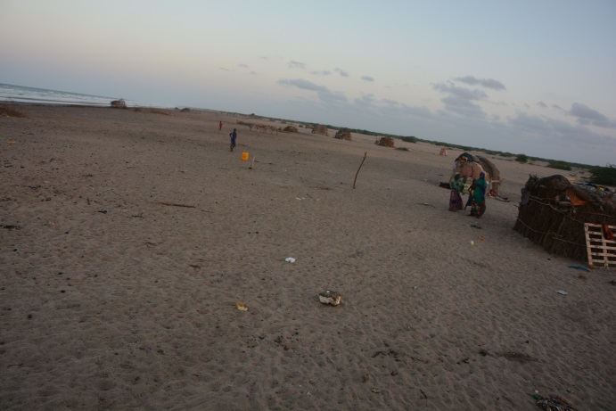

- Local government (executive secretary and members of Lughaya district parliament) and the community indicateLughaya as one of the districts highly hit by the current drought. The drought has been on-going for the last four years since 2011
- There are 24 villages in Lughaya district and all are affected by the drought. The drought is very severe and no green or dried grass can be seen in the district
- No human causalities because of the drought so fa. But new displacements have occurred as most people lost all of their livestock as a result of drought and diseases
- There are around 400 IDP HHs in Lugyaha town. The IDPs live at peripheries of the town and near their relatives
- No assistance so far from aid agencies and the government for Lughaya town including IDPs. Only three IDP HHs went to Gergara village and received goats during the distribution of the animals. But the goats were sick and passed diseases to local animals, causing livestock deaths. Hence, there is no aid organization/NGO supporting Lughaya IDPs at the moment
- However, some of the other villages in the district have received one time food assistance either from government of Somaliland or the people of Djibouti
- Situation of basic services:

  - Source of livelihood: the IDPs have no source livelihood as they have lost their livestock. They depend on the support of their relatives in the town for their survival
  - Water: water shortage is severe in the town.IDPs purchase a jerrican of water for 250 Somaliland shillings. A lot of water trucking is, hence, currently underway as a result of the severe water shortage in the district. They request for water supply expansion
  - Health: the diaspora constructed a new health centre. The centre, however, lacks physicians and medicines. IDPs use health facilities in the town
  - Education: IDPs share school (primary) with host community. The school is crowded
  - Shelter: IDPs live in worn-out traditional Somali huts (bulls)
  - Sanitation: IDPs have no latrines and use open spaces instead. This poses enormous health risk

- Identified Priority Needs (of the IDPs & host community) - GAPs:

  - Food assistance: foodis the first priority need of the IDPs
  - Sanitation: latrines are needed for IDPs to reduce health risks
  - Livelihood creation: requested for fishing support for livelihood creation and end dependency
  - Water: water supply expansion is needed
  - Health: medicine and health personnel support is required for the new health centre. Livestock health support is also needed
  - Education: additional classrooms at existing school
  - Shelter: Permanent/semi-permanent shelter; NFIs (incl. plastic sheets & mosquito nets)

Zeila District:

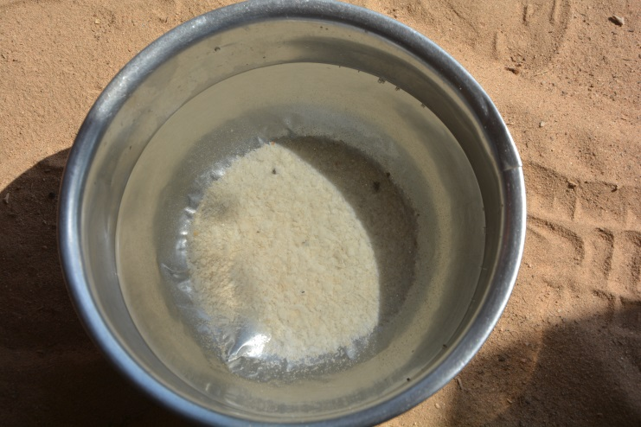
El-Gaal village:
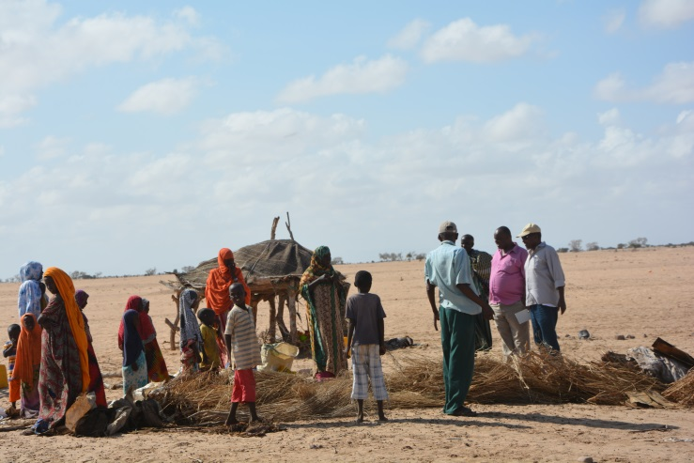

- Local government chairman, Ahmed Ali Gelee, and community & IDP groups mentioned that the drought in the village has been on-going for the last four years but this year it is more severe. IDPs started to be seen in the village when drought began in 2011 and after people lost their livestock
- Currently there are 220 IDP HHs out of which 55 HHs are newly displaced ones in this year, 2015. IDPs live very close to the village and their relatives to get support
- Situation of basic services:

  - Source of livelihood: the IDPs have no source livelihood as they have lost their livestock. They depend on the support of their relatives in the town for their survival. At the end of August 2015, the government of Somaliland distributed food (25 Kg of each of rice, flour & sugar, and 3 litres of oil per household) to 180 HHs. This is the only food assistance so far received in the village. Lots of pregnant women are dying due to malnutrition. Four women died during the last month alone (September 2015). Save the Children distributed 20 shoats (5 sheep & 15 goats) to 45 IDP HHs in April 2015. The shoats were healthy during distribution and they were all purchased from within the district. However, all the shoats died as a result of the drought.
  - Water: Both the villagers & the IDPs are suffering from lack of safe drinking water. The water people are using is extremely salty and salt deposits can be seen at the bottom of water jeericans/barrels. The people, including children and lactating women, are hence suffering from diarrhoea and kidney problems as a result of the water. They request support for fresh watersupply
  - Health: There is no MCH/ health centre in the village, including for IDPs, and hence no health services in the village
  - Sanitation: IDPs have no latrines and use open spaces instead. This poses enormous health risk
  - Shelter: IDPs live in worn-out traditional Somali huts (bulls)
  - Education: IDPs share school (primary) with host community. The school is crowded

- Identified Priority Needs (of the IDPs & host community) - GAPs:

  - Water: Getting fresh drinking water is the first priority of the IDPs as well as the villagers
  - Food assistance: foodand nutrition assistancesare the other most important needs of the IDPs
  - Health: an MCH/health centre is another basic need as there is none. Ambulance is also required
  - Sanitation: latrines are needed for IDPs to reduce health risks
  - Shelter: Permanent/semi-permanent shelter; NFIs (incl. plastic sheets & mosquito nets) also needed for all IDPs
  - Livelihood creation: restocking and livelihood support required
  - Education: additional classrooms at existing school

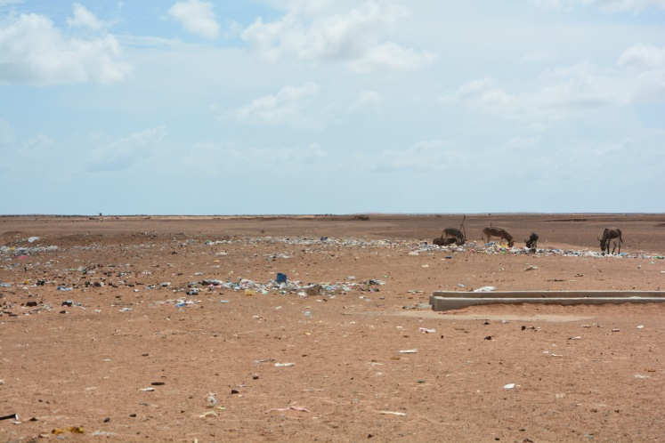
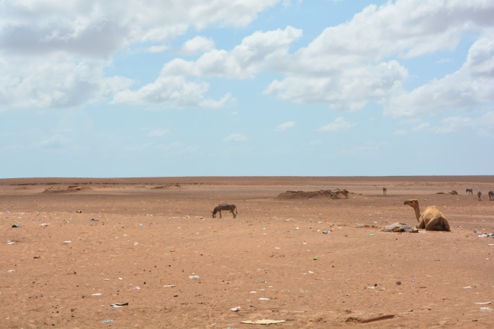
Asha-Ado village:

- According to the chairman of the local government, Mohamed Seed Abdulahi, and community & IDP groups,there are 150 IDP HHs in Asha Ado village ate the moment.
- Situation of basic services:

  - Source of livelihood: IDPs have no source livelihood as they have lost their livestock. They depend on the support of their relatives in the town for survival. Moreover, no food support is received from the government of Somaliland so far in the village, including IDPs, as reported by Asha Ado elders & residents. The villagers, moreover, said that, “the food sent to them by the government has been diverted by the governor of the district for personal use”.
  - Water: Both the villagers & the IDPs do not have safe drinking water. The villagers say tht the water they use is saline and causes problems to their health. They, hence, requested support for fresh water supply
  - Health: There is no MCH/ health centre in Asha Ado village, including for IDPs, and hence no health services in the village. The people always struggle to reach Lawya Ado for medical services. There is no ambulance as well for transporting patients
  - Sanitation: IDPs have no latrines and use open spaces instead. This poses enormous health risk
  - Shelter: IDPs live in worn-out traditional Somali bulls
  - Education: IDP children share a primary school with the host community

- Identified Priority Needs (of the IDPs & host community) - GAPs:

  - Water: Getting potable drinking water is the first priority of the IDPs as well as the villagers
  - Food assistance: foodand nutrition assistancesare the other most important needs of the IDPs
  - Health: an MCH/health centre is another basic need as there is none. Ambulance is also required
  - Sanitation: latrines are needed for IDPs to reduce health risks
  - Shelter: Permanent/semi-permanent shelter; NFIs (incl. plastic sheets & mosquito nets) also needed for the IDPs
  - Livelihood creation: restocking and livelihood support is also required

Harirad District:

Jidhi Village:
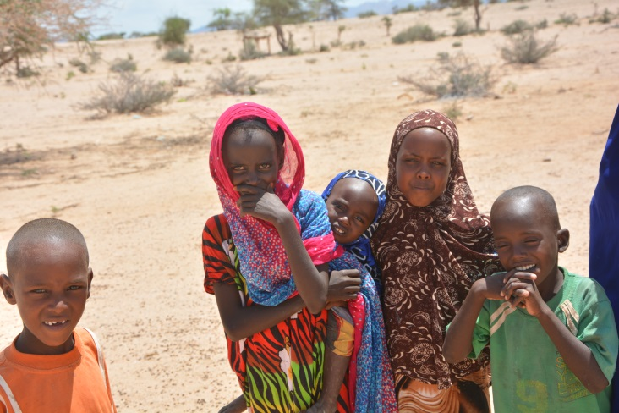
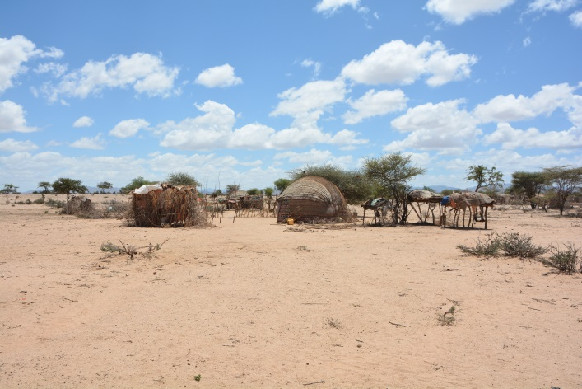

- Jidhi village has 117 resident households
- The IDPs in the village are estimated to be around 95 HHs
- The IDPs are composed of people displaced during the droughts of 2011 as well as 2015 after losing their livestock on which they solely depend for living
- Community elders (including Zeila district Member of Parliament (MP) representing Jidhi – Ahmed MigleEltraiy) and IDP representatives say that the displaced people did not receive any humanitarian assistance so far including from the GoSL
- The community perceives that both the GoSL and Djibouti think that the other party need to assist the village and they hence remain unassisted as one throws the responsibility on the other
- Situation of basic services:

  - Source of livelihood: the IDPs have no source livelihood as they have lost their livestock. They depend on the hand-to-mouth assistance of their relatives in the village for their survival
  - Water: the village has an existing water supply source that is not currently functioning due to lack of maintenance of the water pump and other equipment
  - Health: There is an MCH at the village which IDPs also access
  - Education: A primary school (consisting of only 3 classes (grade 1 – grade 3 classes)), recognized by Ministry of Education (MoE),exist in the village and IDP children also attend classes. A total of 80 children (50 girls & 30 boys) learn at the school. But only two teachers teach all subjects (and in shifts) at the school. The school principal (who is also one of the two teachers) indicates that the school is so crowded and has no running water for the children. He, however, confirmed the availability of latrines at the school for the children
  - Shelter: IDPs live in worn-out traditional Somali huts (bulls)
  - Sanitation: IDPs have no latrines and use open spaces instead. This poses enormous health risk
  - Mosque: The construction of a mosque was started by the diaspora in the village. However, the construction is currently halted due to shortage of funds after the walls were erected

- IdentifiedPriority Needs (of the IDPs &host community)- GAPs:

  - Restocking& livelihood creation: to re-establish their livelihood and end dependency
  - Education: additional classrooms at existing school, school feeding and running water supply for the children at the school
  - Water: rehabilitation of the existing water supply source
  - Shelter: plastic sheet and NFIs for all of the IDPs
  - Sanitation: support for the construction of latrines to the IDPs
  - Mosque: Funding support to complete the construction of the mosque being started in the village

Abdiqadir Village:

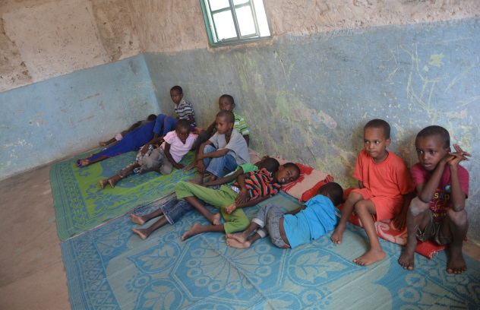
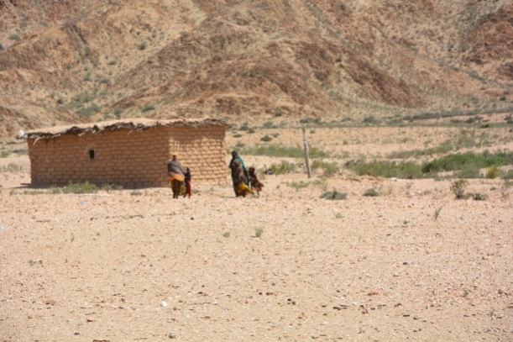

- Abdiqadir village consists of 150 HHs as residents
- However, 30 IDP HHs, who have lost their livestock as a result of the 2011 & 2015 droughts, have also joined the villagers to seek support
- Availability of basic services:

  - Livelihood: the IDPs have lost their livelihood base - their livestock. They are mainly dependent on handouts from relatives for their survival. Some of them engage in daily labour activities as well. The GoSL distributed food (3kg of rice, 3kg of flour and 3kgs of sugar) to 300 HHs in Abdiqadir village (including IDPs) and its surroundings
  - Water: the water source in the village is not fully functioning due to lack of maintenance of the pumping equipment
  - Health: An MCH, which is also accessible to IDPs,is available and functioning in the village. WFP provides malnutrition support at the MCH
  - Education: A primary school (grade 1– 8) exist in the village. 110 children (25 IDPs and 85 local) learn in the school. Eight teachers, paid by MoE, teach in the school. The host community make contributions and regularly feed the 25 IDP children in the school. The assessment team was impressed by the initiative of the host community and visited the 25 children in the school. Many of the children were in good condition as a result of the appreciable deeds of the host community. However, a sizable number of the children still lookvery weak and malnourished. Moreover, the school has no running water and this exposes the children to health risk
  - Shelter: IDPs have no mentionable shelter. They live in traditional Somali huts (bulls) of poor quality
  - Sanitation: No latrines for IDPs in the village. They face health risk as they practice open defecation

- Identified Priority Needs (of the IDPs & host community) - GAPs:

  - Food assistance: this assistance is highly requested by the IDPs
  - Restocking & livelihood creation: needed to re-establish their livelihood and end dependency
  - Education: The host community in Abdiqadir village is doing its level best to feed 25 IDP children and enable them attend school. However, as many of these children are still very weak and malnourished, the humanitarian community (including WFP & UNICEF) need to urgently respond to the conditions observed at the village’s primary school and support the IDP children with malnutrition treatment and regular school feeding program. Moreover, there is an urgent need to extend the water in the village to the school to supply running water to the children
  - Water: Water pump and water tank maintenances are urgently required to improve water supply in the village
  - Shelter: plastic sheet and NFIs for the IDPs. They(IDPs) also requested for permanent shelter support for full integration with the host community
  - Sanitation: support for the construction of latrines to the IDPs

Harirad town:

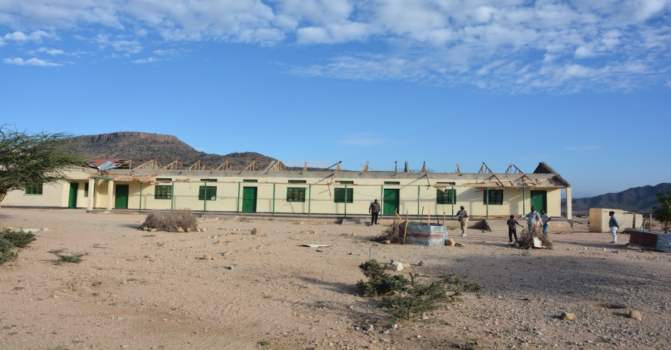

- As mentioned by the district Mayor, Abokor Hussein Guleid, the population of Hariradtown is 1010 HHs
- The town is located at 2.5 kms away from the Ethiopian border
- Its climate is cool as it is located on a high ground
- The IDPs in town are 575 HHs
- IDPs were formed during the last four years due to drought
- Availability of basic services:
  - Livelihood: The livelihood of the IDPs is based on firewood collection, charcoal making and daily labour. They also go to nearby Ethiopian villages (their clan) to get assistance. The have lost their entire livelihood source – livestock & farm produce. They live mixed with the town residents to get support
  - Water: The town has drinking water
  - Health: One MCH (financed by the diaspora) is functioning in Harirad. There is also one Hospital (called Ugas Mustafa Hospital)built by the diaspora in Harirad. The hospital is not, however, functioning fully due to lack of medical equipment and medicines. Currently, the Somaliland Red Crescent Society (SRCS) uses the hospital only for delivering EPHS (Essential Package of Health Services) to mothers. IDPs access the services of both facilities
  - Shelter: IDPs live scattered in the town and in bulls of poor conditions
  - Education: A primary and secondaryschools exist in Harirad. The primary school is functioning and IDP children also access it. The secondary school is not functioning because its roof is damaged and taken away by wind & rain two years ago

- Identified Priority Needs (of the IDPs & host community) - GAPs:

  - Food: Food assistance is a priority for the IDPs at the moment
  - Restocking:required for re-establishing the livelihood of the IDPs who want to return to their places of origin
  - Health: The MCH requires medicine support. The hospital needs support for the provision of medical equipment and medicines. Both also require skilled manpower
  - Shelter: Support for the provision of temporary or permanent shelter is required as some of the IDPs want to be re-integrated into the town. Local government is ready to allocated land for the purpose
  - Education: Support required to maintain the roof of the secondary school and operationalize it once again

Bon District:

Bon town:
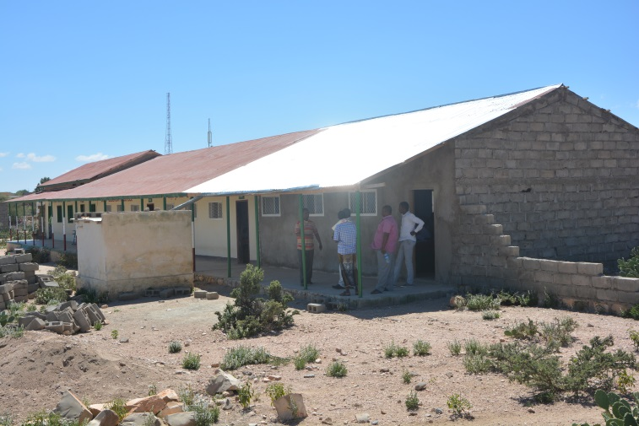
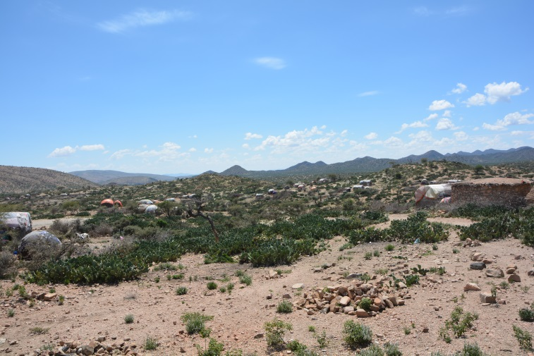

- Bon has a population of 4500 HHs (as mentioned by its Mayor)
- 580 IDP HHs are estimated to exist in the town. Around 180 HHs are newly displaced people due to the 2015 drought. The IDPs are displaced from villages that include Sheik Awale, Fiqi Adan, Hemal, Werar, Abasee, etc. The mayor promised to make a proper counting of the IDPs in the town and update the team very soon. IDPs are supported by residents
- Availability of basic services:
  - Livelihood: IDPs have lost their entire livelihood source – livestock. They live close to their relatives to get support
  - Water: The town gets its water from a well of 8ms depth, which was developed in 1994. It used to have three kiosks but only two are working at the moment. The population of the town has increased tremendously since 1994 and water has become very scarce
  - Health: One MCH functions in Bon town and serves all people. The MCH was managed in the past by SRCS but Save the Children International (SCI) took over its management since the beginning of 2015. SCI brought more medicines and increased the health workers at the MCH. The health services provided at the MCH look sufficient as mentioned by the mayor and community elders. However, the mayor & elders say that, “lots of promises made by SCI, such as malnutrition support, are not yet realized”. Hence, no such support in the MCH at the moment and there is no ambulance as well. The community say that 3 women passed away during labour, in July 2015, because of lack of ambulance to take them to the nearest Hospital in Borama
  - Shelter: IDPs live scattered in the town and in bulls of poor conditions
  - Sanitation: IDPs lack adequate latrines
  - Education: Bon has one primary school of 9 classroomsand a secondary school. 875 children (including IDPs) learn in the primary school. More than 52 students learn in each class (two shifts) in a very congested manner. There is serious overcrowding in the school and newly joining children do not seem to find place to sit next year. There are 18 teachers at the school but only 9 of them get salary from the government (MoE). 150 students study in the secondary school which has only 4 classrooms. The school is not a fully-fledged secondary school; it lacks library, classrooms are very few and it has no fence. From the 8 teachers at the secondary school, only 3 of them are paid by the government and the rest 5 have no salary or incentives. Regarding the support staff at the secondary school, only one of the two guards get salary from MoE but the remaining guard and the cleaning staff do not get any payment
  - Security: Bon has no police station
  - Roads: the road connecting Bon to Harirad town is often cut by runoff that created a gorge especially just outside the entrance to Bon. The team observed the residents and the mayor trying to repair the road by filling it with tree branches, stones and sand. The mayor and community members working at the site told the team that the road is cut at that location always after rain and this often makes Bon inaccessible from Harirad side. Community elders and the Mayor say that WFP has promised to repair the road and is currently maintaining the other parts of the road through food for work. They further said that,“WFP promised to provide a food for work package of 75kgs of Sorghum, 10kgs of oats, 10kgs of pulses & 5 litres of oil to each worker per month; but is currently providing a package reduced by 35 kgs from what was agreed”. The elders requested for further assistance in order to erect a bridge at entrance point of the road to the town.

- Identified Priority Needs (of the IDPs & host community) - GAPs:

  - Restocking: needed to re-establish the livelihood of the IDPs as they have lost their livestock due to drought
  - Water: Assistance needed to expand water availability and install additional kiosks as well as maintain the damaged kiosk in the town
  - Health: support required for the provision of malnutrition treatment in the MCH. The town is also in dire need of an ambulance
  - Shelter: IDPs need NFIs (including blankets) and plastic sheets to reinforce their hats
  - Sanitation: support for the construction of latrines to the IDPs & host community
  - Education: additional class rooms required in both the primary and secondary schools; and a library and a fence needed in the secondary school. Moreover, incentives for teachers and support staff might be considered to ensure the sustainability of the education process
  - Security: support required for the construction of police station
  - Other: the town also requires support in the area of livestock health and road maintenance

(Awdal Region: According to GoSL’sReginal Classifications of SL)

Borama District:

Borama town:

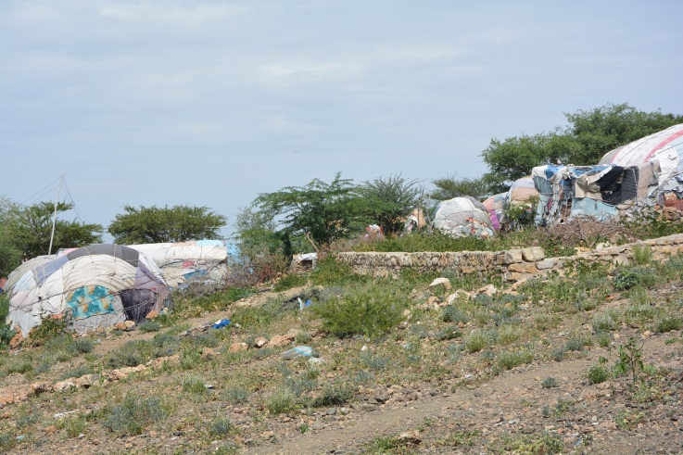
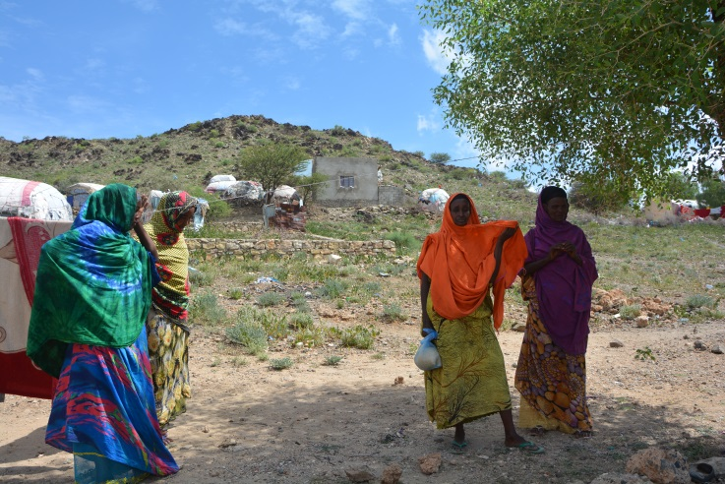

- The current (2015) drought increased the IDPs in Borama town. Most of them settled at the outskirt of the town at all sides. People support the IDPs with food through contributions. Most basic services are located a bit far away from the IDPs. Most of them were displaced after losing their livestock and crops due to drought
- The town administration is planning to establish a committee to assess and formally document the total number of IDPs that reside in Borama town. Currently, however, around 2000 – 3000 IDP HHs are estimated to exist in the town
- IDPs in the town were not targeted during the recent distribution of food by the government.
- There are also 50 Yemen refugees and 300 Somaliland returnees that settled in Borama. NRC handed out cash support of USD 19.5 per person for 240 HHs out of the total 350 refugee and returnee HHs in the town
- 215 permanent homes are also under construction by UNHABITAT in Boroma for distribution to returnees occupying government premises
- Availability of basic services:
  - Livelihood: IDPs have no source of income. The have lost their entire livelihood source – livestock & farm produce. They live close to their clan to get assistance
  - Water:Water is a major gap in the town and for IDPs. The town itself gets running water every two days. IDPs purchase one jeerican of water with 1000 Somaliland shillings
  - Shelter: IDPs live in worn-out bulls close to their relatives and scattered in the town
  - Sanitation: Latrines are in short supply for IDPs and support is required
  - Health: IDPs share MCH &other health services available in the town, but protection support is needed as gender abuses are prevalence
  - Education: IDP children joined the primary schools in the town

- Identified Priority Needs (of the IDPs & host community) - GAPs:

  - Food: IDPs in the town were not targeted during the recent distribution of food by the government.Food is, hence, the number one priority of the IDPs at the moment
  - Water:Water supply assistance is required as this is a major gap in Borama itself
  - Health & protection: rape incidents occur very often among IDPs (a case was even noted on 04 October). Hence, protection and health needs are very high
  - Restocking: for re-establishing their livelihood and improve their self-reliance
  - Sanitation: More latrines are needed for the IDPs
  - Shelter: Support required to provide better housing for the IDPs and NFIs

Dila District:

Dila town:

- The population of Dila town is around 2000HHs (10000 persons). The figure contains 380 IDP HHs that live in the town following their displacement from nearby villages such as Charaherato, Duhun&GediDiqsi as a result of the droughts of 2011 (300 HHs) and 2015 (80 HHs). People displaced from Semal village due to clan conflict at the end of 2014 and returnees from Ethiopia are also part of the IDPs
- According to information received from the mayor of Dilatown, 2/3 of the population in the district is affected by the current drought (2015) and require assistance
- Most of the IDPs were forced to leave their villages after losing their livestock and farming opportunities as a result of the indicated droughts. The price of grain has risen as there are no new harvests. For instance, prior to the drought, the price of one kg of Sorghum was 2000 SLSH and now one kg of Sorghum is sold for 10,000 SLSH in Dila town.
- The IDPs have no separate settlement. They rather settled close to their relatives to be sure of getting assistance.
- UNHCR and DRC distributed NFIs to 300 IDP HHs at the beginning of 2015
- The GoSL distributed food (25Kgs of rice, flour and sugar and 3 liters of oil) to each of 300 HHs from surrounding villages that include Sheik Nur, Tuli, Diqsi and Sabwanag before two months.The government also distributed 20 trucks of water to the villages at the time. Nevertheless, the IDPs in Dilatown were not included in the beneficiary groups. The GoSL promised to conduct separate food distribution for the IDPs at the time but this didn’t take place so far
- DRC also delivered 20 shoats to returnees who first settled in Borama but later resettled at their places of origin in Charaherato and Duhun villages in the district though the Mayor was not informed during the conduct of the process
- Availability of basic services:
  - Livelihood:IDPs have no source of income. The have lost their entire livelihood source – livestock & farm produce. They live close to their clan to get assistance
  - Water:The town has no water well but gets its water from a dam
  - Shelter: IDPs live in worn-out bulls close to their relatives and scattered in the town
  - Sanitation: Latrines are in short supply including for IDPs who congested the service further
  - Health: The town has an MCH where IDPs also access
  - Education: IDP children joined the primary school in the town

- Identified Priority Needs (of the IDPs & host community) - GAPs:

  - Food: IDPs in the town were not targeted during the recent distribution of food by the government.Food is, hence, the number one priority of the IDPs at the moment
  - Restocking: for re-establishing their livelihood and improve their self-reliance
  - Water:Safe drinking water is the major gap in the town and support is required for borehole development
  - Sanitation: More latrines are needed in the town to improve sanitation
  - Shelter: Support required to provide better housing for the IDPs

MagaloCad District:

MagaloCad village:

- Magala Cad village contains 800 HHs
- This figure, however, contains 175 IDP households who have lost their livestock/farming opportunitiesas a result of the 2011 & 2015 droughts and displaced mainly from Baldhere, Tuliand Ulagovillages. The group also contains returnees from Ethiopia who were displaced during the civil war
- The IDPs have no separate settlement. Each IDP HH has taken refugee close to the residence of its relative to ensure its survival
- Availability of basic services:
  - Livelihood: The IDPs are pastoralist and agriculturalist community groups who lost their livelihood base (livestock & crops) due to drought. They have no source of income and are mainly dependent on their relatives for survival. Lots of sorghum and maize plants, on many farms on the way to the village, were seen wilting and drying up before maturing & ripening
  - Health: There is a well-functioning MCH (built by ADRA) in the village to which the IDPs have free access. WFP provides nutrition assistance to malnourished children and to pregnant women at the MCH
  - Water: Islamic Relief (IR) dug a borehole for the village which is near completion. The well is around 5Kms from the village and the residentslook relived as they used to fetch water from very far areas (sometimes more than 20 kms away). IR is to install water points (taps) around the borehole for people to access the water. However, the residents are seeking assistance for extending the water from its source to the village and for the installation of access points (kiosks) in the village. Currently, the village and the IDPs get water from distant dams
  - Shelter: Similar to the other IDPs so far observed, the IDPs in the village live in traditional Somali huts (bulls)
  - Sanitation: There are only 7 latrines in the village for both the residents and the IDPs
  - Education: There is a primary school (grade 1- 8) in the village where IDPs have also an access. The school has 8 teachers and 280 students are enrolled. 5 of the teachers get salary from MoE but the remaining three have no salary
  - Security: There is no police station and there are no police personnel in the village. The village is forced to always request for police assistance from Dila town during insecurity problems and they are usually forced to finance the transport and per diems of the police that come from Dila

- Identified Priority Needs (of the IDPs & host community) - GAPs:

  - Restocking &agricultural support: needed to re-establish the livelihood of the IDPs and end the dependency as IDPs are willing to return to their places of origin if assisted
  - Water: Assistance needed to install pipes that extend water from its source (a borehole of 5kms away) to the village and for the installation of kiosks to improve water access in the village
  - Sanitation: support for the construction of latrines to the IDPs& host community
  - Security: support required for the construction of police station

- SUMMARY AND PRIORITY NEEDS OF IDPS

The assessment was conducted from 29thSep – 07th October with the participation of OCHA, UNHCR, NRC, DRC and MoRRR. Most districts & IDP locations in Awdal region (Garbadadar, Gargara, Lughaya, El-gal, Ashacado, Jidhi, Abdiqadir, Harirad, Bon, Borama, Dila, Magala cad), and Bulahar and Gabiley districts in WoqooyiGalbeed region were covered in the assessment. The objective of the assessment was to look in to the effect of the reported drought on IDPs.

The findings suggest the drought to look severe. Newly displaced people were joining the previous ones and most people report loss of livestock. Dead bodies of animals were also observed in various districts and agricultural crops were wilting on the farm. Most IDPs live close to their relatives to secure assistance.

The findings further report that IDPs in El-gal and Ashacado villages (Zeila district), and Abdikadir village in Harirad district look particularly vulnerable. In El-gal village, both the residents & the IDPs (220 HHs) are suffering from lack of safe drinking water. The water people are using is extremely salty and salt deposits were seen at the bottom of water jeericans/barrels. The people, including children and lactating women, are hence suffering from diarrhoea and kidney problems as a result of the water. There is no MCH/health centre in the village as well. The IDPs in this village look weak and require urgent food, nutrition, health and NFIs assistance. Lots of pregnant women are dying due to malnutrition. Four women died during the last month alone (September 2015). At Ashacado village, no MCH/health centre is available and the IDPs are also in dire need of food assistance. In Abdikadir village, about 25 IDP children are kept and feed at a primary school with contributions collected from the local community. Some of the children looked weak and need urgent nutrition assistance.

Assistances so far provided include food distributed by the government (donated by Arab organizations) in August 2015, to 8100 HHs in most of the villages assessed. The government has also trucked water to some of the villages. The food distribution was mainly to rural people and most IDPs reported not receiving it. Save the Children International was also trucking water in 9 villages in Bulahar&/or Lughaya districts (since July 2015) and food for work activities, supported by WFP in Bon district, were underway. A WFP team was also touring the Awdal region at the time to assess situations at MCHs for providing future assistance. HIRDA, a LNGO, distributed food in 9 villages of Baki district and a village in Garbadadar district in September 2015. It also provided human health assistance (including drug distribution for the treatment of diarrhoea, anaemia & PUD- peptic ulcer disease) to over 560 people and raised public awareness on sanitation in the 10 villages (Qadar Charity donated the assistances). WVI was also conducting rapid assessment in Garbadadar and Lughaya districts to provide assistance.

According to the overall findings, the immediate needs of all the IDPs assessed in these two regions include food, nutrition, water, sanitation and restocking. Other needs include, health (an MCH & ambulance at El-gal &AshaCado, and ambulance at Bulahar), shelter (plastic sheet, semi-permanent homes – for reintegration & NFIs), education (additional class rooms, school feeding and teacher incentives), and police post at Bon &Magala Cad.

- MAJOR RESPONSES REQUIRED

The following table summarizes the immediate and medium term responses required for the IDPs assessed in the two regions. The districts highlighted in red, in the table, are those that are particularly vulnerable and should be given priority for urgent assistance.

Region/  District | No. of IDP HHs (local gov’t & community estimation) | Assistance required
 |  | Immediate/urgent | Medium (to long) term
Awdal
Garbadadar | 300 (10 new) | - Food | - Restocking & livelihood creation; education (additional classrooms); water supply expansion; health; veterinary support
Gargara | 750 | - Food; health | - Water supply expansion; Restocking & livelihood creation; education (additional classrooms); shelter; NFIs
Lughaya | 400 | - Food; latrines; veterinary support | - Water supply expansion; fishing assistance; additional school classrooms; medicine and health personnel; shelter; NFIs
El-gal | 220 (55 new)  (serious situation) | - Food; malnutrition treatment; safe drinking water; MCH; ambulance; latrines; NFIs (incl. plastic sheets & mosquito nets) | - Restocking & livelihood creation
Ashacado | 150  (serious situation) | - Food; malnutrition treatment; potable water; MCH; ambulance; NFIs (incl. plastic sheets & mosquito nets); latrines | - Restocking & livelihood creation
Abdiqadir | 150 (30 new)  (serious situation) | - Food; malnutrition treatment for IDP children & pregnant women ; school feeding latrines; running water at primary school; NFIs | - Restocking & livelihood creation
Jidhi | 95 | - Latrines; NFIs; rehabilitation of water source | - Restocking & livelihood creation; education (additional classrooms); financial support to complete the construction of a mosque
Harirad | 575 | - Food; medical equipment & medicine for hospital; roof maintenance at secondary school | - Restocking; health personnel; additional classrooms at primary school; shelter; NFIs
Bon | 580 (180 new) | - Malnutrition treatment at MCH; an ambulance; NFIs (including blankets & plastic sheets); latrines; police post | - Restocking; health personnel; additional classrooms at primary & secondary schools; library & fencing for secondary school; teacher incentives; shelter; NFIs; livestock health and road maintenance
Borama | 2000 HHs (no clear figure) | - Food; water; latrines; NFIs | - Health (including protection); shelter; restocking & agricultural inputs
Dila | 380 (80 new) | - Food; safe drinking water | - Restocking; shelter; more latrines
Magala cad | 175 | - Water pipes & kiosks; latrines; police post | - Restocking; agricultural inputs
W.Galbeed
Bulahar | No IDPs found | - Ambulance for the town; fishing gear & training | - Restocking; water supply improvement; additional wards at health center; additional classrooms at the school; teacher incentives
Gabiley | 800 HHs (no clear figure) | - Food; latrines; NFIs | - Water supply expansion; shelter; restocking & agricultural inputs

- PARTICIPATING PARTNERS OF THE INTER-AGENCY ASSESSMENT

UNOCHA, UNHCR, NRC, DRC and Ministry of Resettlement, Rehabilitation and Reconstruction (MoRRR) have actively participated in the fact finding mission.

_____________________________ END ____________________________________________
Hassan Warsame
Humanitarian Affairs Analyst
UNOCHA
Hargeisa

04November 2015

