DRAFT 1 Strategy: Shelter et NFI Cluster

Cyclone Idai Reponse (16/3/19)

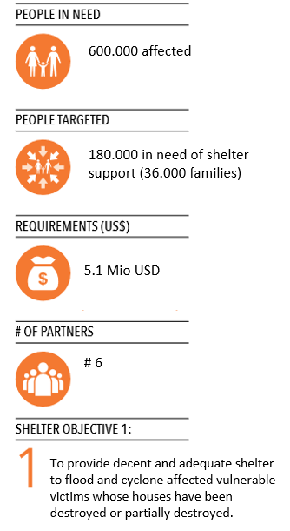

Background

A category 4 cyclone has made landfall in Mozambique on Thursday evening, bringing with it high wind speeds of up to 224km/h and rain. Before making, the storm had already affected 103.000 people in Mozambique, 9.932 houses were partially destroyed and 12.655 were completely destroyed. 15,258 were displaced in 18 camps (numbers INGC).

There are reports of damage and power cuts as the tropical cyclone made landfall. According to the Mozambique National Institute for Disaster Management (INGC), the National Operational Emergency Centre (CENOE), it is expected that 486.000 people were affected by the cyclone. This brings the total caseload of the people affected by the floods and the cyclone close to 600.000 people.

A first assessment team, under the leadership of INGC left Marc 15th Caia to Beirra and first reports are expected to come in March 16th, with more detailed information to follow.

The day after the cyclone had hit, the Mozambican government via INGC requested for support to cover the most urgent needs with 3.000 tents, 5.000 tarpaulin sheets, 5.000 Mosquito nets and 2.000 water units.

Objectives

* To safeguard the health, security, privacy and dignity women and men, boys and girls affected by Cyclone Idai through the provision of emergency shelter and NFI assistance.
* To support durable solutions to protracted displacement (avoiding the creation of camps and allowing safe return from collective centres).
* To promote early self-recovery through a participatory neighbourhood/settlements approach that integrates WASH, health, livelihood and protection.

Settlement typologies

Initial feedback from agencies indicates that the affected population are divided into the following settlement types in urban and rural areas.

Different interventions will be required depending on displacement and damage type: urban, rural, displaced, non-displaced and the specific context

|  |  |  |  |  |
| --- | --- | --- | --- | --- |
| Damaged public buildings | Shelter for people affected and displaced | | | |
| Not included in this strategy | People living in public buildings (i.e. schools)  **Priority** | camps to be avoided, where possible | host families | People who have lost their land (flooding) |

Response Action

The Shelter Cluster aims to use combined approaches in the delivery of assistance to the targeted population:

1. ***Emergency: Common pipeline for In-kind contributions***

Different partners have offered to send shelter items (shelter kits and tents) and NFIs to Maputo Airport/ Port. After agreement is reached on the quality and relevance of NFs being offered, IOM, acting on behalf of the shelter cluster, has agreed receive and clear goods at the airport, store them in a warehouse (WFP or INGC - depending who has space) and organise the onward transportation in trucks / planes to Beira or any other place that will be identified in the coming days in the different assessments.

In the province, the items will be temporarily stored in WFP or INGC warehouse, while IOM hands them over to an implementing partner from the Shelter / NFI cluster, such as COSACA, CHEMO or the Mozambican Red Cross/IFRC that then will take over the distribution in the province in close coordination with INGC.

While the shelter cluster will agree on the main areas of distribution of the goods based on the inter-cluster assessments, the distributing NGO will do the fine tuning with the government in the districts. Reporting will go back to the shelter cluster.

1. ***Emergency: Common pipeline for Provision of further shelter kits and NFIs***

As the needs will be bigger than what will be provided in-kind, there will be a need to buy further shelter material and NFIs.

For this a common pipeline should be established which will allow Shelter Cluster partners, to request materials form the pipeline management agency (IOM).

1. ***Support on shelter and camp establishment***

Although Camps are to be avoided, the reality is that will be formed. The shelter cluster will provide material, technical support for camp establishment and support the data collection in basic service infrastructure (damage assessments of schools, hospitals, etc). As usual in Mozambique, the camps will be managed by INGC.

1. ***Training in safer construction***

Building on the work of UNHABITAT and MITADER, as well as the work of other cluster partners, train and supervise hands-on training on building back safer construction and community-based hazard awareness, preparedness and DRR, throughout the response.

1. ***Transitional shelter support***

Transitional shelters are designed to be more effective and last longer than the tents and plastic sheeting traditionally offered by relief organizations. They are designed to be safe and durable. Based on a strong core structure, the design also incorporates a longer-term development component as there is the potential to expand the structures later or to reuse the materials in building permanent houses. Unlike money spent on temporary housing, resources used to construct transitional shelters can be considered an investment in long-term, permanent housing.

Cash-for-shelter

1. ***Multi-sectorial approaches***

As the cyclone hit urban as rural areas, the approach will need to be adapted and include also livelihood support (coordination with other clusters).

Approaches

* To support the work of INGC, who has the overall lead in the crisis response
* Support to owner-driven recovery processes. This starts immediately.
* Prioritisation of vulnerable groups, including displaced women and men, boys and girls.
* Working at neighbourhood and settlements level with integrated programming.
* Pay particular attention to households who need to be relocated.
* Avoid the creation of camps.
* Activities must be conducted in coordination with WASH, protection, livelihoods.
* Activities should be conducted with the aim of mitigating **pull-factors** to urban centres, avoiding secondary displacements and supporting safe and voluntary return.
* Particular attention to Gender specific needs.