Non-food items and emergency shelter cluster guidelines on post-distribution monitoring

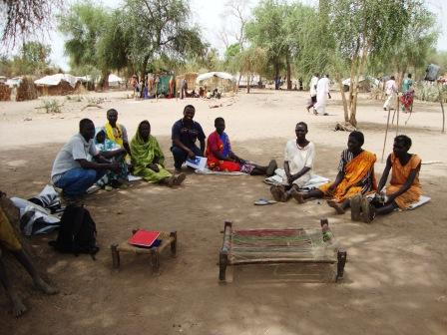
July 2012
Version 1

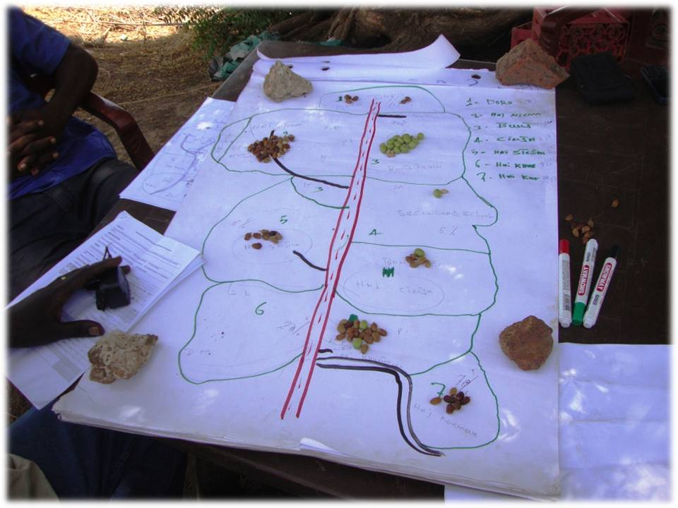
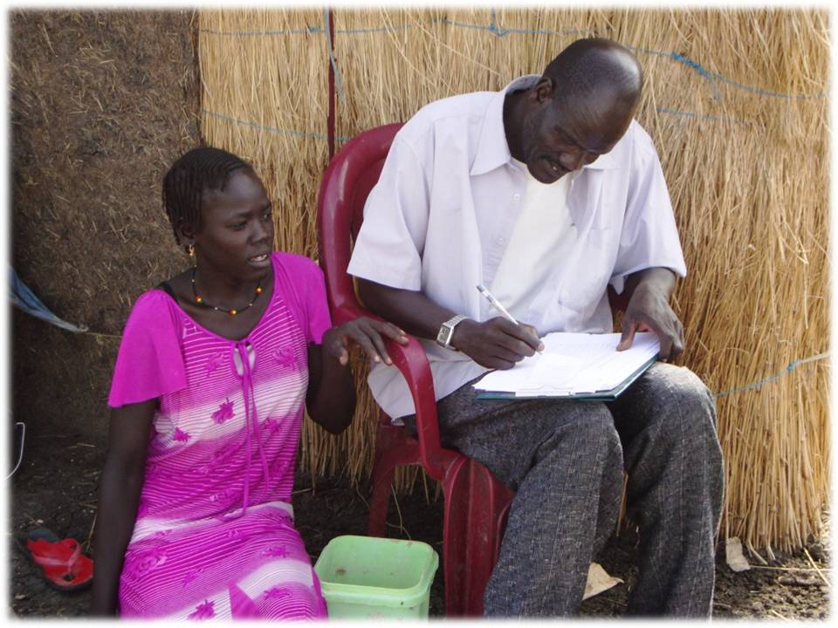
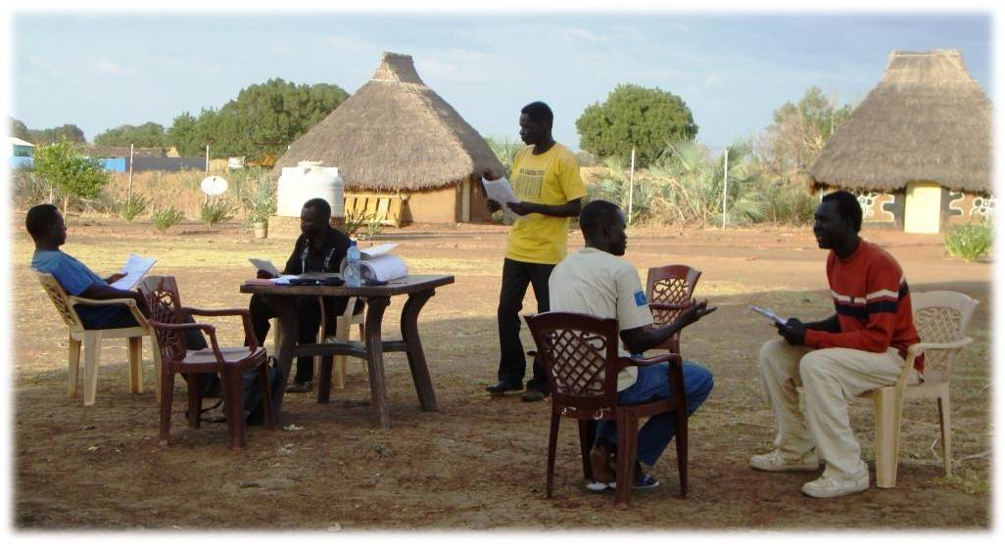

Acronyms

ALNAP Active Learning Network for Accountability and Performance
ES Emergency Shelter
FGD Focus group discussion
IDP Internally displaced person
IOM International Organization for Migration
KII Key informant interview
M&E Monitoring and evaluation
NFI Non-food item
NGO Non-governmental organization
OECD-DAC Organization for Economic Cooperation and Development – Development Assistance Committee
PDM Post-distribution monitoring
RRC South Sudan Relief and Rehabilitation Commission
UN United Nations

Contents
Acronyms 3
Introduction 6
What is a PDM? 6
Why carry out a PDM? 7
When to carry out a PDM? 8
What type of PDM? 8
How to do a PDM? 11
Setting the questions 11
The PDM team 13
Training and pre-testing 14
Data collection methods 15
Desk review (standard and mini PDMs) 15
Household questionnaires (standard PDMs) 15
Focus group discussions (mini and standard PDM) 23
Key informant interviews (mini and standard PDM) 24
Market surveys (standard PDM) 25
Data entry and cleaning 26
Data analysis and presenting recommendations 26
Advocacy and learning lessons 26
Bibliography 27
Annex 1: Indicator flow charts 28
Annex 2: Indicator tables 31
Annex 3: PDM Household Questionnaire 43
Annex 4: Sample schedule for a standard PDM 47
Annex 5: Guidance on data collection 48
Household questionnaires 48

Outline of the PDM process

Introduction
The non-food items and emergency shelter (NFI&ES) cluster in South Sudan provides life-saving assistance to internally displaced persons (IDPs), returnees and refugees caught up in disasters around the country. However, there remain many challenges to ensure that this assistance is delivered in the most effective manner, in a way that best meets the needs of affected people. This makes monitoring and evaluation (M&E) an essential aspect of the cluster’s work. Without strong systems of accountability and learning in place, combined with a desire to strengthen working practices and put disaster-affected people at the centre of programming, the cluster’s work will not succeed.
Post-distribution monitoring (PDM) is one M&E tool that is used by cluster partners to strengthen performance. By shining a light over the work of organizations working under the banner of the cluster, PDMs provide an opportunity to evaluate interventions in an impartial and independent way so organizations can be held accountable for their actions and lessons can be learned from their mistakes.
Until now, however, no guideline on how to conduct PDMs in South Sudan has existed. This has meant, for example, that PDMs have produced recommendations that have been difficult to trust, with the result they have not turned learning into improved performance. PDM recommendations will only feed into improved performance if they can be trusted. This will only happen where transparent and consistent data collection methodologies are laid out in clear guidelines. The following guidelines therefore address this gap by explaining what is expected of both standard and mini PDMs.
While they cover all of the topics necessary to conduct a good quality PDM, they should not however be seen as a comprehensive M&E guide. Rather, prior M&E knowledge and experience is assumed and further reading may be necessary where guidance provided is insufficient.

What is a PDM?
Given the variation in what has been considered post-distribution monitoring of NFI&ES interventions in South Sudan, it is first important to provide some clarity. Post-distribution monitoring (PDM) can be defined in different ways. For the purposes of the NFI&ES cluster in South Sudan, PDM is the process of evaluating an NFI and/or ES intervention after it has finished, to improve interventions in the future. It can take two different forms; standard PDM and mini-PDM.

Why carry out a PDM?

- For accountability: to render the quality of NFI/ES projects accountable (to beneficiaries, partners and donors)

‘We hold ourselves accountable to both those we seek to assist and those from whom we accept resources’ (The International Red Cross and Red Crescent Movement, 1994)
In order to assess whether the cluster is doing its job of providing life-saving emergency assistance to disaster-affected people, it cannot rely on activity based monitoring data alone. Knowing how many kits were distributed to which type of beneficiary in which location, while useful, tells us very little about the actual quality of the intervention. Did these beneficiaries need NFI kits? How was it decided to distribute only to this group of people and not to others? Did the distribution cause riots because those that did not receive were not told about the targeting criteria?
Post-distribution monitoring recognizes that there is more to good performance than the fact that a distribution has been done. The indicators set out in this guideline should complement those that already exist, forming part of the cluster’s M&E plan. The performance of individual interventions, as well as that of the cluster as a whole, can then be measured. It is intended that performance is then made known to all partners in the cluster’s monthly report.
- For learning: to feed learning into NFI/ES cluster policy and practice

‘The performance of humanitarian agencies is continually examined and communicated to stakeholders; projects are adapted in response to performance. (The Sphere Project, 2011)’
‘The organization learns from experience to continually improve its performance. (HAP International, 2010)’
Yet PDM is also a tool for learning and continuous improvement that acknowledges that there are common lessons to be learnt by NFI&ES partners. Mistakes should not be repeated, while good practice should highlighted for others to replicate. For example, the more is known about beneficiaries’ preferences for NFI items the easier it is to make decisions concerning what items should be distributed and in what quantities.

When to carry out a PDM?
Post-distribution monitoring should be carried out within a timeframe after the distribution has taken place that allows for:
- the beneficiaries of the distribution to be located
- the beneficiaries of the distribution to be able to recall the events surrounding the distribution
- the beneficiaries of the distribution to have had the opportunity to use the items they received
- an independent and impartial PDM team (led by a representative from an organization not involved in the distribution and composed of staff that did not take part in the distribution) to travel to the location
This usually means that PDM is carried out between 2 weeks and 4 months of the distribution.

What type of PDM?
There are two types of post-distribution monitoring; standard PDM and mini PDM. Deciding which to use depends on various factors, including resources, time and personnel available, how strong an evaluation is required, whether gaining indicators is important, and specific donor requirements (see table below).
There are many similarities between the design of the standard and mini PDMs, but the main difference is that mini PDMs do not require household or market surveys to be conducted, thereby significantly reducing the workload. However, because they are not grounded on a representative sample of beneficiary feedback, their findings and recommendations carry less weight.
The indicator flow charts in Annex 1 show which indicators require a household survey (in orange). These are quantitative indicators that can be compared using confidence intervals across different standard PDM, as long as simple random sampling is use. They also show which indicators do not require a household survey and can therefore be collected using mini PDMs.
(Note: This list of indicators should not be considered exhaustive. Instead it should be seen as a useful guide for structuring a PDM.

Comparing standard and mini PDMs:
 | Standard PDM | Mini PDM
Overall objective | - To improve the quality of programming in the NFI/ES cluster | - To improve the quality of programming in the NFI/ES cluster
Objectives | - To render the quality of NFI/ES projects accountable (to beneficiaries, partners and donors), with the use of household level indicators  - To feed learning into NFI/ES cluster policy and practice | - To render the quality of NFI/ES projects accountable (to beneficiaries, partners and donors)  - To feed learning into NFI/ES cluster policy and practice
Specific objectives | To evaluate a distribution’s:  - appropriateness  - effectiveness  - coverage | To evaluate a distribution’s:  - appropriateness  - effectiveness  - coverage
Advantages | - Allows household level quantitative indicators to be captured to compare interventions  - Provides a stronger basis for findings and recommendations  - Uses more rigorous sampling | - Requires relatively little time, personnel and resources  - Does not require PDM leader to be strong in managing questionnaire based household surveys
Disadvantages | - Requires more time, personnel and resources  - Requires PDM leader to be strong in managing questionnaire based household surveys | - Does not allow household level quantitative data to be captured to compare interventions  - Household level data collected is less representative
When | - 2 weeks – 4 months after the distribution | - 2 weeks – 4 months after the distribution
PDM team | - 1 PDM leader  - 4≤ PDM team members  - 0-3 Interpreters (depends on language skills of PDM team members) | - 1 PDM leader  - 1≤ PDM team members  - Interpreters (depends on language skills of PDM team leader/members)
Total field time | - 2≤ days (depending on logistics etc)  - Includes half a day for training | - 6≤ days (depending on logistics)  - Includes 1 day for training 1 and a half days for pre-testing
Data collection methods | - Desk review  - Household questionnaires  - Focus group discussions  - Key informant interviews  - Market surveys | - Desk review  - Focus group discussions  - Key informant interviews
Types of sampling | - Probability (simple random sampling)  - Non-probability | - Non-probability

How to do a PDM?

Setting the questions
Setting the questions the PDM will answer is an essential first step in its design and plan. What questions will be asked will depend on the demands, whether formalized or not, of the project’s various stakeholders including, for example, beneficiaries, partners, state focal points and donors.
The overarching questions below are based on the OECD-DAC definitions of appropriateness, effectiveness and coverage (ALNAP, 2006). To answer these questions, additional ones must be posed to capture certain indicators. For further information, see Annexes 2 and 3.
Area of evaluation | Overarching questions to be answered
Appropriate | Was the distribution tailored to local needs?
Effectiveness | To what extent did the activity achieve its purpose?
 | Was the distribution carried out in a timely manner?
Coverage | Did the distribution reach major population groups facing life-threatening suffering wherever they were?

Among these indicators there are 6 ‘core indicators’ that should be considered essential to capture. Apart from B3, these require a household questionnaire to be administered.
Core standard PDM indicators
- A2c. Quality of range recommendation (%) / Appropriateness of range of items distributed (%)
- A2f. Quality of quantity recommendation (%) / Appropriateness of quantity of item distributed (%)
- B1. Overall distribution rating of distributing agency %:
- B2. NFI item general beneficiary quality rating %
- B3. Distribution initiated within 10 days of the assessment?
- C3a. Quality of communication of targeting criteria %

The PDM team
Firstly, the PDM team has a PDM leader. This person must have strong M&E and leadership skills, and must not have been involved in the intervention that took place (assessment through to distribution). His/her responsibilities include:
- Providing overall leadership and guidance for the entire PDM process
- Managing logistics and finance
- Managing human resources, including establishing the PDM team and recruiting local interpreters where necessary
- Training PDM team members and interpreters on data collection and (for standard PDM) sampling
- Managing data collection and (for standard PDM) sampling
- Leading data analysis and report writing
- Advocating for recommendations to be adopted into policy and practice
Secondly, it has PDM team members. These are NGO and/or UN agency staff members. They must not be recruited locally for the purpose of the PDM. (Experience has shown that the quality of post-distribution monitoring is significantly dependant on the capacity of the PDM team members. Local people do not have the skills or experience to be PDM team members). Their responsibilities include:
- Attending the full PDM training and (for standard PDM) pre-testing stage
- Collecting data from beneficiaries, through focus group discussions, key informant interviews, and (for standard PDM) household questionnaires
- Interpreting responsibilities where necessary
- Managing logistics where necessary
Lastly, where necessary, the PDM team may also have interpreters. This can be necessary where the local language is not the same as the language of the PDM team members. Interpreters can be hired at the state or county level, but must go through a recruitment process to be part of the PDM team. Their responsibilities include:
- Attending the full PDM training and (for standard PDM) pre-testing stage
- Interpreting during the focus group discussions, key informant interviews and (for standard PDM) household questionnaire and market survey stages
- Providing local knowledge of the community and location

Training and pre-testing
The training and (for standard PDM) household questionnaire pre-testing stage of the PDM should not be overlooked as it is essential for the PDM to produce reliable and trustworthy results and recommendations. This is the time where the PDM leader familiarizes the PDM team with the processes and techniques that will be used during the data collection stage, as well as (for standard PDM) carries out the pre-testing of the questionnaire. It should take around half a day for mini PDMs and at least 2 days for standard PDMs.
The contents and structure of the training should vary depending on the group. However, in general the follow topics should be covered:
- Understanding the purpose of PDMs
- Understanding how to collect good quality data – introductions, informed consent, confidentiality, bias - and (for standard PDMs) applying protocols for administering questionnaires
- Sampling procedures and the use of paper and mobile phone based data questionnaires (for standard PDMs)
- Understanding the roles and responsibilities of enumerators and interpreters
- Understanding the content of the paper and mobile phone based questionnaire (for standard PDMs)
- Practising the questionnaire using role plays in English and local languages (for standard PDMs)
- Pre-testing the questionnaire among the target population (for standard PDMs)

Data collection methods

Desk review (standard and mini PDMs)
The desk review gathers all key documentation relating to the intervention with a view to gaining an overview and capturing certain indicators (see Annex 2). Key documents include; inter-agency assessment reports, NFI&ES needs assessment reports, registration/verification reports and/or lists, and distribution reports.

Household questionnaires (standard PDMs)

Steps | Scenario 1 | Scenario 2
- Identify circumstances | - Beneficiary list available  - Beneficiaries easily accessible  - The people’s whereabouts is known | - No beneficiary list available, or  - Beneficiaries scattered across a large area making accessibility difficult
- Choose sampling type | - Probabilistic: simple random sampling | - Non-probabilistic: purposive sampling (proportional quota sampling and snowball sampling)
- Define sampling unit | - Household, as represented by the beneficiary | - Household, as represented by the beneficiary
- Define sampling frame | - Beneficiary list from distribution | - All beneficiaries accessible in the location
- Define required sample size | - Depends on number of beneficiaries (see table or calculator)  - Based on 90%, 10% | - Depends on number of beneficiaries (see table or calculator)  - Based on 90%, 10%
- (Randomly) select the respondents | - Use RAND function | - Mapping  - Local knowledge  - Proportional piling
- Locate the respondents and administer the questionnaire | - Ask chief for assistance  - Administer at the household’s tuckel | - Ask chief for assistance  - Administer at the household’s tuckel
Steps to be taken:
- Identify circumstances
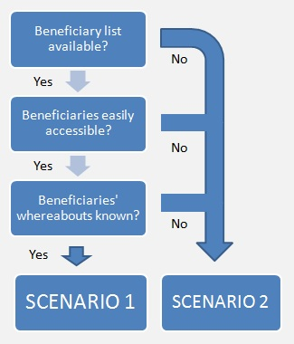

The scenario (1 or 2) being faced determines the type of sampling possible for a standard PDM.
SCENARIO 1:
- Choose the sampling type
Use simple random sampling..
- Define the sampling unit
The sampling unit is the beneficiary household, represented by the beneficiary recorded on the list. As the beneficiary is on the list, he or she received assistance during a particular distribution that took place in a given location, at a certain time.
- Define the sampling frame
The sampling frame is the list of all beneficiaries contained on the beneficiary list.
- Determine the required sample size
Before individual recipients are randomly selected from the list it is first necessary to determine the sample size. The required sample size depends on how accurate indicators need to be. For the purposes of PDMs, it is acceptable to use a 90% confidence level with +/-10% confidence intervals. The required sample size can then be obtained either by using the sample size calculators below, or by using the standard formula (see Annex 5).
Macorr Research solutions online sample size calculator (click to follow link)
Raosoft sample size calculator (click to follow link)
Examples of required sample sizes are indicated in the box below (For more information, see Annex 5):
Total NFI / ES beneficiaries | Household sample size required (90%, 10%) | Sample size increased by 20% | Household sample size required if more precision is desired (95%, 10%) | Sample size increased by 20%
100 | 41 | 49 | 49 | 59
300 | 56 | 67 | 73 | 88
500 | 60 | 72 | 81 | 97
700 | 62 | 74 | 84 | 101
1000 | 64 | 77 | 88 | 106

- Randomly select the respondents
To randomly select the respondents from the list, make a sampling interval base on the required sample size and select the first respondent using the Excel RAND function. This should ideally be done before getting to the field.
- Locate the respondents and administer the questionnaire
Use community leaders to locate the selected respondents. Interviews must take place at the respondent’s tuckel. This is important particularly for verifying respondents’ answers on the items received, as well as allowing for privacy when administering the questionnaires.

SCENARIO 2:
- Choose the sampling type
Use non-probability sampling.
- Define the sampling unit
The sampling unit is the beneficiary household, as represented by a head of household / equivalent.
- Define the sampling frame
The sampling frame is all of the beneficiary households from the given distribution, contingent on their accessibility.
- Determine the required sample size
For the purposes of standard PDMs, the required sample size is the same as for simple random sampling (see Annex 5)
- Select the respondents
To reduce bias in the selecting of household respondents proportional quota sampling should be used:
- Draft a map of all the locations where the beneficiaries are thought to be located. (This requires the involvement of local people, including RRC and interpreters hired that have good local knowledge).
- Gain an estimate (again using local knowledge) of the likely whereabouts of the population of households that received assistance.
- Use proportional piling to understand what proportion of the households that received assistance is living in which bomas / sub-bomas.
100 stones (or equivalent) are collected. The RRC representatives, along with the interpreters with local knowledge, then place the stones in the locations in proportion to the estimated number of beneficiary households. See the illustration below:

- Then the geographical distribution of households to be sampled can be decided upon, on the basis of the required sample size. For example, if there were 1000 household beneficiaries (making the required sample size 77) and there were three locations where an estimated 10%, 40% and 50% respectively of the beneficiary population were said to be living, sampling would take place as follows:
Location | Estimated proportion of entire beneficiary population living in location (according to proportional piling exercise) | Target sample size for location
Boma A | 10% | 8
Boma B | 40% | 31
Boma C | 50% | 37
 | TOTAL | 77

However, should these targets turn out to be unrealistic, and there are in reality more beneficiaries in some locations than anticipated, the number of respondents can change. As such, these targets should be taken only as guides for planning.
- Locate the respondents and administer the questionnaire
Once the locations and target sample sizes have been decided, enumerators should use snowball sampling to reach the required sample size.
In other words, after one household that meets the targeting criteria has been interviewed, another household that also meets the criteria can be found with the aid of the first household.
This can usually be verified by asking the respondent for the token she received. If the token is not available then the enumerator must be very sure that the respondent meets the criteria.

Paper and Smart phone based questionnaires
There are two ways of collecting quantitative data using the household questionnaires; paper based questionnaires and Smart phone based questionnaires. The pros and cons of each include:
Paper-based household questionnaires

Smart phone-based questionnaires

The NFI&ES cluster owns several Smart phones (Huawei Ideos) that use the Android 2.2 Operating System. If the PDM leader would like to make use of these phones for data collection they can be loaned from IOM. For more information on the recommended software for data collection, as well as the relevant downloads, see:
Dooblo SurveyToGo (click to follow link)

Focus group discussions (mini and standard PDM)
Summary of PDM focus group discussion:
Objectives | - To collect primary data that answer PDM questions  - To triangulate data gained from other sources
Target groups | - Beneficiary women  - Beneficiary men  - Non-beneficiary women  - Non-beneficiary men  - Beneficiary children (if possible)  - Non-beneficiary children (if possible)
Composition of groups | - 6-12 people meeting the above criteria

The purpose of the focus group discussions is to collect qualitative data that will help answer the particular questions set by the PDM in the areas of appropriateness, effectiveness and coverage. They are intended to triangulate data collected by other means as well as to provide beneficiaries and non-beneficiaries alike with the opportunity to raise topics that most concern them. They are supposed to be semi-structured in the sense that the discussions are structured around set questions and topics but are flexible enough for alternative feedback to be raised.
Focus group discussions are to be composed of groups of people that share certain characteristics and are intended to generate open and honest discussions especially where these would not otherwise be possible, for example due to the presence of community leaders, elders, husbands, wives or children.
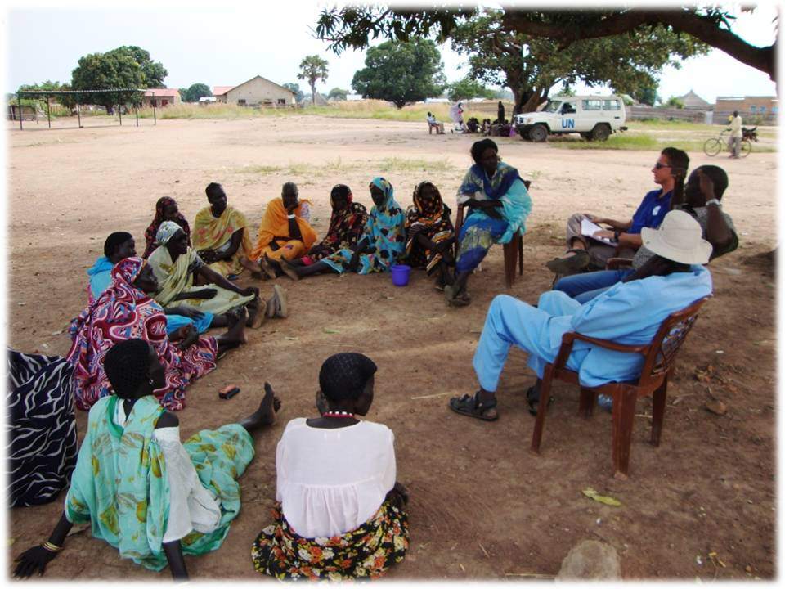
PDM focus group discussions are usually in the following groups; beneficiary women, non-beneficiary women, beneficiary men, non-beneficiary men, beneficiary children, non-beneficiary children. They should be made up of between 6 and 12 people. In other words, not so small that there is too little discussion or too few perspectives, nor too large that only the talkative, loud and confident feel able to air their views.
Just as the criteria for respondent selection must be rigorously applied when carrying out household questionnaires, so too must the eligibility criteria for attending a focus group discussion. To begin a focus group discussion, a community leader must be instructed to gather together 6-12 individuals that meet the given targeting criteria. For example, ‘women who themselves received an NFI kit by IOM on 1st December last year’. Once the potential focus group discussion participants are gathered together, the FGD leader must carry out brief individual interviews to make sure that the person does in reality meet the criteria. If the person fails to meet the criteria, their attendance at the FGD must be politely declined.
While the FGD is taking place, the leader must ensure that only those that met the criteria are present. All others, including children (apart from infants if alternative carers cannot be found) must leave to ensure the discussion only represents the desired target group, to ensure confidentiality and to minimize bias.
If interpreters are required for the FGD leader to communicate, their role must be made very clear from the outset. The interpreter should only interpret and not add his or her own views. To help the interpreter, he or she should be given a briefing on the likely contents of the FGD in advance, as well as written questions if they would be helpful. Additional tips for carrying out focus group discussions:
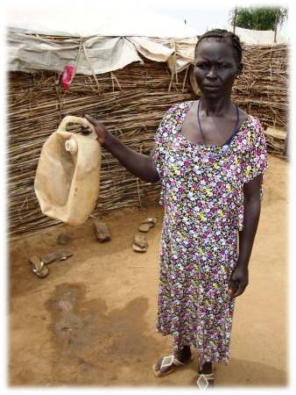
- Introduce yourself; who you are, where you are from, what you have come to do and why.
- Make it known that this is the participants’ opportunity to raise issues they have not previously been able to raise.
- Speak clearly and in short sentences for the benefit of the interpreter.
- Be willing to hear alternative or unusual perspectives.
- Make notes as you go along.
- Provide an opportunity at the end for any other questions.
- Answer questions honestly and do not raise false expectations.

Key informant interviews (mini and standard PDM)
Key informant interviews are intended to gather important information about the intervention throughout the project cycle to address the questions the PDM seeks to answer. Key informants include members of the assessment, registration/verification and/or distribution teams, government officials involved in the intervention e.g. RRC director, the Commissioner, the Executive Director, Payam administrators and chiefs, and any other individuals whose roles have been important during the course of the intervention.

Market surveys (standard PDM)
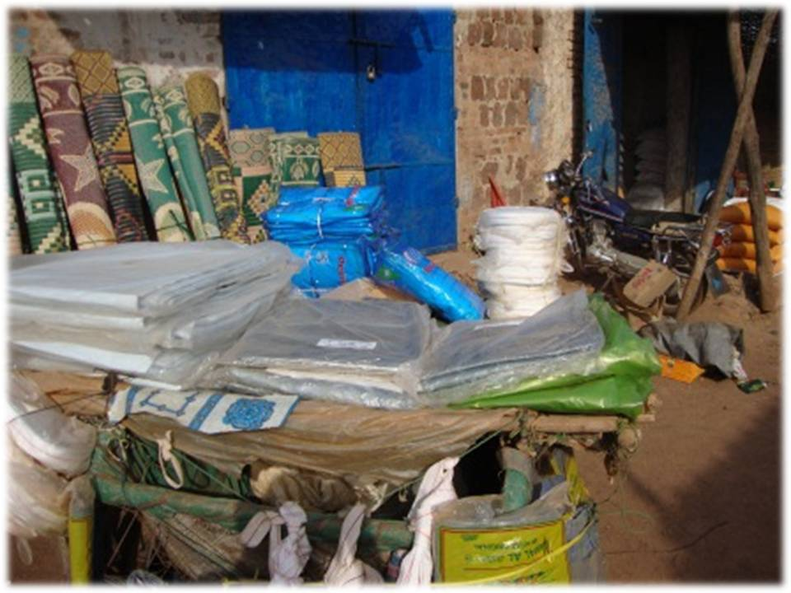
Market surveys are a fifth element of PDMs, and are carried out if a market is present near the distribution location and if the PDM is taking place within a maximum of two months after the distribution (so that traders are able to accurately recall any changes in price and supply, as well as any additional factors that may have affected them.
They are done to find out whether the distribution had any negative impact on local market dynamics. They specifically investigate among local traders:
- whether there had been a fall in the price of the various generic items distributed (the product type, with similar characteristics, inclusive of all brands) in the time since the distribution took place.
- whether there had been an increase in the supply of the various generic items distributed in the time since the distribution took place.
.
They collect this quantitative and qualitative data through a questionnaire and direct observations, and usually follow these steps:
- Identify how many traders are selling the generic items included in the distribution.
- If there is a sufficient number of traders in the market, pre-test the questionnaire in order to make modifications where necessary and practice protocol.
- Depending on the number of traders selling the generic items (most likely a small number), approach as many as possible to a) carry out the questionnaire, b) investigate any other non-constant factors that might have affected the supply and/or price of the items.

Data entry and cleaning
If a paper-based questionnaire is used to collect household level quantitative data, training for data entry staff on how to use the database and clean data should be carried out. If, on the other hand, Smart phones have been used for data collection then data entry is automatic, by-passing the need to do manual data entry. Data can be uploaded to an Excel, Access or SPSS file with SurveyToGo.

Data analysis and presenting recommendations
Once the qualitative and quantitative data has been collected (and entered and cleaned if using a paper-based questionnaire) it is then possible to identify significant trends and patterns and calculate key indicators within the question areas set during the planning stage. As PDMs use different data collection methods it is possible to triangulate findings between, for example, the results of the household questionnaires and the focus group discussions. Doing this enhances the reliability of findings, making a strong foundation upon which to base recommendations.
When drafting recommendations, it is essential that they derive from the findings made. Recommendations should be practical and realistic in light of the context and should keep in mind their target audience. However, recommendations presented in a PDM report must also be presented in relevant meetings, at the state and national level. If recommendations are not discussed in the open, they are unlikely to impact policy and practice.

Advocacy and learning lessons
While recommendations made in PDM reports must be discussed immediately after their circulation, it is important that they yield fruit in the long-term. As such, the PDM leader and other responsible programme representatives must consider advocacy based on PDM recommendations to be an ongoing task. Only if this is to take place will lessons be learned and practices changed for the better.

Bibliography
ALNAP. (2006). Evaluating humanitarian using the OECD-DAC criteria. London: Overseas Development Institute.
HAP International. (2010). The 2010 HAP standard in accountability and quality management. HAP International.
The International Red Cross and Red Crescent Movement. (1994). The Code of Conduct for in the International Red Cross and Red Crescent Movement and NGOs in Disaster Relief.
The Sphere Project. (2011). Humanitarian Charter and Minimum Standards in Humanitarian Response. The Sphere Project.
UNHCR. (2011). Post distribution monitoring guidelines. UNHCR Somalia.

Annex 1: Indicator flow charts
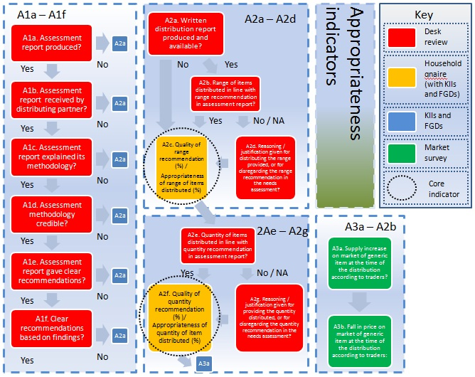
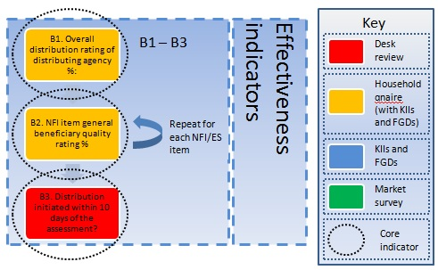

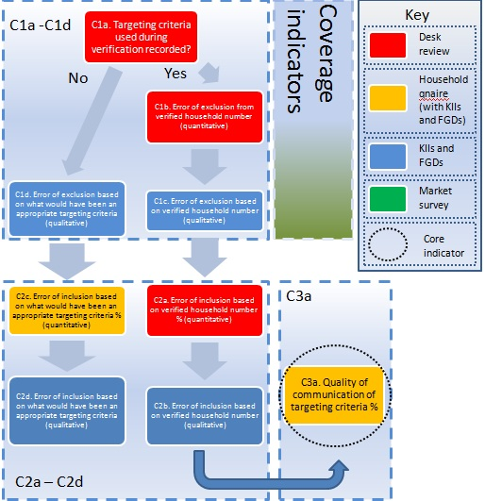

Annex 2: Indicator tables
Area of evaluation | Overarching questions to be answered | Specific questions to be answered | Information source(s) | Indicator (Calculation, where appropriate) | Target | Method required | Question sequence
A.Appropriateness | Was the distribution tailored to local needs? | Was an NFI&ES specific (not inter-agency) written needs assessment report produced? | Lead assessment agency  Assessment report | A1a. Written NFI&ES specific (not inter-agency) needs assessment report produced? | Yes | Desk review | Yes → Continue  No → A2a
 |  | Was an NFI&ES specific written needs assessment received by the (lead) distributing partner?  Asking this question assumes the distributing partner is different from the lead assessment agency. | Distributing partner  Assessment report | A1b. Written NFI&ES specific needs assessment report received by the (lead) distributing partner? | Yes | Desk review | Yes or N/A → Continue  No → A2a
 |  | Did the NFI&ES specific written needs assessment explain its methodology? | Assessment report | A1c. Explanation of needs assessment methodology included in NFI&ES specific written needs assessment report? | Yes | Desk review | Yes → Continue  No → A2a
 |  | If the NFI&ES specific written needs assessment did explain its methodology, could this be considered a credible method for generating reliable findings? | Assessment report | A1d. Credible needs assessment methodology? | Yes | Desk review | Yes → Continue  No → A2a
 |  | Did the NFI&ES specific written needs assessment include clear recommendations? | Assessment report | A1e. Clear needs assessment recommendations? | Yes | Desk review | Yes → Continue  No → A2a
 |  | If clear recommendations were included in the assessment report, were they based on clearly presented findings? | Assessment report | A1f. Clear needs assessment recommendations based on clearly presented findings? | Yes | Desk review | Yes → Continue  No → A2a
 |  | Was a written distribution report produced and is available for the PDM leader to see? | Distribution partner | A2a. Written distribution report produced and available? | Yes | Desk review | Yes → Continue  No → A3a
 |  | Was the range of items distributed in line with the recommendation provided in the assessment report? | Needs assessment report  Distribution report | A2b. Range of items distributed in line with range recommendation in assessment report? | Yes | Desk review | Yes → Continue  No → A2d
 |  | How good was the range recommendation provided in the needs assessment report? | Needs assessment report  Distribution report  Beneficiary feedback | A2c. Quality of range recommendation %, or alternatively, Appropriateness of range of items distributed %  (1 -#responses of most popularly requested item not received but urgently needed at the time of the distribution  DIVIDED BY  Total#all items urgently needed but not received at the time of the distribution) | 85<% (‘good’ or better) | Household survey | → A2e
 |  | If the distribution did not distribute the range of items recommended in the needs assessment report, did it provide any reasoning/justification for this? | Distribution report | A2d. Reasoning/justification provided for distributing the range provided, or for disregarding the range recommendation in the needs assessment? | Yes | Desk review | Yes → A2c  No → A2c
 |  | Was the quantity of items distributed in line with the recommendation provided in the assessment report? | Needs assessment report  Distribution report | A2e. Quantity of items distributed in line with quantity recommendation in assessment report? | Yes | Desk review | Yes → Continue  No → A2g
 |  | How good was the quantity recommendation provided in the needs assessment report?  Or, alternatively, if no quantity recommendation provided, ‘How appropriate was the quantity of the given item distributed? | Needs assessment report  Distribution report  Beneficiary feedback | A2f. Quality of the quantity recommendation (%), or alternatively, Appropriateness of quantity of the given item distributed %:  (Total#RESPONDENTS reporting to have received the given item type, MINUS  Total#RESPONDENTS reporting to have SOLD, EXCHANGED OR GIVEN AWAY the given item type , DIVIDED BY  Total#RESPONDENTS reporting to have received the given item type) | 70<% (at least ‘good’) | Household survey  Triangulation: FGDs and KIIs | → A3a
 |  | If the distribution did not distribute the quantity of items recommended in the needs assessment report, did it provide any reasoning/justification for this? | Distribution report | A2g. Reasoning/justification provided for distributing the quantity provided, or for disregarding the quantity recommendation in the needs assessment? | Yes | Desk review | Yes → A2f  No → A2f
 |  | Did the distribution have a negative impact on local market dynamics?  (This question complements those above that look to assess the appropriateness of the range and quantities of items distributed) | Market survey report | A3a. Supply increase on market of generic item at the time of the distribution according to traders:  #traders reporting an increase in the supply of the generic item at the time of the distribution where this cannot be accounted for through any other factor, DIVIDED BY  #traders interviewed | 0% supply↑ | Market survey | Yes → Continue  No → Continue
 |  |  | Market survey report | A3b. Fall in price on market of generic item at the time of the distribution according to traders:  #traders reporting a fall in price of the generic item at the time of the distribution where this cannot be accounted for through any other factor, DIVIDED BY  #traders interviewed | 0% price ↓ | Market survey | Yes → Continue  No → Continue
B. Effectiveness | To what extent did the activity achieve its purpose? | Were the beneficiaries satisfied with the distribution? | Beneficiary feedback | B1. Overall distribution rating of distributing agency %:  (#Very good responses X 5) + (#Good responses X 4) + (#Reasonable responses X 3) + (#Poor responses X 2) + (#Very poor responses), DIVIDED BY  (#total responses X 5) i.e. maximum possible score | 65<=% (at least ‘good’) | Household survey  Triangulation: FGDs and KIIs | → Continue
 |  | Were the beneficiaries satisfied with NFI/ES item X? | Beneficiary feedback | B2. NFI item general beneficiary quality rating %  (Total#good ratings X 3) +(Total#reasonable ratings X 2)+(Total#poor ratings), DIVIDED BY  (Total#responses X 3) i.e. maximum possible score | 70<=% (at least ‘good’) | Household survey  Triangulation: FGDs and KIIs | Repeat for X number of items, then → Continue
 | Was the distribution carried out in a timely manner? | Was the distribution initiated within 10 days of the assessment?  ‘Initiated’ has yet to be defined.  ‘The assessment’ can be taken to mean the circulation of the assessment report recommendations. | Assessment report  Distribution report | B3. Distribution initiated within 10 days of the assessment?  Date of assessment report circulation  Date of ‘initiating’ of distribution | Yes | Desk review
C. Coverage | Did the distribution reach major population groups facing life-threatening suffering wherever they were? | Do the reports available explain the targeting criteria used during the verification exercise? | Assessment / verification report  Distribution / verification report | C1a. Targeting criteria used during verification recorded? | Yes | Desk review | Yes → Continue  No → C1d
 |  | What proportion of verified households was missed out?  (This assumes that a clearly defined targeting criteria was consistently applied) | Assessment report  Registration/verification report  Distribution report | C1b. Error of exclusion from verified number (quantitative indicator based on verified numbers)  #households verified as meeting the targeting criteria that did not receive assistance, DIVIDED BY  #households that received assistance | 5<=% | Desk review | → Continue
 |  | What is the likely proportion of people meeting the targeting criteria at the time of the distribution that was missed out?  (In other words, what was the likely error of exclusion?)  Use this question when there is no information available on number of people/households that were verified. | The targeting criteria used, OR the targeting criteria that should have been used (if none was used) | C1c. Error of exclusion from verified households number (qualitative indicator based on focus group discussions and key informant interviews)  This cannot be calculated with much accuracy. Instead, an impression should be gained during the course of the focus group discussions and key informant interviews for the likely proportion of people/households that were excluded. | Small error of exclusion | Focus group discussion among beneficiaries and non-beneficiaries, as well as key informant interviews | → C2a
 |  | What is the likely proportion of people meeting the targeting criteria at the time of the distribution that was missed out?  (In other words, what was the likely error of exclusion?) | The targeting criteria that would have been appropriate if none was documented | C1d. Error of exclusion based on what would have been an appropriate targeting criteria (qualitative indicator based on focus group discussions and key informant interviews)  Possible targeting criteria include: residency status of beneficiaries of the distribution in question (IDP conflict affected, IDP natural disaster affected, returnee, refugee, host community), and vulnerability status (beneficiary respondent household including pregnant/lactating mothers, elderly, sick)  This cannot be calculated with much accuracy. Instead, an impression should be gained during the course of the focus group discussions and key informant interviews for the likely proportion of people/households that were excluded. | Small error of exclusion | Focus group discussion among beneficiaries and non-beneficiaries, as well as key informant interviews | → C2c
 |  | What proportion of people/households not verified as meeting the targeting criteria was included?  (In other words, what was the error of inclusion based on the number of people verified i.e. assuming the registration and verification was performed well) | Assessment report  Registration/verification report  Distribution report | C2a. Error of inclusion based on verified household number (quantitative data based on verified numbers)  (#households that received NFI/ES assistance, MINUS  #households verified as meeting the targeting criteria)  DIVIDED BY  #households that received NFI/ES assistance | 5%>= | Desk review  Triangulation: FGDs and KIIs | → C2b
 |  | What is the likely proportion of people not meeting the targeting criteria at the time of the distribution that was included?  (In other words, what was the likely error of inclusion?) | Distribution report | C2b. Error of inclusion based on verified household number (qualitative indicator based on focus group discussions and key informant interviews)  This cannot be calculated with much accuracy. Instead, an impression should be gained during the course of the focus group discussions and key informant interviews for the likely proportion of people/households that were excluded. | Small error of inclusion | Focus group discussion among beneficiaries and non-beneficiaries, as well as key informant interviews | → C3a
 |  | What is the likely proportion of people not meeting the targeting criteria at the time of the distribution that was included? | Distribution report | C2c. Error of inclusion based on what would have been an appropriate targeting criteria (quantitative)  (#households that received NFI/ES assistance, MINUS  #households that would have met an appropriate targeting criteria)  DIVIDED BY  #households that received NFI/ES assistance  Possible targeting criteria include: residency status of beneficiaries of the distribution in question (IDP conflict affected, IDP natural disaster affected, returnee, refugee, host community), and vulnerability status (beneficiary respondent household including pregnant/lactating mothers, elderly, sick) | 5>=% | Household survey  Triangulation: FGDs and KIIs | → C2d
 |  | What is the likely proportion of people that would have received assistance when they should not have done if a certain targeting criteria had been used? | Distribution report | C2d. Error of inclusion based on what would have been an appropriate targeting criteria (qualitative indicator based on focus group discussions and key informant interviews)  This cannot be calculated with much accuracy. Instead, an impression should be gained during the course of the focus group discussions and key informant interviews for the likely proportion of people/households that were excluded. | Small error of inclusion | Focus group discussion among beneficiaries and non-beneficiaries, as well as KIIS | → C3a
 |  | How well was the targeting criteria communicated? | Registration/verification report  Distribution report | C3a.Quality of communication of targeting criteria  #respondents familiar with targeting criteria, DIVIDED BY  #total responses | 85<% (at least ‘good’) | Household survey  Triangulation: FGDs and KIIs

Annex 3: PDM Household Questionnaire

Introduction
Introduce yourself and explain that you are here to ask some questions about NFI assistance
Say that you have not come to carry out an assessment, not do you plan to do a further distribution after this
Beneficiary criteria and informed consent
Did your household receive NFIs in early December last year? |  |  |  |  |  |  | Yes No | No → End interview
Did your household receive the NFIs at either RRC office or Doro site from World Vision? |  |  |  |  |  |  | Yes No | No → End interview
Did the distribution include plastic sheets, mosquito nets and blankets? |  |  |  |  |  |  | Yes No | No → End interview
Are you the head of household/equivalent? |  |  |  |  |  |  | Yes No | No → End interview
Are you happy to answer some questions on the NFI assistance you received? |  |  |  |  |  |  | Yes No | No → End interview
Interview details
A1 | Interview code: ____ | A2 | Sub-boma: ___________________ |  | A2 | Date of interview: (dd/mm/yyyy) ___/____ / ________
A3 | Location of NFIs receipt: _________________________ |  |  |  | A4 | Name of interviewer: ___________________________
Household and migration details
No. | QUESTION |  |  | ANSWER CATEGORY |  |  |  |  | CODE | SKIP
B1 | What is your name?
B2 | How long have you been living in this boma? |  |  | Less than 2 weeks |  |  |  |  | 1
 |  |  |  | Between 2 weeks and 3 months |  |  |  |  | 2
 |  |  |  | More than 3 months |  |  |  |  | 3
B3 | Do any of the following categories apply to your household?  Read the categories available |  |  | You have very elderly people |  |  |  |  | 1
 |  |  |  | You have a pregnant / lactating woman in your household |  |  |  |  | 2
 |  |  |  | You have someone with a long-term illness or physical disability |  |  |  |  | 3
 |  |  |  | You have children under years old |  |  |  |  | 4
 |  |  |  | You do not have a man who leads your household |  |  |  |  | 5
B4 | What WAS your residency status in this location in December? |  |  | Host resident |  |  |  |  | 1 | → B6a
 |  |  |  | IDP |  |  |  |  | 2
 |  |  |  | Temporary resident |  |  |  |  | 3 | → B5b
 |  |  |  | Returnee |  |  |  |  | 4 | → B6a
 |  |  |  | Refugee |  |  |  |  | 5
B5a | At the time of receiving the NFI assistance, when DID you expect to return to your place of origin (if IDP or refugee)? |  |  | I didn’t know – it depended |  |  |  |  | 1 | → B6a
 |  |  |  | Within 2 weeks |  |  |  |  | 2 | → B6a
 |  |  |  | Within 1 month |  |  |  |  | 3 | → B6a
 |  |  |  | Within 3 months |  |  |  |  | 4 | → B6a
 |  |  |  | In more than 3 months |  |  |  |  | 5 | → B6a
B5b | At the time of receiving the NFI assistance, when DID you expect to move on to your final destination (if temporary resident)? |  |  | I didn’t know – it depended |  |  |  |  | 1
 |  |  |  | Within 2 weeks |  |  |  |  | 2
 |  |  |  | Within 1 month |  |  |  |  | 3
 |  |  |  | Within 3 months |  |  |  |  | 4
 |  |  |  | In more than 3 months |  |  |  |  | 5
B6a | Do you have a WFP card that I can see? |  |  | Yes |  |  |  |  | 1
 |  |  |  | No |  |  |  |  | 2 | →B6c
B6b | What was the size of your household according to your WFP card in November?  You must see the WFP card to verify the figure |  |  |  |  |  |  |  |  | →C1
B6c | What was the size of your household in November according to you?  A household is defined as the number of people that fall under the responsibility of the head of household

General NFI Questions
Items | C1. Did you receive a (item name) during the distribution?  - Yes  - No  - Don’t know  If ‘no’ or ‘don’t know’ , GO TO next item | C2. How many (item name) did you receive during the distribution? | C3. How many (item name) from the distribution do you still have?  If same as C2 skip to C5 | C4. What is ONE reason why you now have less than what you received?  - Sold  - Exchanged  - Broken while using  - Broken when received  - Gave away  - Used up  - Lost  - Stolen  - Other (specify) | C5. What was the QUALITY of the item received?  - Poor  - Reasonable  - Good  If Poor or Reasonable go to C6 else skip to next item or D1 | C6. Why do you consider the item to be of POOR or REASONABLE quality?  - Too small  - Damaged when received  - Broken while using  - Other (specify) | C7. Item observed?  - Yes  - No
A. Plastic Sheeting
B. Sleeping Mat
C. Blanket
D. Jerry can
E. Cooking pan
F. Knife
G. Table spoons
H. Serving Spoon
I. Plates
J. Aluminium Cup

No. | QUESTION | ANSWER CATEGORY | CODE | SKIP
D. Range of contents of items distributed
D1 | WERE there any additional items that you URGENTLY needed at the time of the distribution that were NOT included in the NFI assistance you received? | Yes | 1
 |  | No | 2 | E1
D2 | If yes, what were these? Of these, what were the THREE most needed items?
E. Targeting, Transparency and Timeliness

E1 | How did you hear about the date and location of the DISTRIBUTION?  Clarify the difference between registration and distribution | World Vision representative | 1
 |  | Chief | 2
 |  | Community Leader (not chief) | 3
 |  | SSRRC | 4
 |  | Local Authority (not SSRRC) | 5
 |  | Rumor | 6
 |  | Radio | 7
 |  | Other (specify) _____________
E2 | Did you personally receive the NFIs at the distribution site? | Yes | 1
 |  | No | 2 | D12
E3 | How long did you have to wait to receive your NFIs after the distribution started?  This is from the time the beneficiary arrived at the distribution site to the time they received their NFIs goods | Less than 2 hours | 1
 |  | 2 to 6 hours | 2
 |  | 7 hours to 1 day (not over night) | 3
 |  | Over night | 4
E4 | How would you judge the distribution method used by World Vision in the distribution of NFIs? | Very Good | 5 | D9
 |  | Good | 4 | D9
 |  | Reasonable | 3
 |  | Poor | 2
 |  | Very Poor | 1
E5 | If reasonable, poor or very poor, why do you think so?
E6 | Was a tax of any kind imposed on you by anyone during the distribution?  Reassure respondent it is okay to answer this question honestly | Yes | 1
 |  | No | 2 | D12
D7 | If yes, what did you have to pay or give out? Please tell me the item and the quantity.  List all items and their quantity. Continue to probe: Anything Else? Until you are confident all items have been recorded | Item | Quantity
E7 | Who did you have to give these items to?  Circle all mentioned. Ask- Anything else? | RRC | 1
 |  | Payam administrator | 2
 |  | Chief | 3
 |  | Community Leader (apart from 3 above) | 4
 |  | World Vision representative | 5
 |  | Other (specify): ________________ | 6
D12 | Have you ever been harassed or ill treated by those who did NOT receive NFIs?  Reassure respondent it is okay to answer this question honestly | Yes | 1
 |  | No | 2 | E1
D13 | If yes, why do you think this happened?  Reassure respondent it is okay to answer this question honestly
E. Additional questions

E1 | Do you have any questions for us?
E3 | Do you know of any other households nearby that received NFIs in the same distribution? Could you show them?
End Of Survey- THANK YOU!

Annex 4: Sample schedule for a standard PDM

Days | Activities
Thursday 26th April | Meet with local authorities, recruit interpreters
Friday 27th - Saturday 28th April | PDM training – including PDM theory and practice, questionnaire handling, sampling methods, interview technique, field testing, PDM planning
Monday 30th April – Thursday 3rd May | Data collection – HH questionnaires, FGDs, KIIs, market survey, review of preliminary results
Friday 4th May | Review of preliminary findings/last bits of data collection
Saturday 5th May | Travel from Mabaan to Malakal, and Malakal to Juba
Monday 7th May onwards | Carry out detailed analysis and make recommendations and follow up

Annex 5: Guidance on data collection

Household questionnaires
The importance of method: The household questionnaires form the backbone of data collection, allowing ‘core’ indicators (as well as additional ones that may be desirable) to be collected. The way they are administered and the sampling procedures that are used in selecting households are essential for generating reliable data.
The end result of the data collected from the household questionnaires is a set of indicators that measure, either directly or indirectly, the extent to which the intervention has been appropriate, with good coverage and effective. If probability sampling is used then it is possible to describe the indicators in terms of confidence intervals. This way the quality of different interventions across different locations can be compared. If non-probability sampling is used then comparisons cannot be made in terms of confidence intervals. However, the data can still be valuable on its own.
Sample size
The required sample size when using simple random sampling can also be obtained by using the following formula:
$Sample size required=\frac{n}{\left(1+\left(\frac{n}{population}\right)\right)} where, n=Z x Z ( \frac{P\left(1-P\right)}{D^{2}}$)
Once calculated, the sample size should be increased by 20%. This is done as it is likely that some of the randomly selected beneficiaries will either not be found or will not be available. This means that without increasing the number of respondents it is unlikely that the required sample size will be achieved.

SCENARIO 2:
Choosing the sampling type
While doing probability sampling using simple random sampling is preferable, if scenario 2 is encountered then the PDM must use non-probability methods instead. This means that there is not an equal chance of each individual in the sampling frame being selected and so it is not possible to assign a level of scientific confidence to indicators even though the results may be accurate. With non-probability sampling we are therefore not able to compare indicators across different PDMs with scientific confidence.
Determining the required sample size
With non-probability sampling we cannot produce point estimates with confidence intervals and so there is no black and white rule when deciding upon the sample size. However, for the purposes of standard PDMs, the required sample size should be the same as for when using simple random sampling. For example, if there were 1000 household beneficiaries that received assistance during the distribution, then 64 household recipients should be targeted, plus 20%. The additional 20% on this occasion is not to anticipate selected respondents being absent, but rather to compensate for bias introduced by using non-probability sampling (as well as spoiled questionnaires).

Point 9.
This depends on the number of standard PDMs that are conducted in the year.
Core standard 5.
Standard 6
Appropriateness: ‘Appropriateness is the tailoring of humanitarian activities to local needs, increasing ownership, accountability and cost-effectiveness accordingly.’ Coverage: ‘The need to reach major population groups facing life-threatening suffering wherever they are.’ Effectiveness: ‘Effectiveness measures the extent to which an activity achieves its purpose, or whether this can be expected to happen on the basis of the outputs. Implicit within the criterion of effectiveness is timeliness.’
For further information, see Annex 5.
This means that there is not an equal chance of each individual in the sampling frame being selected and so it is not possible to assign a level of scientific confidence to indicators even though the results may be accurate. With non-probability sampling we are therefore not able to compare indicators across different PDMs with scientific confidence.
While this method does have inherent bias, given the usual difficulties of locating beneficiaries that meet the targeting criteria it has been found to be the most effective means of reaching households.
P = 0.5 (True proportion of the factor in the population. This is assumed to be 50% (0.5) since without the benefit of an informed estimate, the true proportion that has the most conservative confidence intervals – 0.5 – should be chosen.) D = 0.1 (Maximum difference between the sample mean and the population mean where it is defined to be ± 10%) Z = 1.645 / 1.96 (Area under normal curve corresponding to the desired confidence level. For 90% confidence levels this 1.645. For 95% confidence levels, this is 1.96.)
While a 10% increase in the sample size is normal, experience has shown that even if all of the conditions for carrying out simple random sampling are apparently met, it may still be difficult to interview all of the people on the sampling list. To avoid having to devise a replacement list and then to start the process of locating beneficiaries all over again, increasing the sample size by 20% is preferable even though it may result in more questionnaires being administered than absolutely necessary.

