Shelter Cluster Specific Guidance
JIAF 1.1 2022 HPC Process
In 2021, it was agreed that the Joint Intersectoral Analytical Framework (JIAF) would undergo a slight revision from version 1 to version 1.1 prior to its implementation in the 2022 Humanitarian Programme Cycle (HPC). The JIAF is a “methodologically new approach to analysing the overlapping needs of populations in crisis.” Its key application in the HPC process is to support the identification of people in need (PiN). While largely believed to be a quantitative calculation method, the JIAF should aim to support the analysis process. Currently the JIAF guidance and annexes may take up to 5 hours and 16 minutes to read through once. This Shelter Cluster specific guidance aims to simplify and synthesize this information and highlight Shelter specific realities found in the JIAF. Each step of the JIAF is covered including some multisectoral processes, so that as a Shelter Cluster team you are better prepared to engage in each of the JIAF steps.
In 2020, several challenges arose in the JIAF’s implementation. These challenges included:
- Heavy reliance on the Multi-Sector Needs Assessments as the (only) source of data
- Lack of reliance on expert (sectoral) judgement in analysis of the data sources
- Lack of understanding of critical indicators
- Improper selection and implementation of data scenarios
The revision to the JIAF seeks to improve these challenges and therefore strengthen the analysis of experts at field level.
Steps to know about in the JIAF Process
- The Analysis Team- As a Shelter Cluster Coordination team, you should be ready to participate in such discussions at ICCG and IMWG levels and ensure representation of Shelter Cluster partners in any technical assessment working groups (TAG/TAWG) established.
- Set the Scope of the Analysis: In this stage, the Shelter Cluster will work with other Clusters to determine the overarching characteristics and key measures of the crisis:
  - Consult the guidance on initial situation analysis and secondary data review and assessment strategies in the Information Management and Assessment (IMAS) Toolkit and Coordination Toolkit. Identify context, impact, and potential risks for the Shelter sector in the context. Some examples to describe the impact can include but are not limited to # of damaged homes, # of people displaced by settlement type, # of people displaced by shelter type.
  - Agree with other clusters on the geographical areas impacted by the crisis. Given current scope of the JIAF this is typically done to Geographic Administrative Level 2.
  - Identify profile of the affected groups according to demographic and vulnerability characteristics. As Shelter Cluster, a key contribution should be to identify settlement and accommodation/shelter types of the affected population.
  - Narrative to be written summarizing the analysis of context, risk, and impact on affected population.
- Review Indicators and Define Humanitarian Conditions: The Global Shelter Cluster along with other clusters has contributed to a working list of core indicators to help you measure needs and severities within the sector. The Global Shelter Cluster has additionally compiled an indicator bank of Shelter and Settlements Indicators which are useful for helping you to measure attributes of need in the sector and to help you in establishing your own contextually appropriate indicators and thresholds. The indicators can be used as proxies and as part of data collection processes. Examples from country-level Shelter Cluster and Working Groups are available in Chapter 3A. CALCULATING PEOPLE IN NEED (PIN) AND ESTABLISHING SEVERITY chapter of the IMAS toolkit. In defining severity for new indicators, the following severities are assigned, but at a later stage it will be critical to classify and describe what these levels of severity mean in Shelter terms in the context.
Level of Severity | Description
1 | None/Minimal
2 | Stress
3 | Severe
4 | Extreme
5 | Catastrophic
Setting thresholds: Damage to shelters is good example. While an indicator may be % of shelters damaged, the type and severity of damage could be positioned in each of the severities depending on context and shelter type.
- Definition of Critical Indicators: Critical indicators are determined to be those that are “time-critical life- threatening consequences” more specifically “if people are not assisted as soon as possible, they will die.” Critical indicators must be in Severity Level 5. It is critical to note that these indicators can help in informing the severity of a situation but should not be the only ones taken into consideration for calculating Intersectoral PiN. The guidance states, “In fact, PiN would be defined based on expert judgement, considering not only the critical indicators, but a wider array of sectoral indicators.” Critical indicators could change per context. For example, lack of shelter in cold climates could be more critical in some contexts than in others.
- Initial Analysis Stage (previous steps) for ICCG and HCT: As Shelter Cluster Coordinator, it is critical to be aware of this stage both for discussions at ICCG level in ensuring expert judgement involvement and also for briefing the Cluster’s representative to the HCT on any relevant discussions on the JIAG.
- Collating and Collecting Data: Based on the indicators selected, data will be collected and collated by the Clusters. Data collection can include Secondary Data Analysis and primary data collection. The source of data should not be limited to the multi-sector needs assessment, and you can rely on other sources of data seemed suitable to your analysis of people in need.
- Write narrative for the sector linking analysis of context, risk, and impact and how each of the affected groups have needs in the Shelter sector and the severities of these needs based on the data collected. Please upload your data sets to your country page at www.sheltercluster.org and also to Humanitarian Data Exchange.
- Selection of Scenario based on 2 Data Scenarios prior to JIAF Aggregation: Based on the finding of the data collection and collation exercise, clusters will be required to aggregate and analyse their indicators together in order to begin calculation of what the JIAF refers to as the “preliminary PiN” that PiN representing humanitarian conditions. There are two data scenarios currently approved in the JIAF guidance:
  - Scenario A which is purely data from the Multi-Sector Needs Assessment (MSNA)
  - Scenario B which includes household indicators from multiple surveys or area level indicators
In analytical terms, multiple sources of data synthesized in a coherent manner is always preferable for ensuring an evidence base. Nevertheless, when applying the JIAF, Scenario A (one single source of data: typically, an MSNA or other single household data survey) controls for the risk of differing sample populations. Scenario B may be more appropriate
- when data collection is limited,
- There are limited indicators per sector included in an MSNA HH survey
- Data sources do not only include household level indicators. Example: Area-based indicators are very appropriate when talking about settlement planning activities or distance of the shelter to markets, WASH services, or other aspects such as recreational space. (% of houses damaged in Area X/% of houses in Area X) is also an area indicator.
- According to the Data Scenario, follow the instructions in the Annexes for how to calculate Scenario A and Scenario B:
# | Scenario A | Scenario B
1 | For each household in the data set, replace the result of each indicator with its level of severity from 1,2,3,4,5 for shelter indicators.  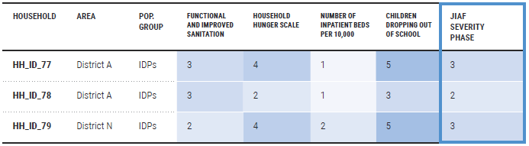 | Classify all data resources into a single line according to geographic area and population group.  For each indicator based on looking at various assessments, estimate which % of households fall under a given severity class.  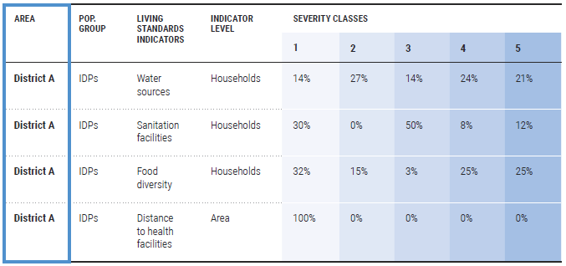
2 | Once all clusters have replaced the level of severity for each indicator, calculate the intersectoral severity for each household in the dataset. JIAF recommends the following methods of Mean of Max 4 or 50%:  - If 4 indicators or less, add indicators together and take the average. (Indicator1+Indicator2+Indicator3+Indicator4)/4  - If more than 4 indicators, add indicators together, take the average, and then apply 50% to the average: ½((Indicator1+Indicator2+Indicator3+Indicator4+Indicator5+Indicator6)/6) | The theory behind Scenario B is that the People in Need of any population group in each area is 25%.  Classify intersectoral severity for each indicator by following the rules of 25%. Add the %s from right to left until the cumulative sum of each column is at least 25%; the column where this occurs is the severity score for the indicator. 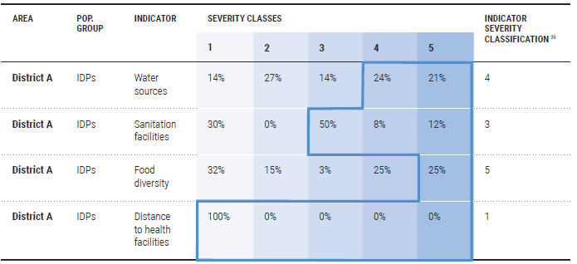  To calculate the JIAF Severity Phase Score for each area and population group, apply the Mean of Max 50% rule described in Scenario A.  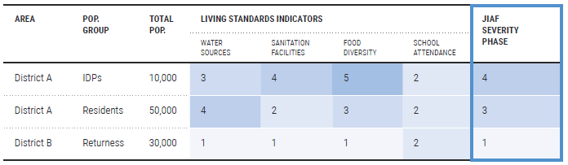
3 | Critical Indicators: If any critical indicator for that household is higher than the JIAF Severity Score, the critical indicator will replace the JIAF Severity Phase Score.  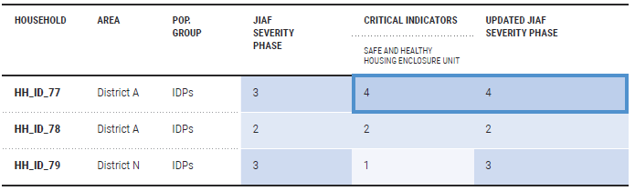 | Critical Indicators: If any critical indicator for that household is higher than the JIAF Severity Score, the critical indicator will replace the JIAF Severity Phase Score.
4 | Looking at the data set, calculate the percentages of households which fall in each severity Score.  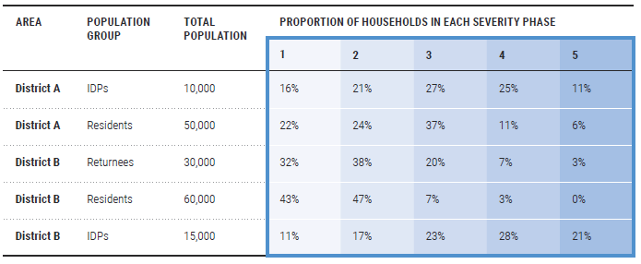 | Estimate the “minimum number of people” in need in each area by taking 25% of the estimated population for that area if the severity is 2 or higher. If the severity phase is 1, the minimum population in that severity phase or higher is 100%.  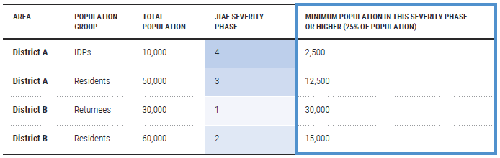
5 | Based on population estimates, use the %s to estimate the number of people in each severity phase. Severities 3-5 are calculated as PIN  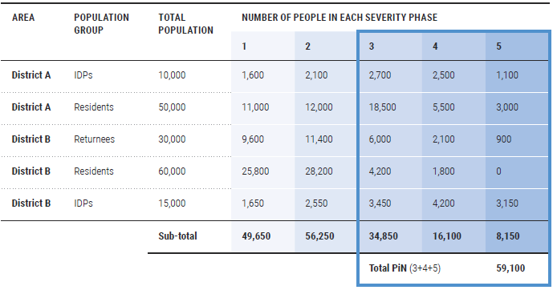 | Assign an estimate of PiN using “More than”; “More than equal to”; “Less than”; “Less than equal to” denominators. <,>,=, etc.  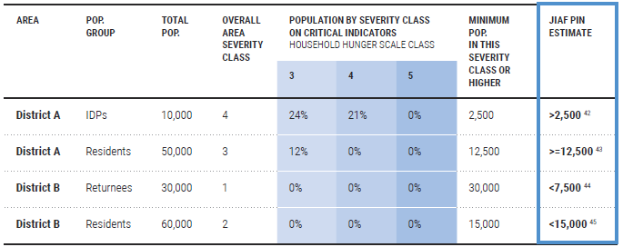
6 | Analytical additions: Often expert judgement is not exercised on these quantitative figures and it is important to ensure that the numbers match the reality of understanding of the ICCG, the Shelter Cluster partners, and evidence available to the Shelter Cluster.  - Ensure that the data includes a disclosure on the validity of the results: confidence level, representativeness of sample size per geographic level  - Analyse the results with other sources of data available to the Shelter Cluster such as 5W in terms of what aid has been delivered per district and where gaps may yet or not exist. The JIAF draft does not yet explain why Severity 2 is not included, but also as a Sector coordinator, you should be able to evaluate what lack of assistance could mean for that population. The JIAF guidance makes frequent reference to, “IF current assistance would decrease, the severity phase would likely increase.”  - Does the quantitative estimate of PiN correspond with the feedback of partners and how Shelter needs may be exacerbated by needs in other sectors such as WASH, Livelihoods, CCCM, and Protection? | Analytical additions: Often expert judgement is not exercised on these quantitative figures and it is important to ensure that the numbers match the reality of understanding of the ICCG, the Shelter Cluster partners, and evidence available to the Shelter Cluster.  - Ensure that the data includes a disclosure on the validity of the results: confidence level, representativeness of sample size per geographic level  - Analyse the results with other sources of data available to the Shelter Cluster such as 5W in terms of what aid has been delivered per district and where gaps may yet or not exist. The JIAF draft does not yet explain why Severity 2 is not included, but also as a Sector coordinator, you should be able to evaluate what lack of assistance could mean for that population. The JIAF guidance makes frequent reference to, “IF current assistance would decrease, the severity phase would likely increase.”  - Does the quantitative estimate of PiN correspond with the feedback of partners and how Shelter needs may be exacerbated by needs in other sectors such as WASH, Livelihoods, CCCM, and Protection?

- Based on the two data scenarios, classify the indicators, and results according to the 3 main pillars of Living Standards, Coping Mechanisms, and Physical& Mental Wellbeing. This will result in a table per geographic area and population group, and the indicators classified into each severity based on the above analysis. Discussion should occur through the Analysis Team and the ICCG on what are the underlying factors of these indicators and the impact on people because of these identified needs and severities.
- The final stage of establishing the PiN is to anticipate future scenarios. This should be based on an existing interagency contingency plan. It is possible that that this may not exist in your context. During the HRP/HNO process there may not be enough adequate time to develop plausible scenarios for how the situation may develop, so as a Shelter Cluster it is recommended to draw upon your own strategy and sectoral findings. If working with UNHCR as lead agency, you can consult with UNHCR’s Preparedness Package for IDP emergencies to analyse possible evolution of the situation that may increase the number of people in need.
- Validation of Current Results: The Analysis Team will analyse the final figures for people in need in all pillars according to future and current needs. This is a key stage where expert judgement should be included. As Shelter Cluster Coordinator ensure that the findings match the reality of the situation. Use available Shelter Cluster resources and rely on subnational and local knowledge within your cluster.

JIAF FAQ yet to be released
Pp. 3 and 10 provide useful diagram of this. https://www.humanitarianresponse.info/sites/www.humanitarianresponse.info/files/documents/files/humanitarianprofilesupportguidance_final_may2016.pdf
https://www.umsl.edu/~lindquists/sample.html
https://www.surveysystem.com/sscalc.htm
https://www.surveysystem.com/sscalc.htm

